Thank you for being a leader in our community by raising awareness for CanCare Atlanta’s “Survivor by your Side” programs while participating in this community wide daffodil planting project coordinated by Johns Creek Beautification, Inc. With your assistance, this project will cover our community with beautiful spring flowers that will return every year bringing hope of renewal to survivor and caregiver alike.

Daffodils add bright, vibrant color to the landscape and they are one of the easiest and most popular spring bulbs to grow. Though typically associated with the characteristic sunny yellow bloom, there are actually more than 40 species and over 32,000 registered cultivars or hybrids. Daffodils multiply each year, making them great for naturalizing.

Daffodils are highly resilient bulbs and can survive even the most rudimentary planting attempts! These bulbs are deer resistant which makes them well suited to our Georgia landscape. With that in mind, we understand that not every planting activity can achieve the recommended instructions of this guide. The guide was written to give Planting Partners/site coordinators the best set of planting directions we could assemble to achieve maximum bloom production and long lasting results. However, if your group can only manage to dig a few holes and drop the bulbs in place, that’s perfectly okay! The important message here is that this project is about our community working together in support of cancer survivorship and to remember our veterans. The remarkable little daffodil with its cheery, bright, spring bloom projects hope and resilience and we appreciate all efforts to create beautiful daffodil beds throughout our city.

Project Requirements- Steps for a successful project

- Site Selection
- Set Your Key Dates
- Recruit Your Volunteer Group
- Donate Online
- Prepare Your Planting Bed
- Plant Your Bulbs
- Daffodil Care and Maintenance

  - Site Selection

- Get permission from property owner
- The site must be able to be accessed and viewed by the public
- 200 square feet (approximately the size of a large parking space) will accommodate 1,000 bulbs.
- Choose a spot receiving at least six hours of full sun daily, from late winter through mid-spring. Light shade in late spring is beneficial for many late season bloomers – the shade helps the flowers retain their color. Insufficient sunlight will diminish blooming dramatically.
- Daffodils do not enjoy sitting in wet soil. Choose a location that is well-drained or the bulbs will rot.
- The planting bed can be any shape. The key is to mass the bulbs together for best flower power effect!
- You can split the bulbs into multiple beds. For example, two beds of 500 bulbs each, or three beds of 333 bulbs each, or any combination equaling 1,000.
- It can be the extension of an existing bed. Daffodils in front of existing shrubs look great!

- Set Your Key Dates

Register as a Partner, Reserve your Daffodil Bulbs, Donate
- Register online: https://www.johnscreekbeautification.org/daffodils4hope, Click on “Become a Planting Partner”
- Deadline: June 15th.
- A donation will reserve 1,000 bulbs and one D4H sign.
- Additional signs can be ordered $25.00/sign.

Plan your date for site preparation
- Prepping your selected site can be accomplished anytime of year.
- Depending on the number of volunteers, plan for at least a half days work

Pick your bulb planting date
- In Georgia, spring-flowering bulbs can be planted from October through November. You can successfully plant them as late as December but the later you wait after October the less time the bulbs will have to establish themselves.

- Recruit Your Volunteer Group
  - Don’t forget to recruit energetic volunteers for your prep day. A successful ground prep ensures an enjoyable planting day and beautiful, lasting blooms for years to come
  - Planting Day: Plan on 1-2 adult volunteers per 100 bulbs, depending on volunteer’s age and gardening skill.
    - Children of all ages love to plant daffodil bulbs and can be a part of this project! Plan on an adult helping them plant about 10 or so each.
    - Senior adults will enjoy this project as well. Again, plan on allowing them to enjoy planting about 20-25 each based on their energy levels.

- Donate Online
- Your group will generally want to plant 1000 bulbs per year and you can reserve them with John Creek Beautification during your registration sign up at https://www.johnscreekbeautification.org/daffodils4hope, Click on “Become a Planting Partner”.
- Please let us know if you will want to supply your own bulbs for your location. That’s good, too! Don’t forget to work with a reputable bulb supplier and reserve them early by mid summer as supplies are limited.

- Prepare Your Planting Bed

The roots of a plant are the foundation on which that plant thrives. The most important factor for creating good roots is good soil preparation. Good soil prep is the key to successful gardening.
- Check for buried utility lines. Call Utility Locate 1(800)282-7411 at least a week ahead.
- Identify any irrigation lines that might be buried beneath the bed.
- Define the outline of your flower bed. Outline the bed using a flexible hose or rope. It is helpful in finding the right shape and size for your bed before work begins.
- Site Prep: depending on the number of volunteers, plan for at least a half day
- Remove the existing vegetation (e.g., sod, weeds, plants).
- Work the soil when it is moist, but not wet. If you work soil when it is too wet, you will cause it to clump and become compacted. If you work soil when it is too dry, you harm the soil structure. Working soil when it is moist will help maintain good air porosity and soil structure.
- Turn the soil over using a tiller, spade/shovel, or garden fork to turn the bed over.
- A tiller will turn the soil to a depth of 6 to 8 inches. It is good to get down at least 12 inches (the depth of a spade or shovel) when turning over (cultivating) a bed.
- Double digging is optimal.
- Mix compost into the bed: once you have turned over the soil, spread a layer of organic matter or compost 2 to 3 inches thick over the bed and turn the soil over again to mix the compost into the soil. Adding compost will improve the soil by adding nutrition and improving soil structure.
- Organic fertilizers such as bone meal are often recommended for bulbs, but they are probably no better than inorganic sources used at the proper rates.
- Add 1 to 2 pounds of 10-10-10 per 100 square feet of bed space.
- Incorporate fertilizer and soil amendments thoroughly and deeply, at least 12 inches.
- If you are preparing the bed a few weeks or months ahead of planting, apply a thick mulch (3-4") over the bed: pine needles, or shredded leaves, or bark products. You can reuse the mulch after you plant your bulbs.

Preparing Your Bed - Tools

- a lot of MUSCLE!
- tape measure
- hose or rope to define the bed
- wheelbarrows
- shovel/spade
- mid-tine tiller (can be rented for the day or half day from Home Depot or Lowes)
- pick
- rake
- broom
- blower
- paper yard waste bags

Preparing Your Bed - Material

- Compost: 1 cubic yard will cover 108 sq. ft. at 3" depth, so you need 2 cu. yd.
- 10-10-10 fertilizer (from Big Box store): 2 pounds/100 square feet of bed space.
- Mulch: shredded leaves, or pine straw, or hardwood mulch, or wood chips.
- Mulch required for 200 sq. ft., 3" deep: from thecalculatorsite.com 1.84 cubic yards, or 16.7 wheelbarrows, or 25 bags (size: 2 cubic feet).

6. Plant Your Bulbs

- Proper spacing will keep the bulbs from competing with each other for water and nutrients, promoting better bloom in subsequent years.
- The tag that comes with your bulbs should indicate their proper spacing.
- In general, large bulbs such as most daffodils should be spaced 6 inches apart, or 5 bulbs per square foot
- Large daffodil bulbs should be planted "pointed side up".
- If you can’t tell which end is "up", plant the bulb on its side.
- You can delineate planting sections: for example you will plant 125 bulbs in a 5’ x 5’ section of bed, therefore you can plan for 8 (5’ x 5’) sections.
- Dig a hole for the bulb that is approximately 6-8" deep and space them in rows, approximately 6" apart.
- Or dig a slightly wider hole and place a larger odd number (5-7) of bulbs in the same hole, creating more of a "bouquet effect" in your garden.
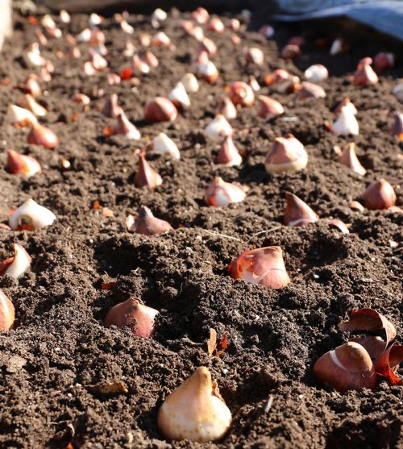
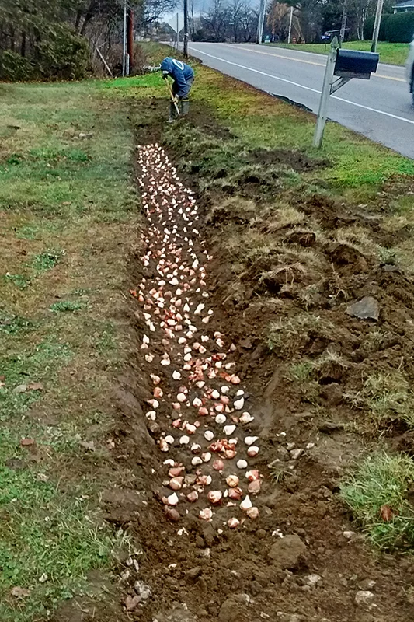
- To plant a lot of bulbs fast, dig out the entire planting area to a depth of 6 to 8” and pile the soil on a tarp nearby. Position the bulbs in the hole and then slide the soil off the tarp to cover them.

- Trench Planting is a quick, efficient method for planting lots of bulbs!
- Thoroughly soak the area with water once all the bulbs have been planted. Roots will form in fall and then the bulb will sprout and bloom in spring.
- Normal rainfall usually provides enough moisture for spring-flowering bulbs. During dry weather, provide supplemental irrigation at weekly intervals.
- Mulch: shredded leaves, or pine straw, or hardwood mulch, or wood chips
- Place your D4H sign in the bed.

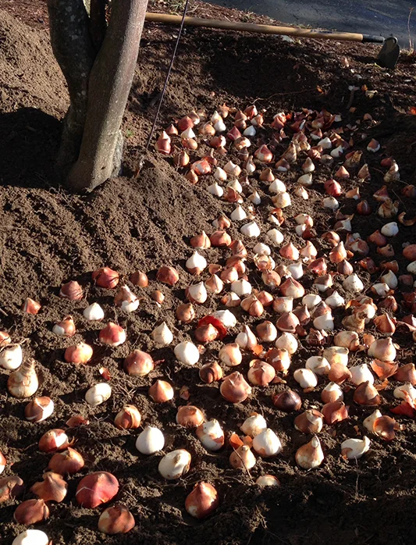
Planting - Tools

- round shovel/spade
- square shovel
- trowel
- bulb planter
- hammer drill and auger
- pick
- bow rake
- tarp
- broom
- blower
- paper yard waste bags
- wood stakes or white plastic cutlery: delineate planting sections

Planting - Material

- 1,000 bulbs
- mulch

7. Daffodil Care and Maintenance

- Daffodils are often "over-planted" with other plants, frequently annuals. Be sure not to dig so deeply as to damage the bulbs.
- Consider over-planting with drought-tolerant annuals such as zinnias, periwinkles or marigolds.
- When the bulbs flower, fertilize them again using the fertilizer and rates previously mentioned. This will help the development of next year’s bloom.
- Water as needed while the plant is growing and blooming.
- When the flowers fade, cut them off to prevent seed formation.
- After the flowers have died, allow the foliage to yellow and die back. The leaves will continue to gather sunlight and make food for next year's blooms.
- Once the foliage has yellowed and dried, it may be removed by gently pulling it out of the soil. If the leaves do not easily pull away from the bulb, they are not ready to be removed
- After you remove the foliage, your daffodils will be dormant and ready to "rest" until next year!
- Store your D4H sign until the daffodils sprout again in the spring.

Sources and References

The University of Georgia has an excellent publication about growing bulbs in Georgia at https://site.extension.uga.edu/colquitthomeowners/files/2022/04/Flowering-Bulbs-for-Georgia-Gardens.pdf

The Georgia Daffodil Society: www.georgiadaffodilsociety.com

Walter Reeves, The Georgia Gardener: walterreeves.com

Google: search "Planting Daffodils in GA"

YOU CAN DO THIS!

HAVE FUN SHARE WITH THE COMMUNITY ENJOY THE PROJECT

Thank you to
Michèle Morel, Master Gardener, for writing this guide.

