2024 ANNUAL REPORT
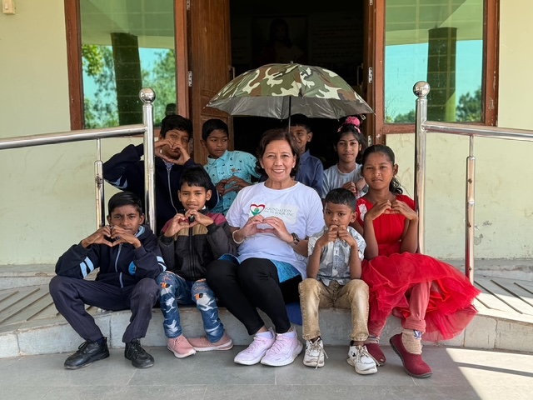
www.foundationforthepoorinc.org
wecanhelp@foundationforthepoorinc.org
Office: 267-544-5600 Mobile: 215-687-0509

Prepared by: Joey Cecilia del Prado

Message from Joey Cecilia del Prado
Dear Supporters and Volunteers,
I can’t thank you enough for the support you extended to Foundation for the Poor Inc. last year. I want to extend my deepest gratitude to each of you. Your unwavering support, generosity, and dedication have made a tangible difference in the lives of those we serve.
Our biggest accomplishment the past year was the School Building Project in Akpoli, Kogi, Nigeria through the supervision of Fr. Williams Nnandozie – no doubt, it was only possible because of you all. Together, we provided hope and opportunity for children in need, proving once again the power of collective action.
Now, as we embark on 2025, I invite you to join me on another life-changing mission. This time, we are setting our sights on the Philippines, where we will work alongside Pastol ng mga Dukha (Mindoro, Philippines) and AJ Kalinga Foundation (Tayuman, Manila/Bohol, Philippines) to uplift communities facing extreme poverty.
The challenges in this field are ever-evolving, and a careful SWOT(Strength, Weakness, Opportunities and Threats) analysis reminds us of both the obstacles ahead and the immense opportunities to create sustainable change. But with your continued support, I have no doubt that we will rise to meet them.
Let’s stand together once more, building bridges of hope and compassion. Thank you for believing in our mission, and I look forward to another impactful year with you by my side. God bless us all!

With gratitude,
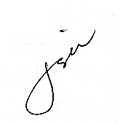
Joey Cecilia del Prado
Founder & President, Certified Non-profit Manager, CCP
Foundation for the Poor Inc.



Facts about the Non-profit industry in the Year 2024 & 2025 Projection
In 2024, the nonprofit sector experienced notable developments both globally and within the United States.
GLOBAL TRENDS:

Feminist Philanthropy: There was a significant shift towards gender-focused giving, with major donors and nations pledging substantial funds to support women and girl’s rights. Despite these commitments, funding remained insufficient, highlighting a gap between feminist aspirations and actual financial support. The effort supports the need to lift women up through solidarity and mutual empowerment.
Impact of USAID Funding Freeze: A halt in USAID and State Department-funded projects led to widespread job losses and organizational shutdowns. Volunteers and nonprofits mobilized to document and mitigate the freeze effects, emphasizing the sector’s resilience in crisis situations.
US TRENDS:
Employment and Economic Impact: Nonprofit organizations employed approximately 12.8 million individuals, accounting for 9.9% of all private-sector jobs.
Charitable Giving Patterns: While total charitable donations surpassed $500 billion for the third consecutive year, the number of individual donors declined, with less than 50% of U.S. households contributing to charity in 2024. This trend suggests that donations are increasingly concentrated among fewer, wealthier individuals.
Increased Demand and Resource Constraints: Approximately 71% of nonprofits reported a surge in demand for their services. However, 74% faced staffing vacancies, and over two-thirds planned to reduce programs and services within the next two years due to financial and operational challenges.
Digital Transformation and AI Integration: Nonprofits increasingly adopted artificial intelligence and other digital tools to enhance efficiency and engagement. This technological shift aims to alleviate employee burnout by automating routine tasks, allowing staff to focus on mission-critical activities.

Generational Giving Shifts: Younger generations, particularly Gen Z, showed a strong inclination towards social and environmental causes. Notably, 93% of Gen Z and Millennials planned to make financial donations in 2024, with 91% intending to volunteer, indicating a potential shift in future philanthropic landscapes.
These trends underscore a dynamic period for the nonprofit sector, marked by both challenges and opportunities. Organizations are navigating economic pressures, evolving donor behaviors, and technological advancements to continue fulfilling their missions.

MISSION & VISION
Mission statement: We strive to offer our partners support the best we can by raising funds for them to bring their projects to the finish line as we promote the “Power of Partnership.”
We encourage them to connect FFP with their families and communities who can relate with the problem they tend to solve with their proposed solution by bringing their projects to fruition, the majority of which is to uplift the lifestyle of the POOR through Education so they can eventually REDEEM THEMSELVES FROM POVERTY.
Vision statement: To be PART OF THE SOLUTION TO ADDRESS GLOBAL POVERTY:
Foundation for the Poor Inc, a small-scale nonprofit, is making a big difference in the fight against global poverty by focusing on impactful partnerships, sustainable projects, and strategic fundraising: such as building classrooms and schools. The reason why these poor nations are poor is because they don’t have access to EDUCATION, as previously reported.

Strategic Goals Implemented
The best effort, for Foundation for the Poor Inc.’s to expand the donor base and increase donations, it has implemented the following strategic goals:
1. Leveraged Corporate Matching Gift Programs
We promoted CyberGrants listing to donors and encourage them to check if their employer matches donations.
We built partnerships with companies that actively participate in matching programs.
We Created an easy-to-access webpage with matching gift instructions.
2. Diversified Fundraising Channels
We expanded beyond traditional donations by incorporating peer-to-peer fundraising, major gifts, and planned giving.
We utilize social media and crowdfunding platforms to reach a broader audience.
3. Enhanced Donor Engagement and Retention
We personalized donor communication with impact stories, newsletters, and thank-you messages.
When it comes to an increased donor base, FFP faces some challenges. We continuously recommend to the board and volunteers that we tap our circle of
friends & relatives who trust us. We started with our existing network – our community during get-togethers and small parties. We spoke about FFP’s future
goals and how their support can help to achieve them. We encouraged them to visit the website so they will know more about the organization.
We provided clear, transparent reports on how donations are used.
4. Strengthened Grant Writing Efforts
Apply for corporate and foundation grants beyond CyberGrants.
Built relationships with prospective grant officers since we don’t have anyone handling grant applications. However, we manage to leverage what Loyola
Foundation can offer, as advised by one of the board members of Loyola Foundation. She suggested that our organization partners apply
individually/separately to avail of the opportunity for a 20k grant, especially if the organization partners are under an archdiocese.
5. Expanded Community and Corporate Partnerships
Engaged local businesses and corporations for sponsorship opportunities.
Collaborated with influencers and advocates to increase visibility.
Established ambassador programs where supporters can promote the cause.
6. Fundraising
Foundation for the Poor Inc (FFP) is a charitable public organization. This means FFP relies on donations from the public. FFP consider this as the most
important goal since “RAISING FUNDS” is the “BLOODLINE” of its EXISTENCE.
The core mission of FFP is to build alliances with existing organizations and come into terms on how FFP can join forces with organization partners in raising
funds to bring their respective projects to completion.

7. Recruited Volunteers
It was challenging for us to recruit volunteers or even potential board members. Recruiting volunteers is indeed the key goal of many nonprofits. We
continuously recommend to the board and volunteers that we tap our circle of friends & relatives who know us inside and out and invite them to join.
To a certain extent, FFP is successful, especially in looking for volunteers in collecting the left-over Pretzels and other stuff from Philly Pretzels in Lahaska and
delivering those pretzels to the pantry in Lambertville, NJ.

8. Boosted email
Email marketing was consistently used, and E-greeting cards were sent during holidays or birthdays if we got hold of their birthdays & anniversaries.
9. Social Media Presence: Exposure on all Social Media Platforms
Foundation for the Poor Inc. has its daily postings on Facebook, Instagram, LinkedIn and reels on Tik-tok.
Postings encourage readers to like, share, follow and even subscribe to generate funds for the organization.

Current Audience on FB Page & IG Followers
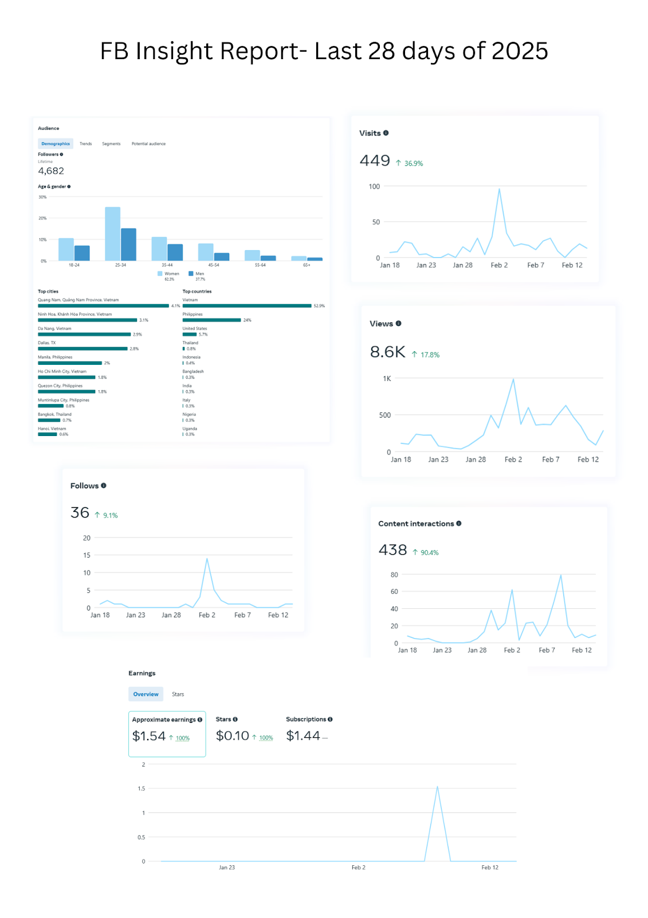

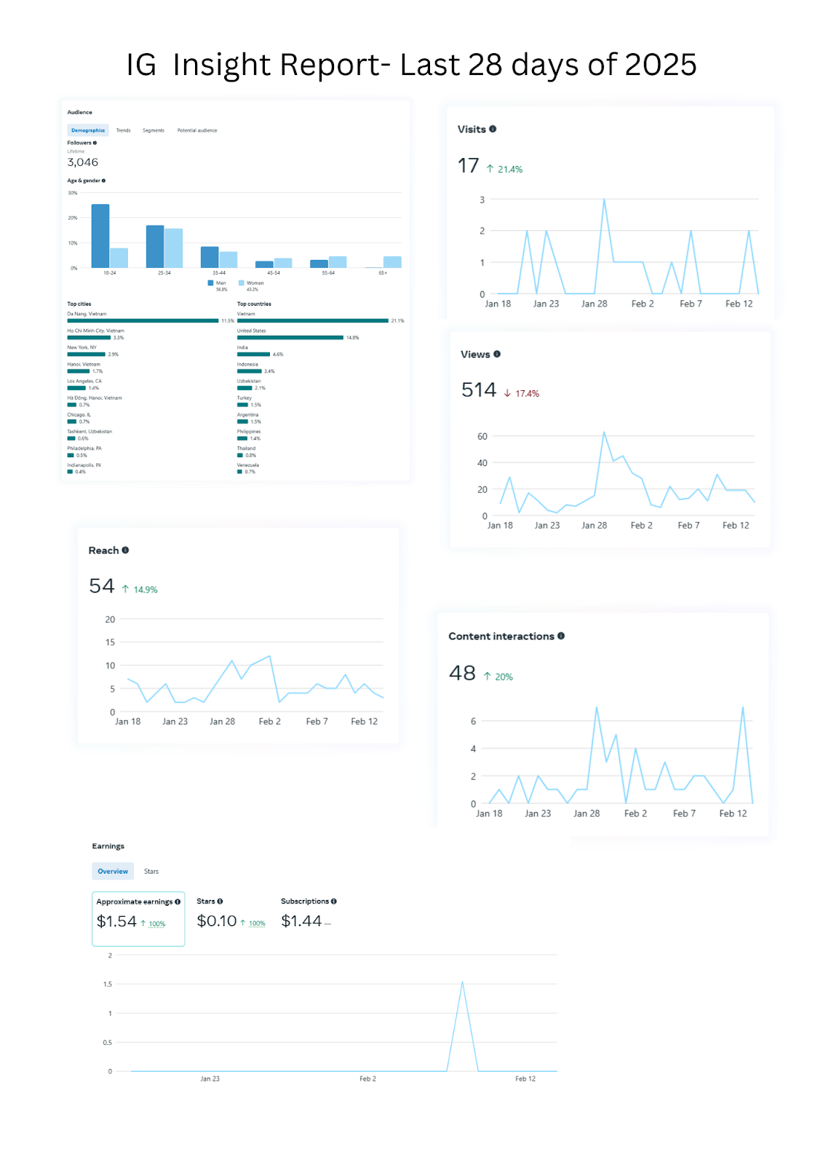

Facebook Insights:
Page and Reach Impressions:
We increased our total followers to 9.1%. total views to 17.8%, content interactions to 90.4%, and visits to 36.9%, which is a good number of unique users, indicating the number of individuals who saw any content from our page.
Good news! We gained 2 subscribers and earned $1.54.
Instagram Insights:
Page and Reach Impressions:
Although we remain on our total followers due to Meta’s guidelines, still we increased in total reach to 14.9%, with total visits to 21.4%, and content.

Conclusion
FFP’s goals vary each year depending on the proposals submitted by our partner-organizations and how fast they submit. Grant applications also take a while.
Looking for grant application opportunities that fit the qualifications mentioned could also be tedious.
FFP continue to avail of the services of Flipcause for the website management. We are considering the fundraising platforms that can be integrated in the website, however using their payment processing.
We will continue to have on board Mr. Umesh Malikum to handle renewals and taxation. As for the accounting, Joey has explored doing it herself so to avoid accounting monthly services using QuickBooks to handle bookkeeping.
Joey Cecilia del Prado is now focused on looking for other platforms to generate funds. Since she regularly goes on live for the ‘Giving Tuesday,’ this can generate funds if watchers are encouraged to like, share, follow and subscribe.
Joey has not given up in reaching out the two (2) companies, Jollibee and Gerry’s Grill, present in the US. Associating FFP with these two companies can level up its presence.
Joey continues to reflect on FFP’s mission and future while creating a direction that everyone can work together, with the mission of making a difference on the lives of the POOR.
We absolutely give merits to our generous donors who trust FFP and have the passion to help the underprivileged which helped FFP achieve the goals for 2023. This calls us to celebrate our wins at the end of the year 2023.
2024 Milestones

Finished the School Building Project of Ss Simon & Jude Catholic Community – Akpoli, Kogi State, Nigeria

Project Cost: $ 74,195
Problems: Early Marriages; The community was using the Church as School – no proper School Facilities. Government has abandoned the community and there was no program laid down for the village at all to help the residents.
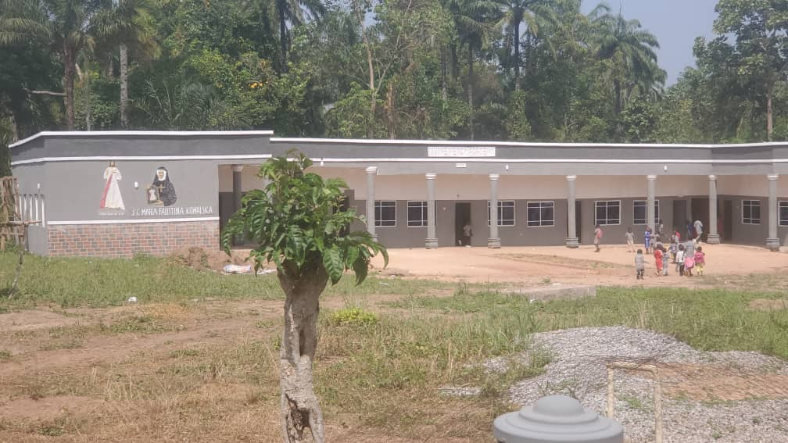

Betterway Africa International – Cameroon
Project: Continuation of the renovation of a 4-classroom stone building in Bonanyang village, in Cameroon
Project Cost: $15, 800
Problem: Children has no easy access to Education
Number of Children: 105 children
Impact: This will enable the community to move the children from rooms in locations that were not meant for schooling into a safe, befitting and appropriate learning environment.
FFP Participation: The organization has allocated $ 13,548 to cover Phases 1 & 3 FFP to allocate $2,252 to cover the last phase of the construction once
BAI submits its progress report with pictures.
Timetable: This is expected to be completed mid of this year.
Project Status: BAI is working on the last phase of the construction which includes the construction of Toilets and access to Water.

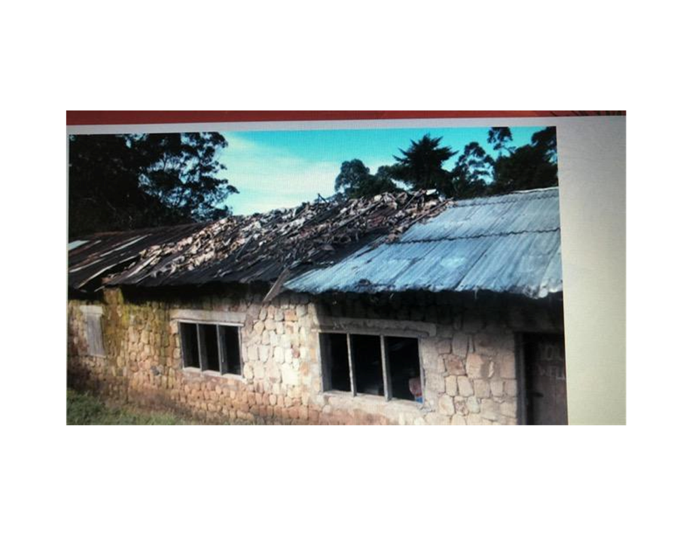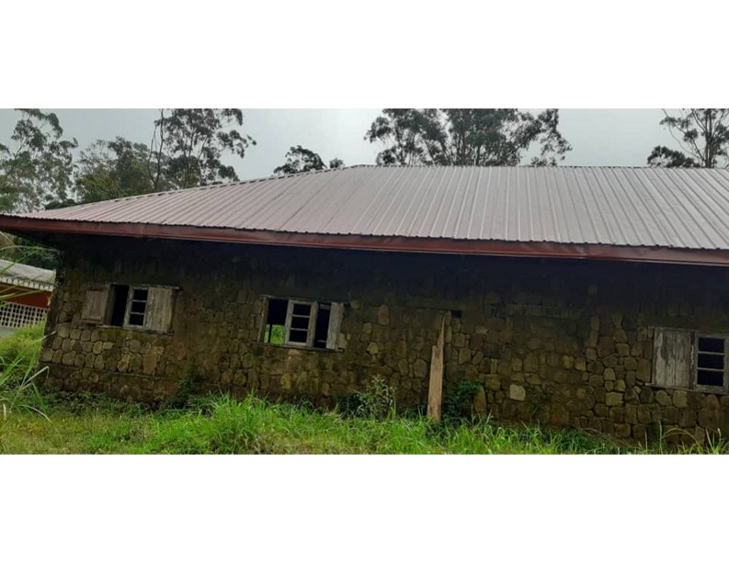

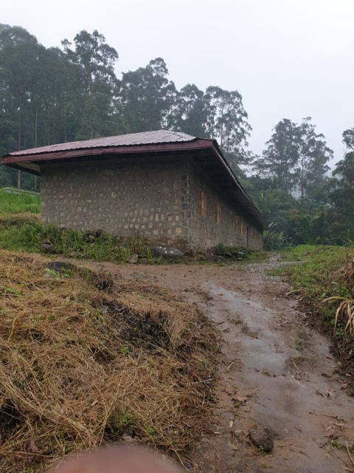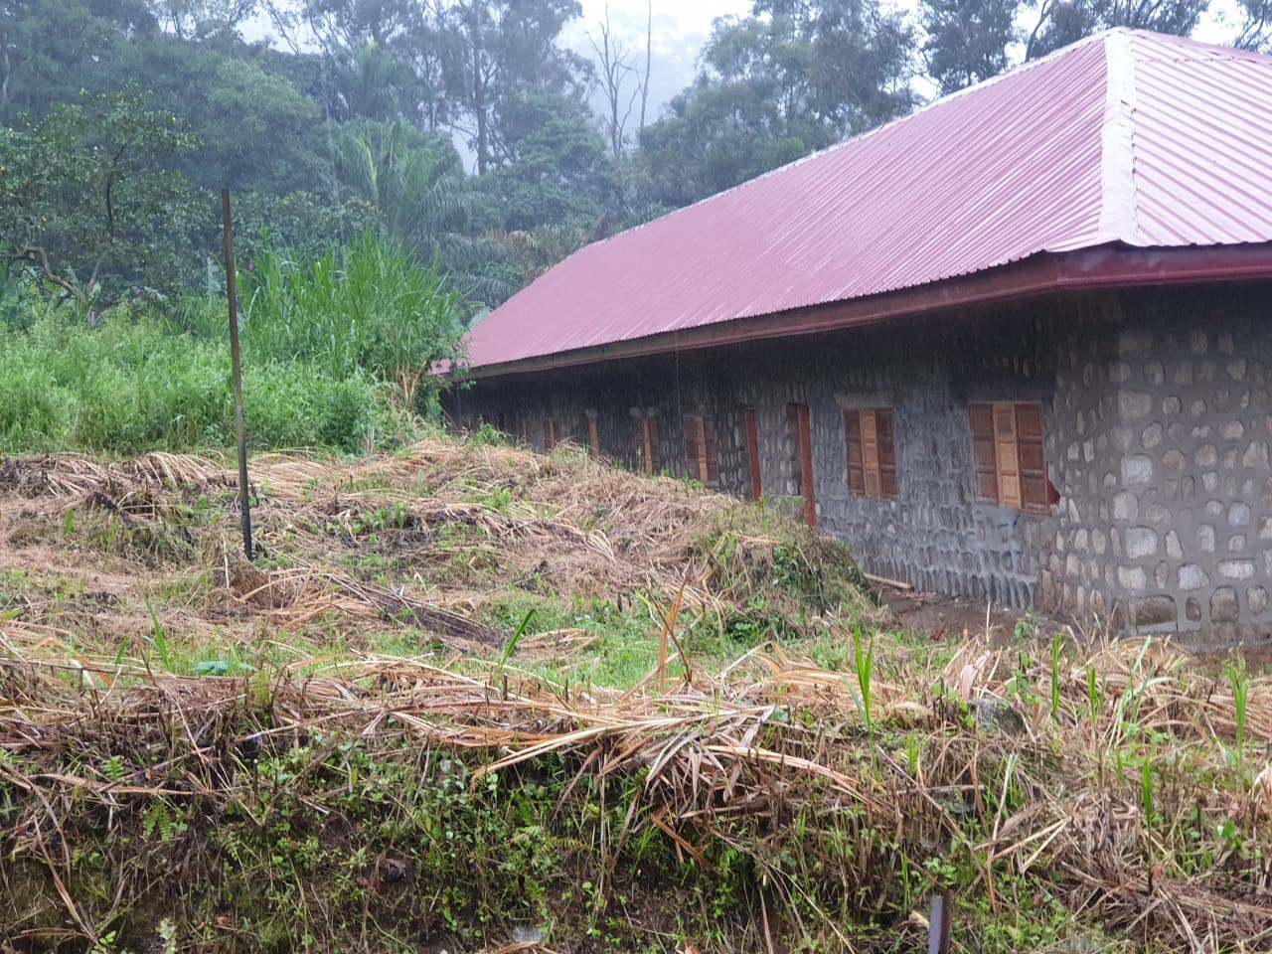

- Internal dividers to create four classrooms and a small office space:
This four-classroom building previously did not have any permanent internal dividers. A total of 3 dividers were constructed to separate the four classrooms. The permanent partitioning of a small office space at one end of the building was also constructed. There have been significant work delays in the construction schedule due to the slow pace of production of local materials by the community. This included the making of 5000 stabilized blocks Stones and sand. The delay was created by a change of the village community leadership and related issues between the outgoing and incoming leadership teams which impeded organization of community work on the site.

Status: 90% completed: Cement for the completion of the remaining dividers is on site. The community is expected to deliver 2 tons of sand to the interior of the building by the end of November. Construction should be completed before the end of 2024.:

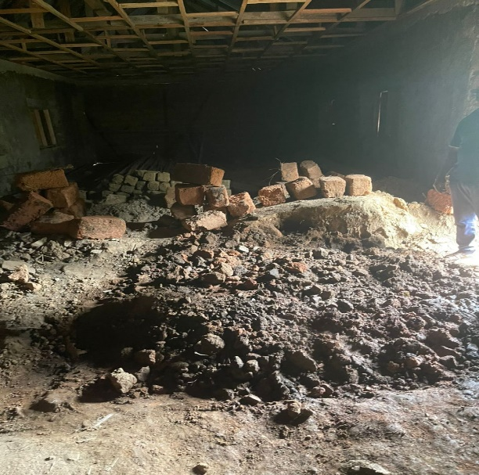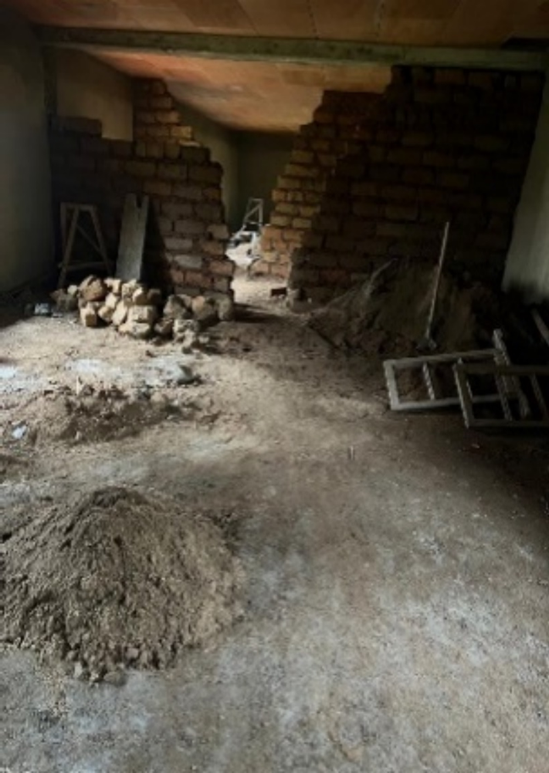

2. Plastering of the internal walls of the classrooms
A thin layer of cement and sand plaster or mortar applied over the masonry surface. Plastering using cement and sand plaster was applied to internal walls of the stone building to provide a smoother finish to the wall’s surface and to strengthen them.. The plaster also works as a damp-proof coat and leveled and smoothened the uneven and rough stone surface of the wall, making the walls look even, clean, and smooth. This also protects against injury. The plasters also provides an adequate base for painting which will be the last step of missionary work on the walls.

Plastering exterior walls is also necessary for as it can protect the building from rain and other environmental elements that could damage the surface. However, this has not been as it was not budgeted for. Should resources be available it would be important to do so

Status: about 90% completed

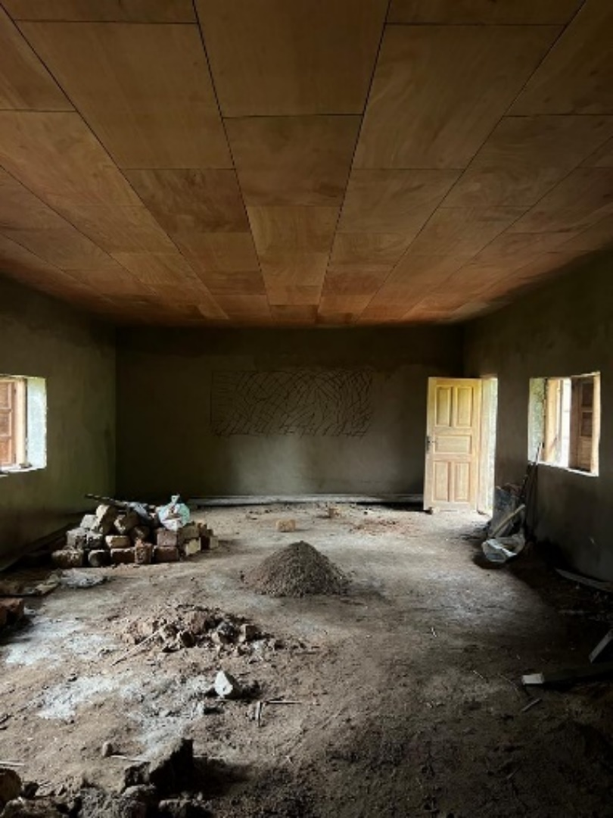

Finished ceiling and internal plastered internal wall stone (cement and sand)
- Completing of Pointing and repairing of the stone walls of the building.
Technical evaluation of the structural integrity of the stone wall and necessary pointing (filling of stressed points with reinforced cement mix. and strengthening was completed.
The areas where final pointing is needed consisted mostly of those where stone work repairs were done.

Status: 100 percent completed:

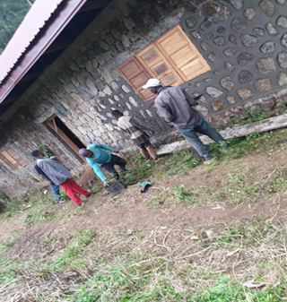

- Concreting of the floors: 10 % completed.
Bags on cement stored in the floors to be constructed after removal of debris

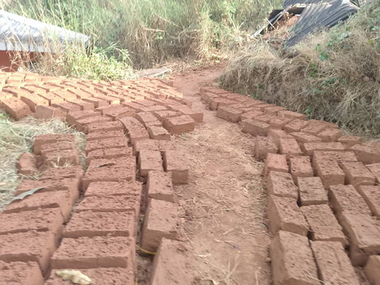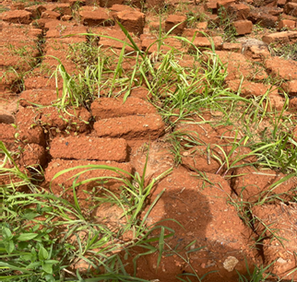

Expenditure table for Phase 3
No. | Item | Total expenditure | Observations
 | Partitioning of the building | $1,100 | Cost of labor for builder and some cement
 | Installation of the ceiling | $ 2,350 | cost of ceiling boards, accessories, cost of Labor for the technician
 | Plastering of the internal walls of the classrooms | $3,700 | Cement, cost of transportation and labor
 | Completion of pointing work on exterior | 500
 | Total |  | $7,650

CHALLENGES ENCOUNTERED
Implementation of phase three was significantly delayed for the following key reasons:
- Delays engendered by the change of community leadership.
Due to tensions between the outgoing and incoming leadership teams of the village, expected community work on the site did not take place for several months. The delays concerned:
- molding of stabilized mud bricks for partitioning of the building into four classrooms and an office, being a total of 5 rooms.
- Collection of sand from nearby waters and conveyance to the building site.
The community has, however, since resumed work, we expect that the remaining missionary work will be completed before the end of the year.
- Limited availability of technicians and builders: For cost effectiveness and to ensure community ownership, the use of technicians from the community is preferred. They are very limited in number and are combining work on this project with other jobs within the community.

- Need for due diligence in approving payments and disbursements.
To ensure optimal use of the grant from the FFP, great care is being taken to cross-check prices, scrutinize requisitions submitted, and to ensure safe transfer of funds to the desired recipient(s). This often results in delays of several days which were warranted to avoid losses that could have resulted from less vigilant handling of funds.

2) Haven of Hope (HOH) - India

Project: Sanjeevani Center, Harrai
The recent trip that Joey (Founder-President) and Jeremy (volunteer) made to India, through the hospitality of Fr. Thomas Therattil, was indeed a productive one and this is indeed a Check & Balance in Action. They both witnessed before their eyes how Haven of Hope is helping the physically-challenged children through the Haven of Hope (HOH) School and Sanjeevani Center facilities that FFP helped in building was being utilized. The Sanjeevani Center is currently being as school for the sewing/tailoring sessions to mothers of the children Moreso, a population of around 40 thousand of people of the neighboring villages are benefiting from it.

Project Cost: $ 67, 000: FFP was able to get a 20K grant from Loyola Foundation in the year of 2023 and the balance of which was raised by both the FFP team and Fr. Pauly Thekken, the Founder of Haven of Hope and brought the project to completion.
Status of the Project: The Sanjeevani Center is now ready for use for more activities such as physio and life-skill activities. Thanks to the Donors who helped FFP bring the project to the finish line. Recognition was given to FFP with a Plaque of Appreciation
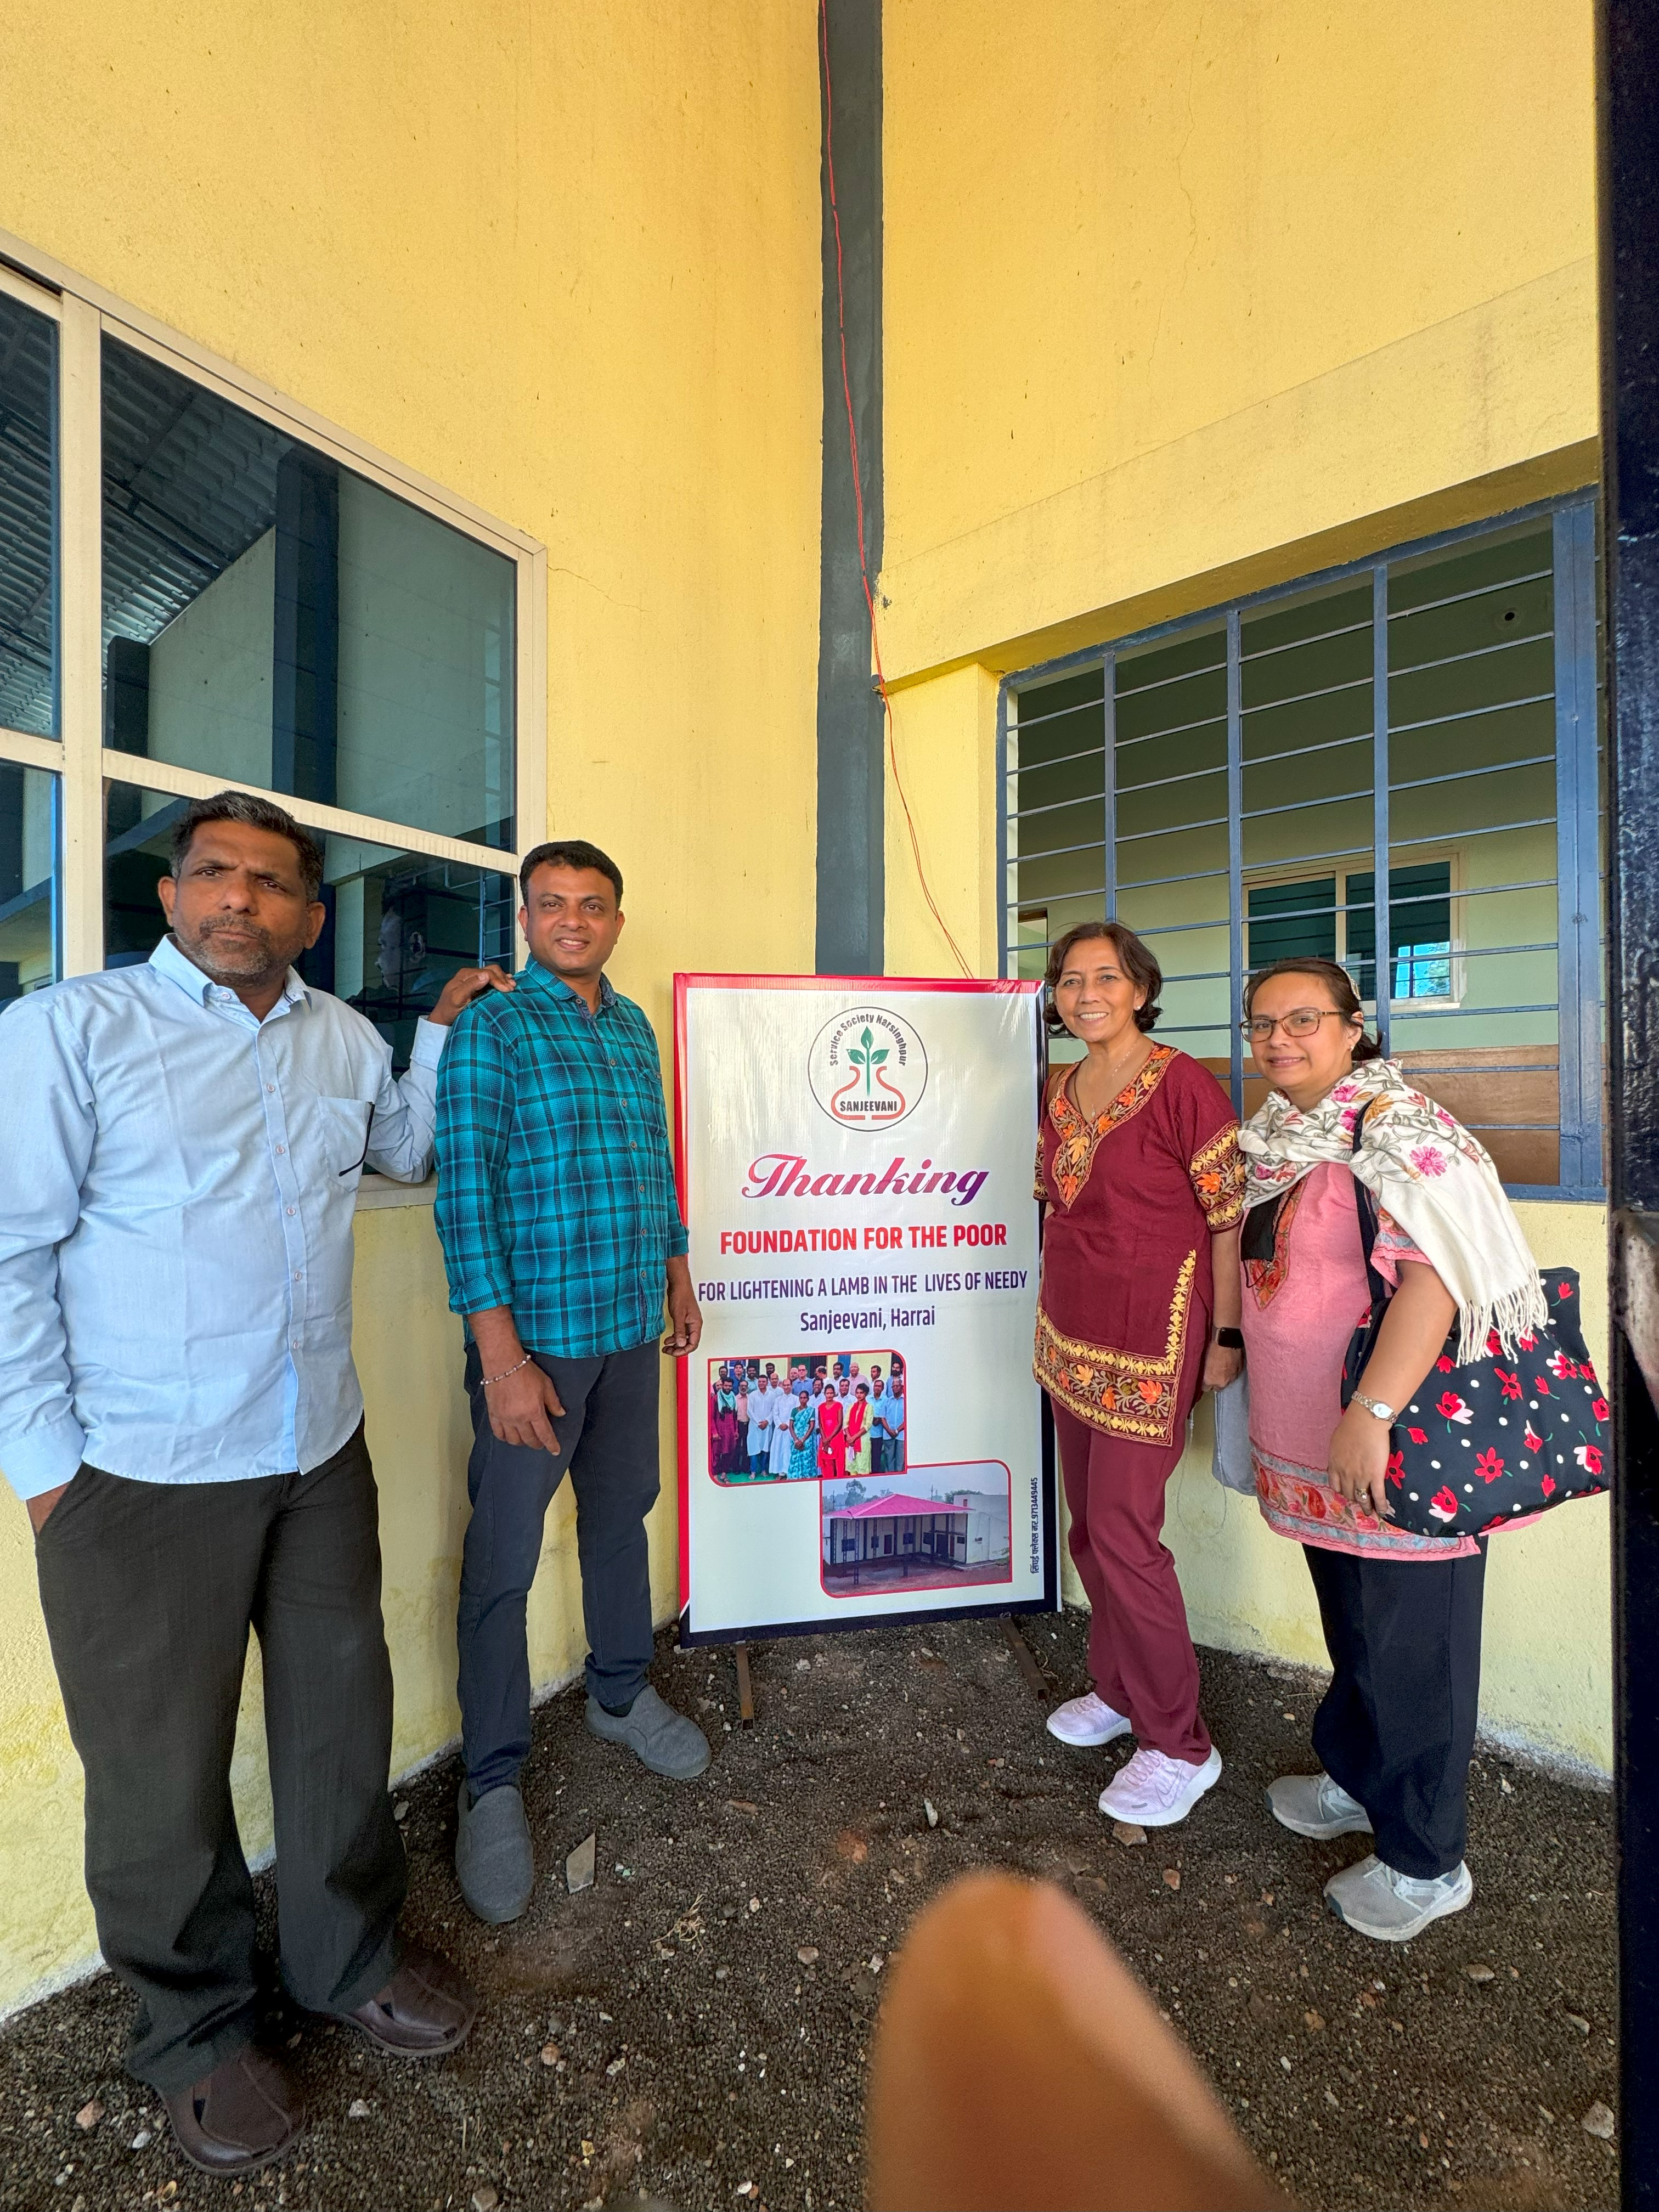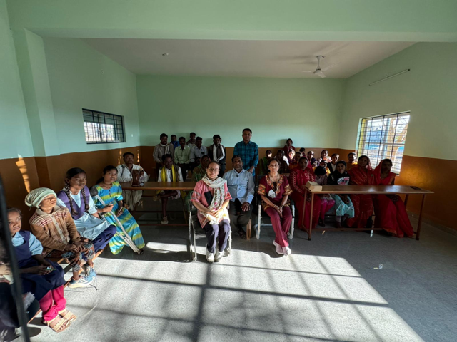

4. IT Tender, Muntinlupa, Alabang, Philippines
Project: Sponsor-A-Child project
$360 or Php 12,000
Problem: Children don’t have access to proper Education.
Impact: Children can go to school (i.e., children from extreme poverty whose families do not have the means to cover their educational expenses). Children are mentored and tutored at IT Tender to become successful in their studies and to become responsible leaders in their community.
FFP Participation: FFP was able to find sponsors for 2 children to be able to go to school and enjoy the benefits of IT Tender's programs. Money contributed: $360 and Php 12,000
Participation of FFP: Timetable: Year-round sponsorship of two (2) children to be continued until the completion of their studies
Current Status of the Project: Ongoing
The following children are:
1) Child’s Name: Carl Jay Villasaya
Nickname: “CJ” Age: 10 years old
Gender: Male Birthday: September 1, 2014
Place of Birth: San. Cruz, Manila, Philippines
Current Grade Level: Grade 4
- Child’s Name: Jenny Rodolfo
Age: 15 years old
Gender: Female
Birthday: November 27, 2008
Place of Birth: Rizal, Occidental
Mindoro, Philippines
Current Grade Level: Grade 9

From the bottom of our hearts, we thank the following DONORS for their generous hearts and believing in our mission!
We offer our daily prayers and masses for you and your family’s special intentions. May God richly bless you and your family!
(In alphabetical order)
Anonymous
Anonymous
Anonymous
Mrs. Leonor Aquino
Ms. Gina Barile
Mr. Jupiter Baylon
Ms. Angie Bernardo
Mr. Zandra Bugagao
Mr. Clyde Burdios
Mrs. Rose Cipriano
Mrs. Gloriastein Corcoran
Ms. Bernadette del Prado
Mr. Francis del Prado
Ms. Lorraine del Prado
Mr. Michael del Prado
Ms. Doina Eipuras
Mrs. Pauline Espiritu
Ms. Joanne Gabriel
Ms. Leanne Hanger
Mr. John & Mrs. Meg Harvey
Mr. Rajeev Kaushal
Mr. Anton & Mrs. Ermie Lopez
Mr. Patrick & Mrs. Chau Lopez
Ms. Maria Lowe
Mr. Vito & Mrs. Angela Mangiapane
Mr. Umesh Malik
Mr. Grey & Mrs. Lisa Meehan
Ms. Shripal Meghani
Ms. Yves Mendoza
Mrs. Alice Mungwa
Mr. Ari & Mrs. Lizette Natividad
Mrs. Ellen Piserchia
Mr. Francis & Mrs. Shifani Rajabose
Mr. Frank Ravinpinto
Mr. Fernando & Mrs. Jen Rodriguez
Ms. Sethi Samir
Mrs. Cora Sanders
Mr. Mark & Mrs. Stephanie Simon
Mrs. Mary Silidker
Ms. Jenny Du-Soriano
Mr. Alan & Mrs. Jennifer Steele
Fr. Pauly Thekken
Mr. Kentaro & Mrs. Jeremy Tuason
Ms. Isabel Udo
Drs. John-Nancy Waters
Mr. Kaushal Yugal

