April 2024 issue 1 WELCOME TO AMIK’S LEGACY

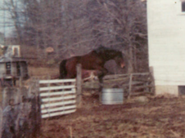 each heart travels free

**Hello to all our family & fans!!!**

Welcome to our newsletter bearing the name of my beloved soulmate… Amik. We’ve had quite an interesting life together & spiritually, Amik is in everything I do… So, follow along as we post Tales of Tails & add to our pretty website! Keep your eyes open here, you never know what you might find! Call me crazy, but I am looking at *monthly* issues! There are just too many wonderful things we want to share, so… let’s see how it goes.

I was ready to begin writing today when our flock of turkeys were seen grazing alongside Lheitah, one of our mares. They have been here since we moved in & although there have been 7 for many years, there are now 14! I do wish I had a telephoto lens. They were so close, spread wings & all just to show off to Lheitah, but they did know I was watching. I wonder what May will bring!

I planned to share our visit from Momma B Turtle & a guest of Bhinkhi’s this morning before the turkeys distracted me. So here are some springtime photos from Amik Run, for you all to enjoy!

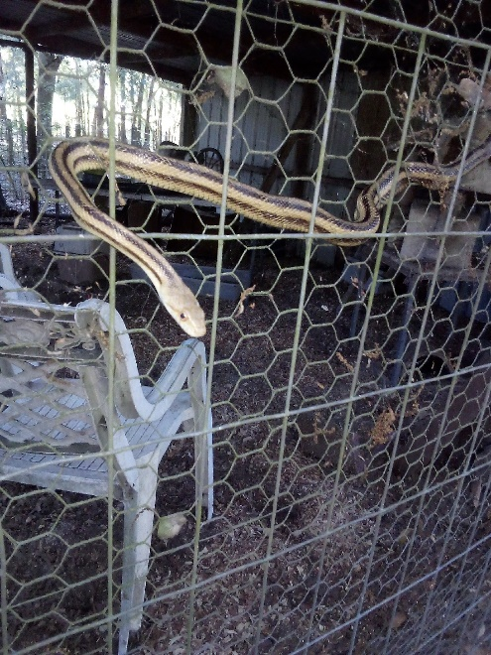 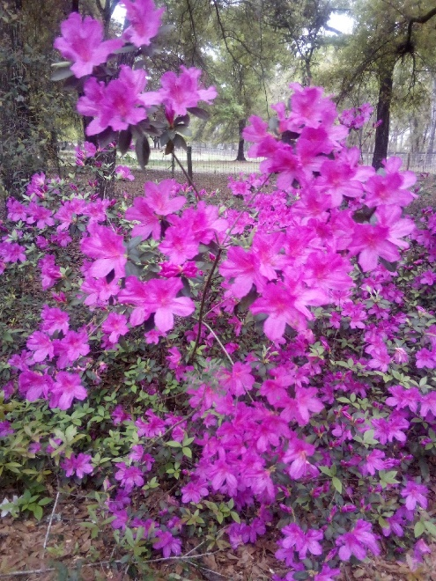 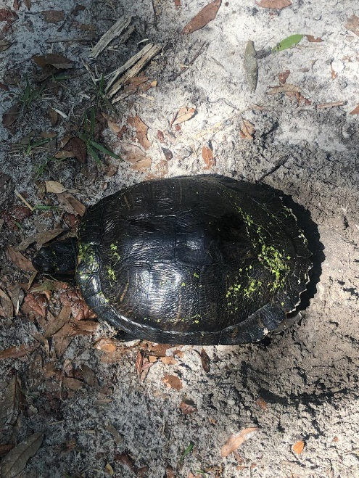

Bhinkhi has his very own outdoor cattery & many visitors: our opossum, armadillo family, birds, squirrels & yes, even snakes. This yellow rat snake is a regular visitor, & although she & the cat get along just fine, they do not dine together. Several other guests do share his fare, but Esmireldah (the snake) is not fond of cat food!

The beautiful flowers are along one of our fence-lines & although I printed it with an email not long ago, by request I was asked to reprint it. The Slider with the wet algae on her back is Momma B Turtle. She was donated to us many years ago by a lovely friend who had her since she was a dime-store pet. As she grew her human got bigger & bigger aquariums, then built a pond, then enlarged the pond… but after a decade of growth we were asked if Momma B could come live in our *much* larger pond – of course we agreed & made various provisions. If all goes well, more of her story will be added to our website, but until then, you will all have to keep guessing at what may follow!

My original plan was to feature at least ONE horse, current or past, as well as ONE other species but the animals have different ideas! Before I present what *THEY* want, let me explain a few things.

Equestrian Spirits, Inc. is a Non-profit Animal Rescue Holistic-Based Forever-Home Sanctuary (yes mom, a run-on-sentence). We were founded in 2010, having done the same out-of-pocket for many decades. Our farm is named Amik Run after my illustrious Show Jumper, Amik. I grew up riding at a wonderful farm called Smoke Run on Long Island, named after their dog Smokey, as a place for him to run. I have thousands of fond memories from there & always connected with the idea behind the name. So, in honor & remembrance of many riding & life lessons, I dreamed one day of having my own farm named after my horse.

Amik, as well as Amik Run, is part of my dream come true, that I now share with you…

We are located on a bit over 60 awesome acres just outside of Ocala, Florida. Our animals all stay for life, while we help other organizations & individuals with their adoptions & behavioral issues.

I live with the animals & in an earlier introduction note, I had promised to reveal a partially unknown fact – for those of you who do not know… we have a *MOOSE!* Yes, we certainly do. Those of you who have met him are giggling now, I hope, but for newcomers… Moose is human; ah yes… Although certainly not a *big man*, he was especially *faasst.* During 7 years playing Semi-Pro football with the California Wolves, his teammates nicknamed him Moose, though they towered over him he outran most, every day on the field.

So now you all know we have a MOOSE! And he lives here loving & feeding every animal, every day.

I will keep you guessing at some of my other promises because I have been warned NOT to make this too long, as I do when I get carried away by my love of what I do.

I promised our beloved Wil-Hee, he could be our first Feature Horse. As I began this newsletter at the end of last month, our sweet orphan suffered a sudden illness - & did not recover. First, I must thank our wonderful attending veterinarian Dr. Evans & his assistant Bree, from Peterson & Smith Equine Hospital & the heartfelt comments & donations from our loyal friends.

Life is an unusual thing… Wil-Hee survived the passage of his mother at birth, endured 2 other starvations by criminal hands, yet every day with us was such a joy. He even whinnied a greeting to me a mere half hour before his heart decided it had enough.

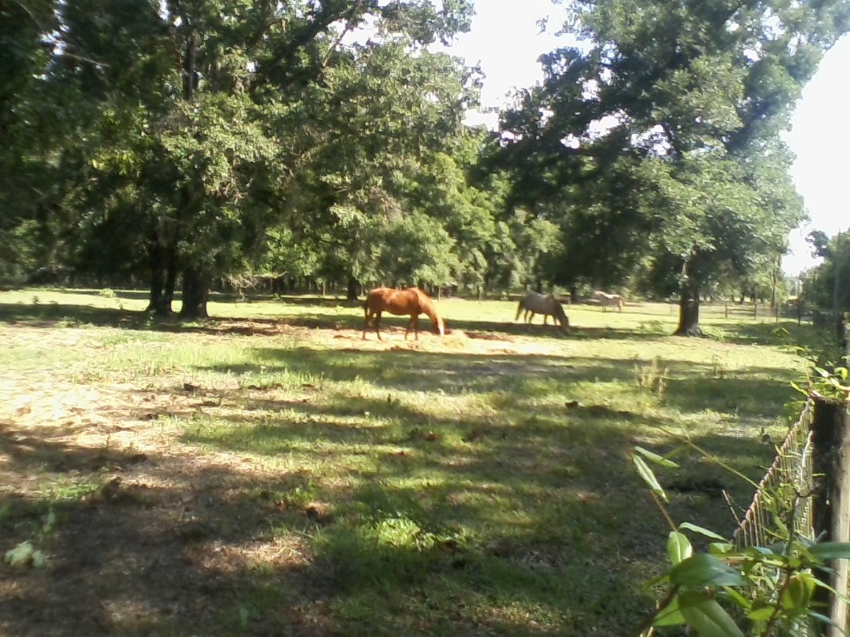Wil-Hee & family 2017

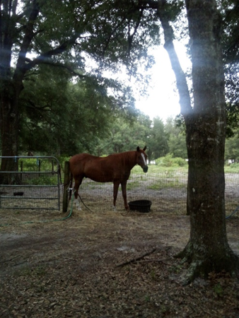Wil-Hee 2020 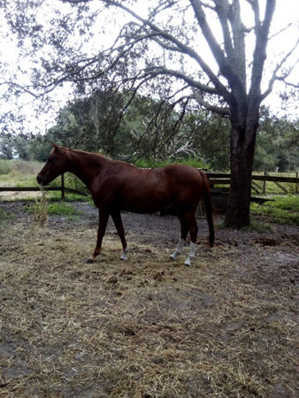 Wil-Hee 2023

I have a precious video of Wil-Hee playing with his family only a week before he joined his dam & many beloveds who were awaiting his arrival. I have yet to understand how to get the video off my camera & onto the pages here, but I will share as soon as I am able. Beautiful Wil-Hee is watching over us, sending special love to his best humans: Moose, who gave him the name Fire Horse, & Tammy who thought after losing her first horse as a child, that she would never have another. Tammy was gifted a half-interest in the horse who stole her heart in 2010, & in 2017 Wil-Hee gave the rest of his heart to Moose. A tidbit was reserved for me & I feel blessed to be included at all. I was with him the day we met, & when he closed his eyes. As an orphan, the chestnut Thoroughbred was nicknamed Willy by a friend of his breeder for “Will He Live; or Will He Die”. As is our style, his spelling changed but we kept the sincerity behind those who initially saved his life.

I plan to remain true to my path & offer pictures, stories, humor, & health ‘stuff’ with each issue.

On that front, I must tout an amazing company called Bighorn Botanicals in Noxon, Montana. I *LOVE* all their products & have been buying from them since I was introduced in 2011. I only wish I’d met them sooner. So, if you do not know of them, please look them up. If you do, I hope your experience with them is as awe-inspiring & lifesaving as mine. Their YewTip products, I hope to never live without. Watch for more about YewTip & Bighorn on our website as the year moves on: <https://bighornbotanicals.com>

In closing, I promised our creatures I’d end each issue on a happy, preferably silly note… We have a game here invented by 2 elder equines, Bhenn & Sky. They call it “Water-Sports”. Sounds innocent enough but it is quite a challenge to get things “Just Right” to obtain the highest score (of which only they know how it is judged). Hopefully more ‘competitions’ will be added to our website this year but in the meantime, here are a few recent accomplishment – gratis Bhenn & Sky…

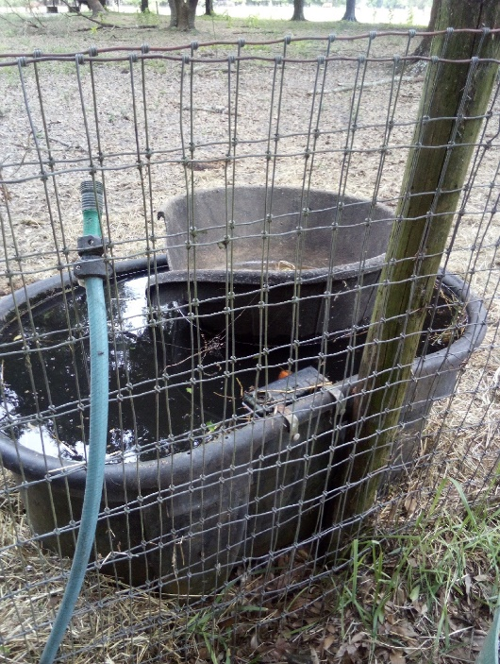 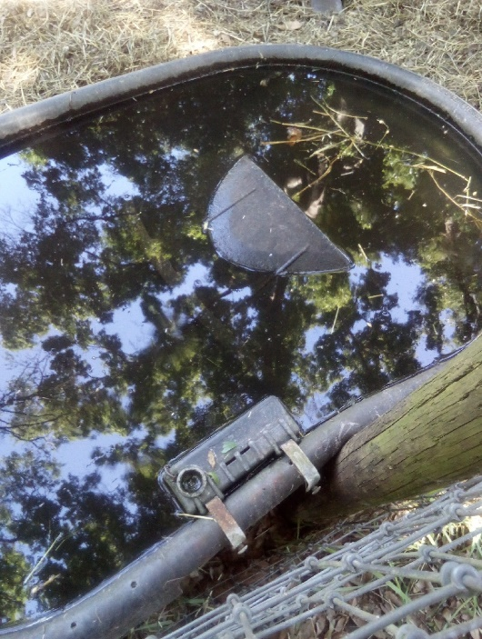 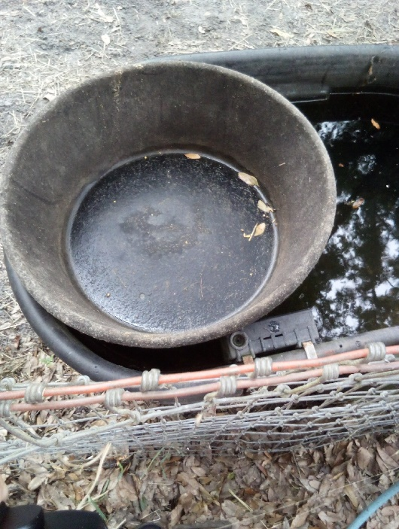 #1: ‘close attempt’ #2: ‘darn-it’ #3: ‘perfection’! AH-HA

For those who may not live with horses, this ‘Water-Sport’; as far as we know, it is not an international sport! LOL. What you see is a 100-gallon water *drinking* trough with a 12-pound feed tub set inside! For a horse to pick one up at all is something of a feat, but to lift with their mouth high enough to set into a tub of water, especially to set it afloat dry, without sinking, is quite a challenge! Hence picture #2! These were all taken at different times - the duo was equally proud each time.

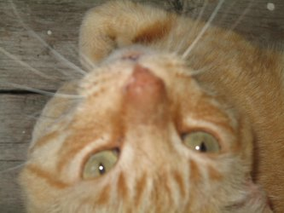 Your challenge for next month… who is this & why is he special? Or: what is OSO

I will end on a moment of THANKS: to MOM & Moose – without whom I would have long-ago, lost my mind… to our friends at Triple J Ranch as we share their grief at the passage of Jack Darling, who has been so special to me personally since the day we met over a calf in 2003… our hearts to Jack’s family & his myriad of friends… Alphabetically I must mention some other, most special supporters, who never lost their way, even as I faltered. I list 1st initial only since they know who they are & many wish to remain anonymous: A, B, D, D, E, E, E, J, J, J, K, K, K, L, L, L, M, M, P, P, P, S, S, S, T – you know who you are – many thanks & much love in keeping faith in us, even while we were drowning…

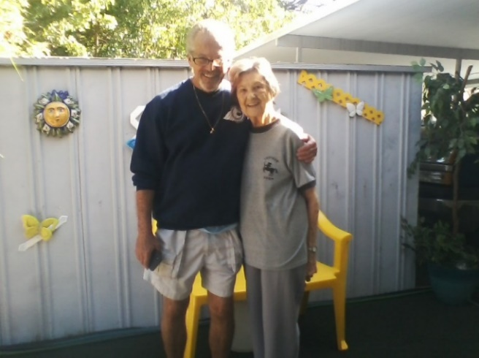 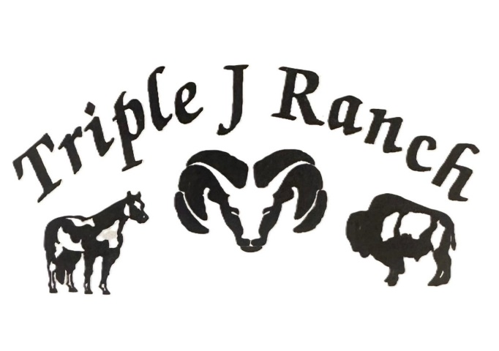

Magic Moose & My MOM Thank you for your friendship & the best hay in town!

**Anyone wishing to donate to Wil-Hee’s Rescue Fund, please click “Save the Animals”** on our website: [www.EquestrianSpirits.ORG](http://www.EquestrianSpirits.ORG). *All proceeds go only to the animals*, as our board is unpaid.

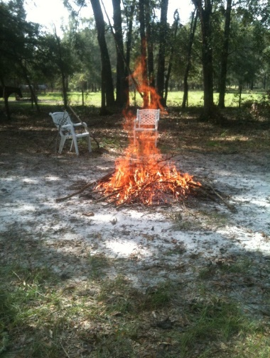 We love you, Fire Horse. May the Heavens be set ablaze by your Playful Spirit…..

Very sincerely, and in the spirit of all who have gone on before me...

many thanks for your interest – Laurie L. Wolf

Newsletter for Equestrian Spirits, Inc. 501(c)(3) EIN: 35-2384797 (863) 368-0775 [www.EquestrianSpirits.ORG](http://www.EquestrianSpirits.ORG) P.O. Box 237 - Morriston, Florida 32668 copyright LLW 2024(c)