October 2024 issue 7 AMIK’S LEGACY

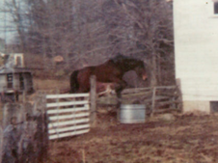 Hallow to family, friends, fans!!! 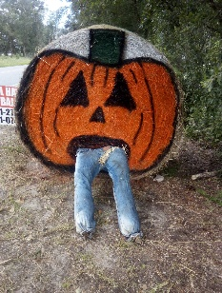

Welcome to October’s newsletter for Equestrian Spirits Animal Sanctuary! Besides some special birthdays, I am a huge Halloween fan, reminiscent of costumes with my sister & dad, eating a lot of sweets & helping my mom pass out apples (ever the conscience mother)! Quite fond memories.

Silly, silly, silly. I am seldom accused of being too serious… My happy Halloween photos should be a reminder of just how much fun we can have with reality vs… well, *you* decide! 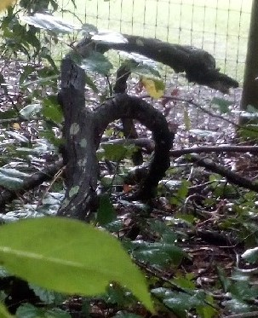 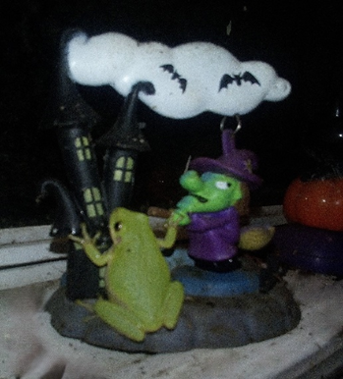 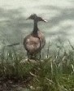

Left - the dogs were barking the other day while Moose & I fed the big herd. At first glance I could not make out who/what aroused their attention. I walked over to the fence-line & peeked into the bushes, immediately seeing what startled them. There, in our lane between pastures, is an area we provide natural foods for wildlife. Instead of finding a racoon, squirrel or other visitor, I clearly saw a *BRANCH*, soaked dark by the rains, that looked like a *serpen*t! I was laughing so hard the dogs wondered why I thought it so funny. When they too, realized this was not a little monster but a *stick* in the brush, they sobered rapidly, wagged tails & laughed along with us. Center - you may have to look closely but…… there is a creature world within my kitchen. I keep several toys that bobble during the day. By evening they are often visited by our ‘Georges’ who are frogs who rid our house of bugs. Now & then I catch them in the most wonderful poses. We call all the frogs ‘George’ (fun story but you will have to wait for the website) Right – is a 2-headed Whistling Duck!! We *love* our Whistlers. Black Bellied Whistling Ducks (yes, that is what they really are) come to visit us every year. These two just happened to be standing so only 1 body & 2 heads showed. I certainly wish I could have gotten closer, but I didn’t dare lose the moment. If one looks with open eyes, there are many unusual sights in our world!

*All of this is part of our holistic non-profit animal sanctuary. Please follow along through the miracles that find us every day. From our tiny ‘Georges’ to 1700-pound horses, there must be something (or someone), to grin about every day. Many thanks to those who have helped us get this far…*

So, what is ‘coy’, you asked? Well, it is short for Coy-dog, a term for any canine who is part Coyote & part ‘dog’. If you are now curious, watch for more information in upcoming issues & on our website!

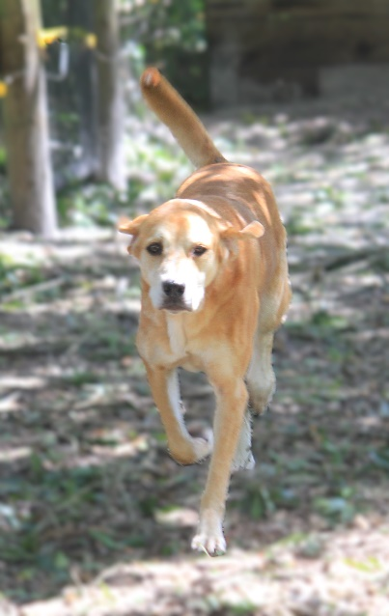 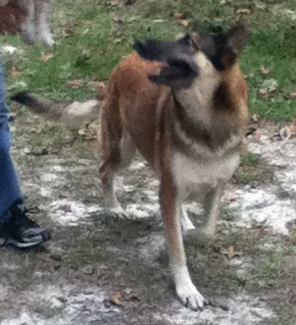

In keeping with my plan to feature specific individuals, this month I have 2 who must be shared as 1. Last month I asked if anyone remembered the ‘Sisters’. Well, their stories will be documented further within our website, but the short version in this case, is very hard to condense…

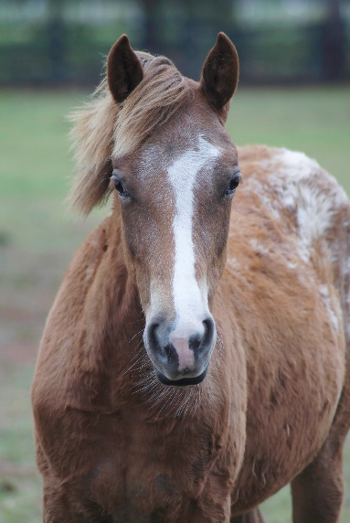 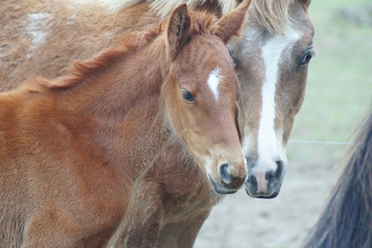 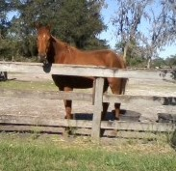

Choici, yearling Sisters Mheli, grown

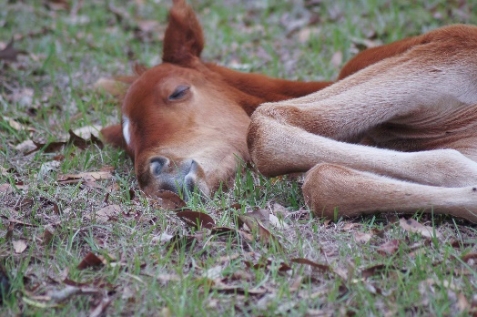 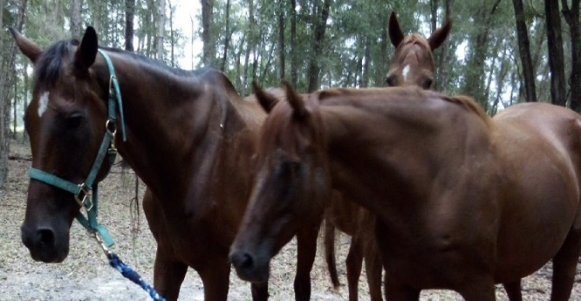 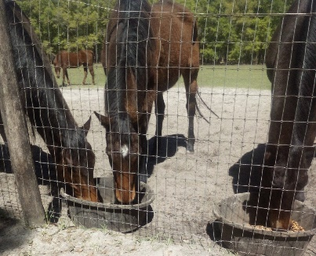

*Baby Mheli – day 3 mother with 2 of 3 daughters Muzyk, mate, & best friend*

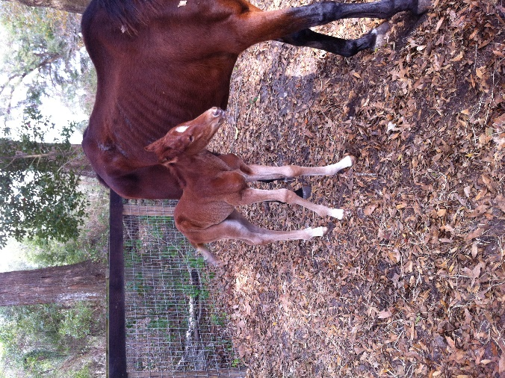 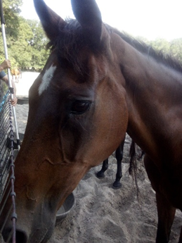 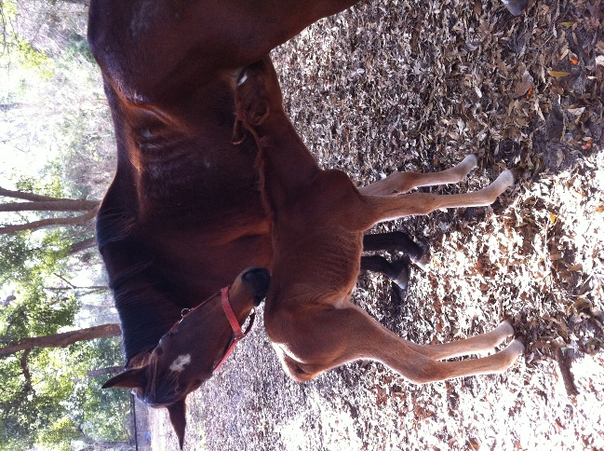

1st day of sunshine a youthful look for 26 2011 “my new little girl”

mare #1: we had a lame, thin mare donated who had a 2-month-old filly by her side; mare #2: the following fall we had an emaciated mare donated & when her vets found out she was pregnant, they gave up all but the smallest of hope. (keep reading, please – this is not a tragedy…). Next: mare #1 was 29 years old when we had to close out her life due to advanced cancer. Almost to the minute, 12 hours later, mare #2 gave birth, immediately adopting the now motherless yearling, as her own.

Part 2 of the abridged version is that although our sweet mare, Kwil, was finally taken down by advancing age, she had become sound, all her bones were covered in healthy flesh & fur, & she got to spend nearly that whole 1st year of her baby’s life with her. She also befriended the originally skinny mare, who promised to foster her friend’s daughter so she would never truly be alone again.

Mare #2 delivered her own filly without complication; the 2 flourished & lived happily & comfortable together for the next 12 years... the orphaned filly easily bonded within their family. Those 2 babies are now 13 & 14 years old, still considering themselves sisters. All well worth the time, labor, vet care & top-notch feeds we supplied. The mothers’ healing & foals’ survival, to us, are 4 separate miracles.

2 vets who wanted to believe me when I said the mares & their progeny could survive, are a legacy to veterinary diligence & a testament of our hope, faith, a lot of joy & some really good food!

If you read the captions, you may have noted the mention of a 3rd sister.

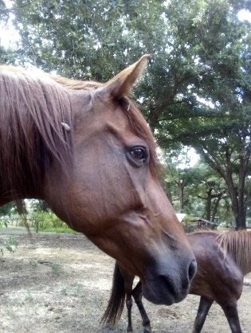 Meet Lheitah, born premature, donated to us as a 2-year-old unable to race. Upon her arrival, Muzyk immediately added another ‘baby’ to her brood. *“And then, there were three”.*

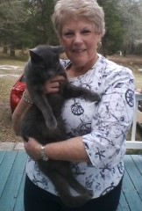 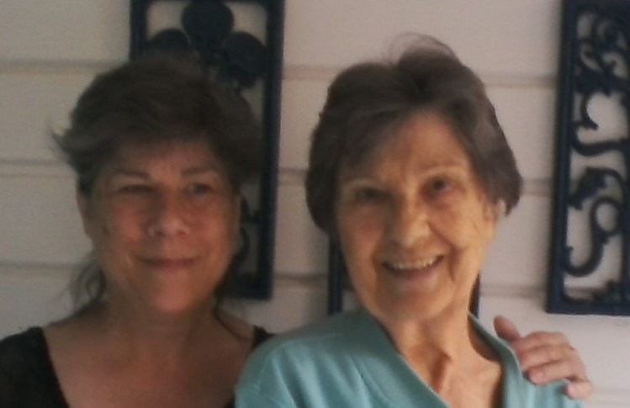 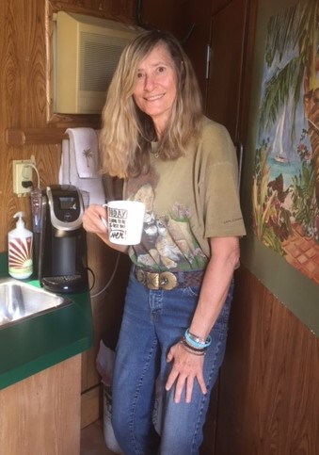

My mother always said, “Birthdays are the very best of days”. Without each Birthday, we wouldn’t have that loved one to celebrate. I may not be able to share every Birthday on our Legacy pages, but there are some who must be acknowledged… To my amazing cousin Debbye, who I have ‘looked up to’ since I was born; to my crazy sister Bonnie, who always reminds me that I am older than she is; & to Ellie, a friend for life who has sent us horses, a cat & was the initiator of Kid’s Khatteri. To each of you & so many others… May your special days be joyous & may your lives be as you dream them to be. We love you all!

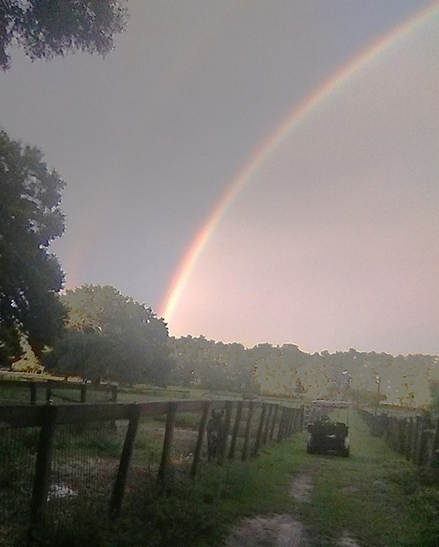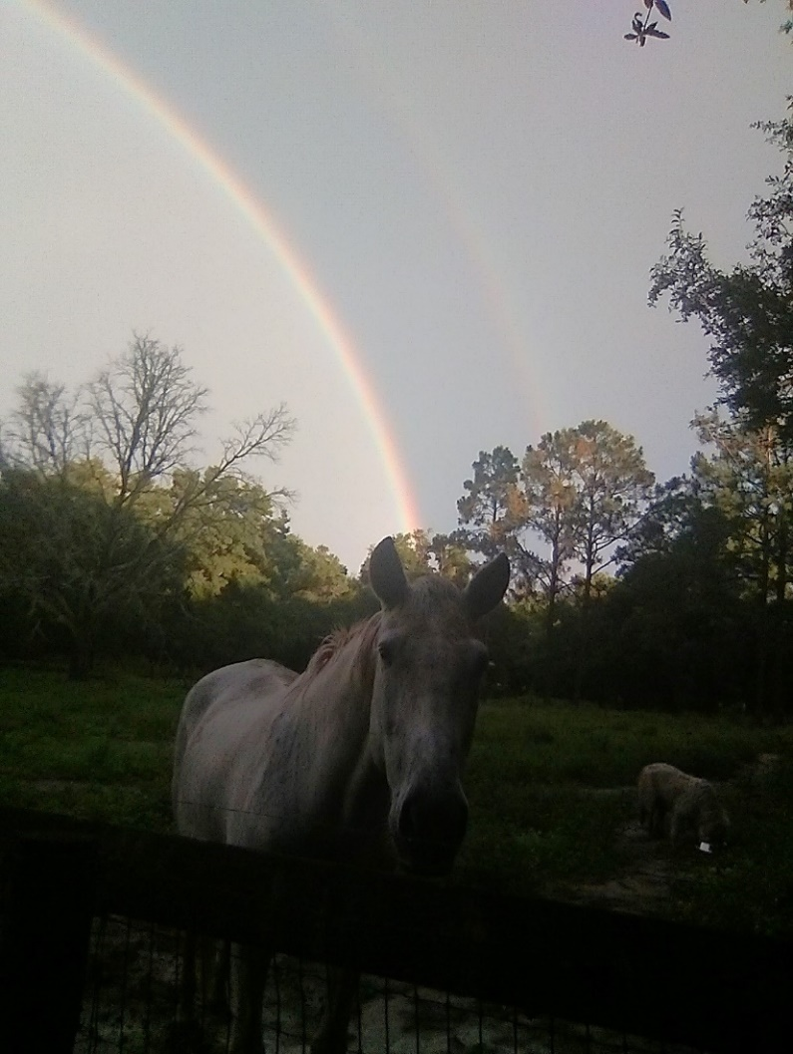

Blessings come in many forms. 2 different days… 2 different pastures… 2 different years…

And - DeLania’s Dream (aka Nikki) on our farm 2021… who says unicorns are fantasy?

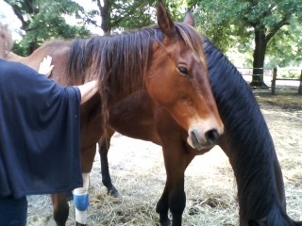 Your challenge for next month… what is happening here & what is ‘Flip’?

Equestrian Spirits, 501(c)(3) has brought life to animals who would “most likely not survive.” We have returned the comfort of soundness to a myriad of “hopeless cripples” who went on into the showring or off for a robust gallop with friends in our fields. Our staff, volunteers, visitors, friends, neighbors & especially veterinarians, have given so many critters, the magic of healing their broken hearts. We have quelled anger, violence & hatred, mostly learned in self-defense of horrid abuse many will never hear of, & oftentimes, even believe. Our farm also creates a haven for those who were safe in their lives but found their world tilting with the passage of caring human providers, loss of financial support, or relocations where their animals could not follow – for whatever reasons. These statements are not to give us kudos for a job well done, because the majority of any who read these pages has, in their own ways, chosen to help, heal, or aid an animal in need. No, the true badges of honor belong to the animals themselves as they let us step in & try to make amends for whatever injustices they have endured. As they find trust when they had none, by believing us when we say, “we will do everything we can”, or are loaded into a transport by a stranger, hoping the peace they feel from the helper is real, or eating slowly because they are pretty certain the food will not run out – this time. They “redefine their lives” in ways they should have been offered upon entering our part of their world. It is not “what they accomplished” or awards they won; it is the look in their eyes when they realize the deceit & neglect… is done. It is watching them stand after surgery & realize they really were not there to have their life closed, but to have their damages - repaired.

I am constantly asked “why” or “how” “do you do it?” Not only do I love what I do, but little measures up to an animal who arrived in terror, pain, or hopelessness, who ends up following me around a field just to be near me. Or one who arrived in anger allowing me to restrain them simply because I asked. When I see the love & trust in their eyes throughout my days, I sleep well knowing no matter how small or large my offering was that day, I made a difference. We need & receive donations. We receive & need to pay bills. But our biggest ‘payment’ is what the animals give back.

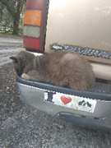 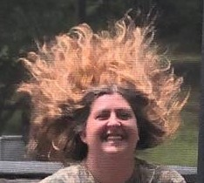 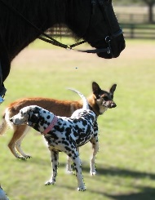 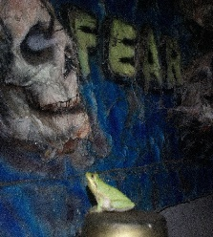 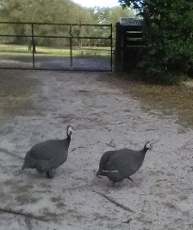 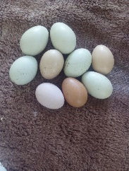 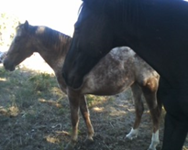

In honor of each life who has been woven into ours, we acknowledge that each of you reading this have felt the same gratitude back from your own. Whether a salvaged rescue, a magnificent purebred, or an inherited pet, those of us lucky enough to know the unconditional love of the creatures we live with, travel along a kindred path. May your days be as kind & beautiful as ours have been. Here is to decades more of wonderful relationships - between mice… & men.

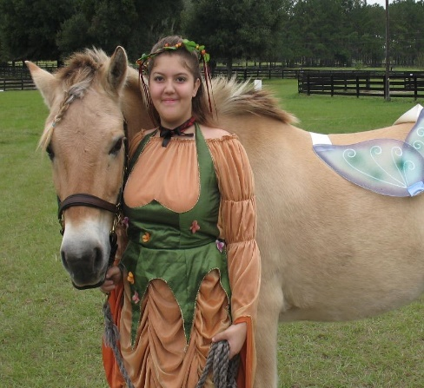 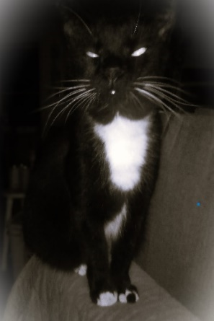 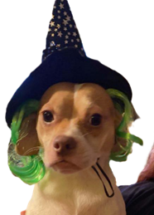 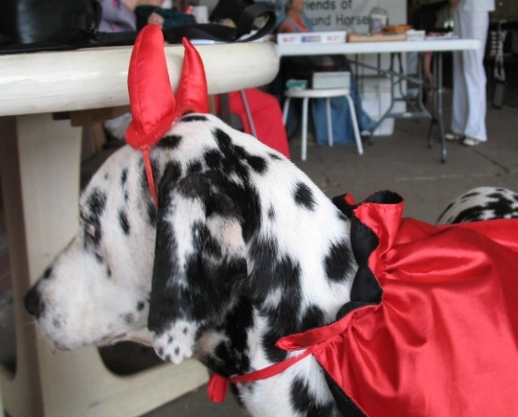

***Every celebration also has an angel! Some are simply in disguise…***

To Tabris Alia, Tirah Ahanjilique, Amazing Ghrayce, Rize Above, Class Act, Small Talk, Chaysaor, Ahbi, Petrouchka, Jolli Myke, Thirtyeightspecial, Myha, Akos, Sporting Chance, Night Moves, Firage, Then Again.

To Corinna, Jake, J’son, Dutchiz, Anniroc, Ki’re, Lady, Banditt, Ra, Lo, Patchiss, Toma, Ivan, Tooki, Velvet.

To Texx, Skhimp, George, Graycie, Rhaylemah, Lhanze, Khirtt, Starrah, Dhominoh, Ringo, Muffy, Raleigh.

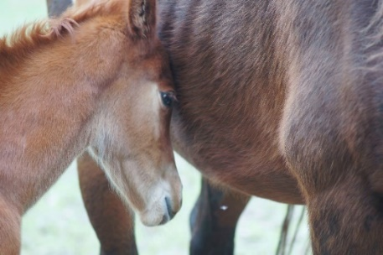 **Anyone wishing to donate to The Sister’s Rescue Fund,** please consider **“Save the Animals”** on our website: [www.EquestrianSpirits.ORG](http://www.EquestrianSpirits.ORG). *All proceeds go only to the animals*, as our board is unpaid. Donations are needed for medical costs & health care, foods & supplements, supplies & repairs, maintenance & improvements. From fear to joy, pain to pleasure, hunger to happiness, *please help us, continue helping them…*

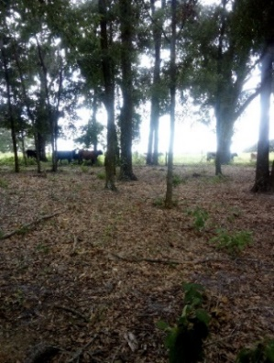 "**I will abstain from all intentional wrong-doing and harm**" AD 245 Hippocratic oath

**each heart travels free**

Newsletter for Equestrian Spirits, Inc. 501(c)(3) EIN: 35-2384797 (863) 368-0775 [www.EquestrianSpirits.ORG](http://www.EquestrianSpirits.ORG) P.O. Box 237 - Morriston, Florida 32668 copyright LLW 2024(c)

Very sincerely, and in the spirit of all who have gone on before me... many thanks for your interest – Laurie L. Wolf