NOVEMBER 2024 issue 8 AMIK’S LEGACY

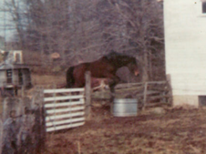 Happy month of Giving Thanks!!! 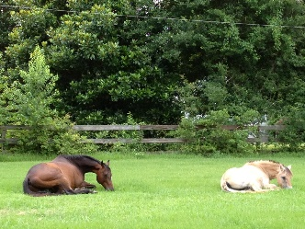

Welcome to the newsletter for our non-profit animal sanctuary, Equestrian Spirits! Follow along with me & the horse who started it all – my soulmate, Amik. Tales of Tails shares many giggles & secrets - see what might be found on your journey through our lives!

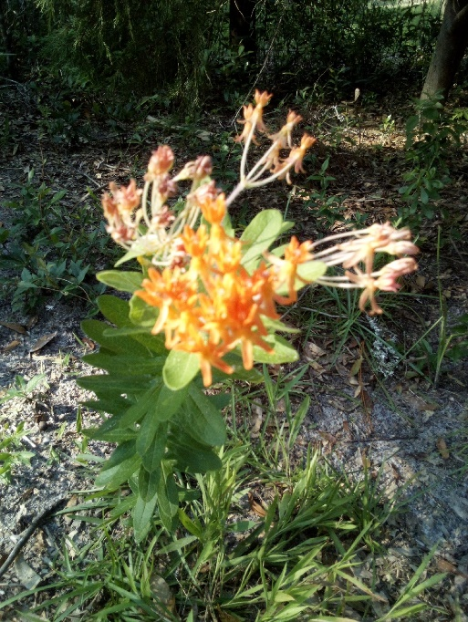 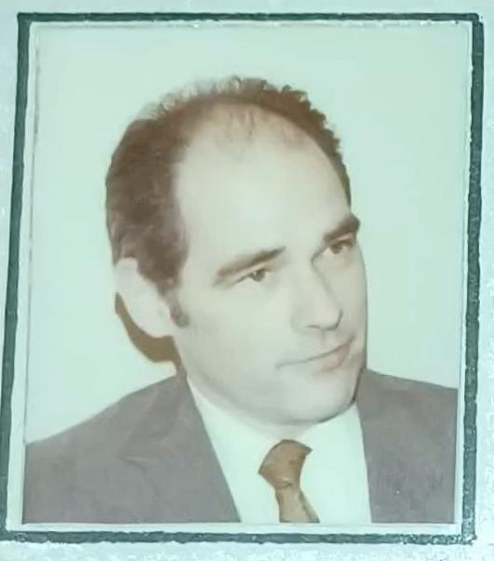 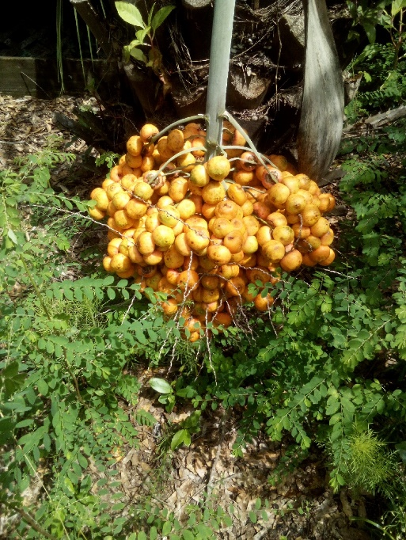

What a handsome fellow! Meet my Dad among the bright bloomings of our haven. I begin our November brithdays with the man who started it all – ME! From my 1st pony ride at 6 months of age all the way through Thomas School 1970 Junior Olympics. I chose this picture of my father since it was taken in the year Amik carried me over the 5’4” Puissance wall as captain of my Junior Olympic team.

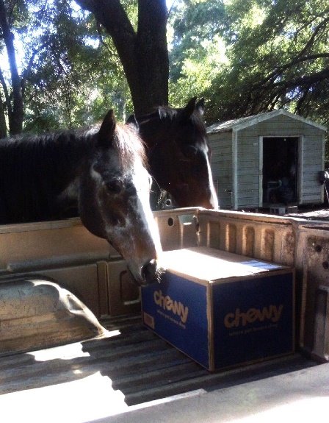 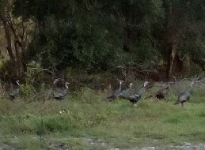 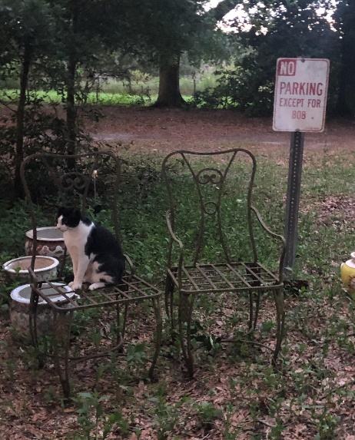

Sky investigates a box of goodies & wild turkeys on the roam, as BoB revels in his new – personal – garden!

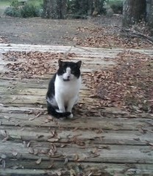 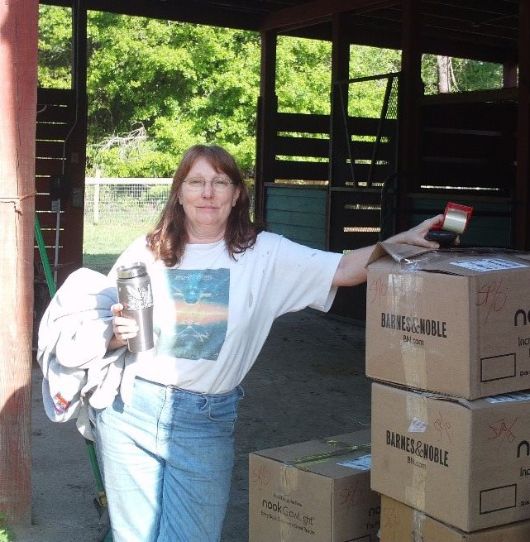 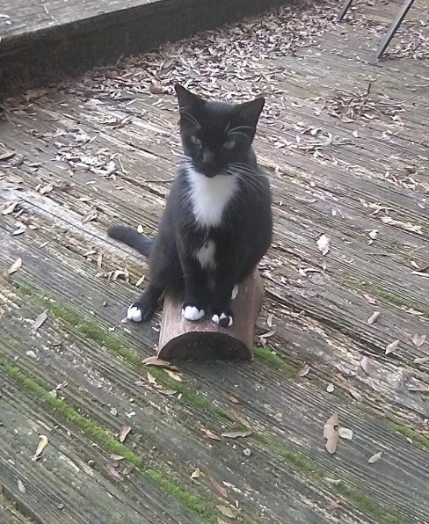

Happy Birthday Cat-Woman! Surrounded by ES life-mates, we honor some very special volunteers. Kathleen moved our sanctuary more than once on the quest for a forever home, while Khlaptin came to us from his feral woods, eventually settling into our living-room & falling in love with sweet Mhinah!

No Birthday montage would be complete without honoring the MOOSE! Every day has been just that much easier with his help, smiles & silly antics. His is also every critter’s favorite volunteer! They consider him *very* trainable… lol

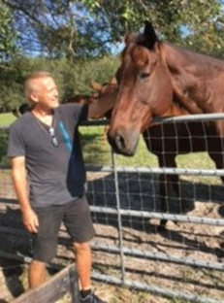 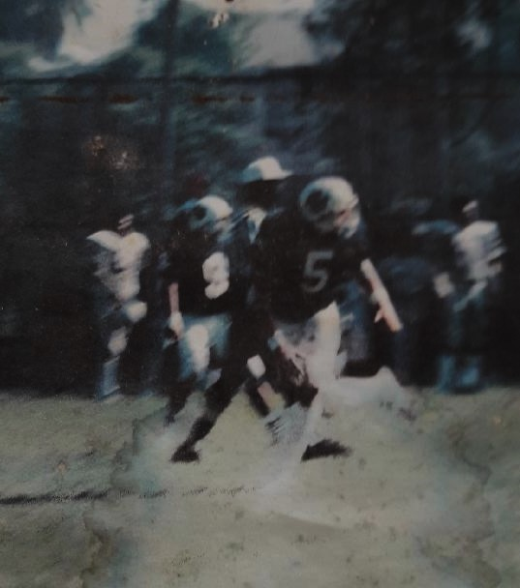

L – R: Moose with Marla’s co-owned giant gelding Slic, Glit-Hir’s mate for life. California Wolves Semi-Pro State Champions 1986…. Moose ‘n my Mom for her 93rd birthday!

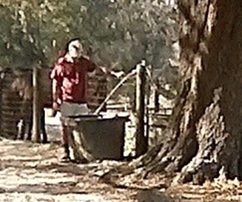 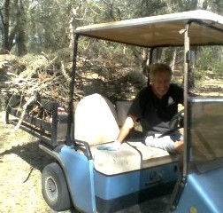 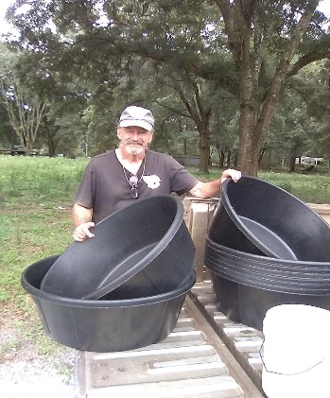

Hard at work filling troughs, hauling storm debris, tamping bedding ‘by foot’ to repair a pasture gate entrance in an attempt to recover from 3 hurricanes this year! And sharing the pride of new feed tubs we received from a grant in 2021, after vandals destroyed our originals. Moose’s work is never done!

Of course, we are not just a birthday review so with that in mind, let me tell you a bit more about us!

Equestrian Spirits, Inc. was founded in 2010 as a Non-profit Animal Rescue Holistic-Based Forever-Home Sanctuary. Local wildlife allows us to share 60+ peaceful acres just outside of Ocala, Florida. All animals stay for life while Moose & I live here as happy ‘slaves’ to furred, finned & feathered friends. Moose prepares & feeds every meal, to every animal, every day, while I help our residents, other organizations & individuals with their adoptions & behavioral issues, worldwide.

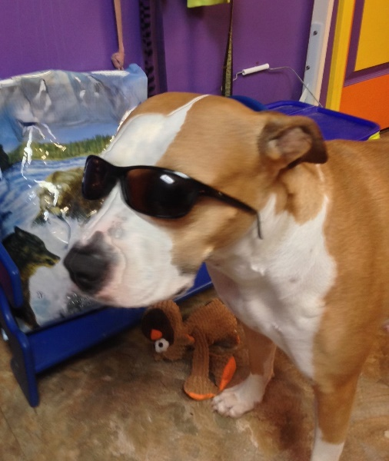 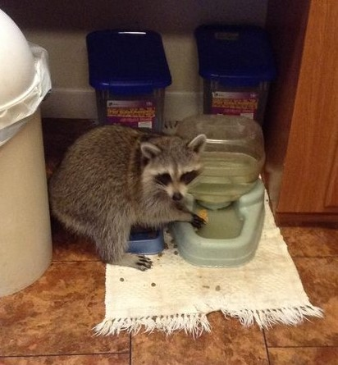 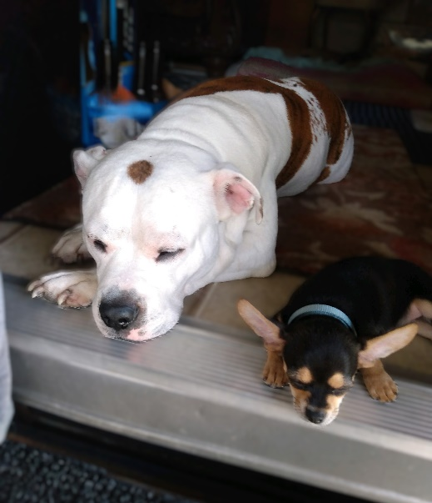

Many of us are defined by our animals… Moose’s loving spy pup Reiley, Tammy’s Ricky (one of dozens of her wild rescues for ES) & Beckie’s family at ease. Critters offer insight into our lives in more ways than we know! Each creature celebrates their person’s birthday in their own way. To any of you out there who are also celebrating another year, our wishes are for this one to be great for all!

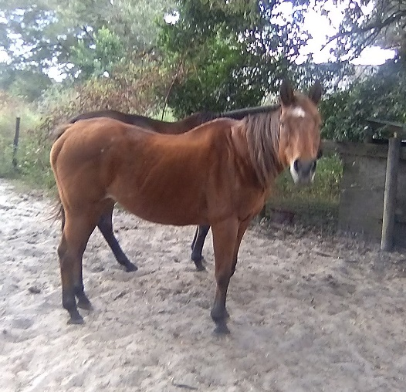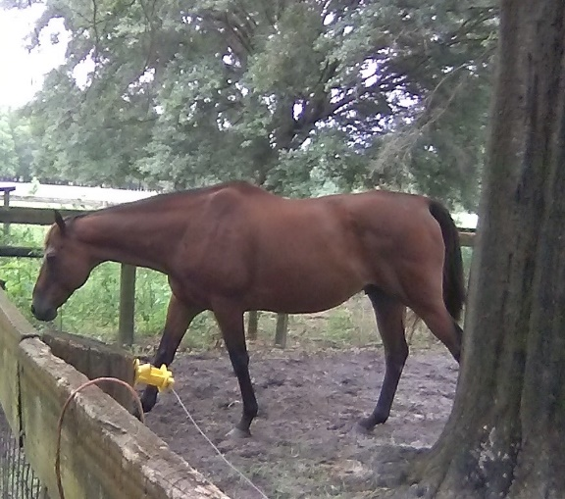 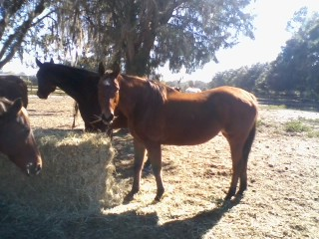

Glit-Hir age 28 love of her life Slic, son of Derby winner Lil E. Tee Glit-Hir age 18

In 2010 an exceptionally well-bred mare came to us emaciated, forlorn & withdrawn. The gelding we acquired months earlier, was far luckier. Recognized as a poor racing candidate, he was sold as a dressage prospect, only to then find his troubles were neurologically based.

So, Slic & Glit-Hir became residents of Equestrian Spirits. The mare began to trust me as her weight & appearance started to change. When I added her to a small herd, life changed forever. Immediately smitten by Slic, the duo became inseparable, sharing feed tubs, seldom found more than a few feet away from each other. While Glit-Hir’s owner neglected, then abandoned her, Slic’s woman contacted us & asked if he could spend his remaining years in the protection of our loving home. We have so much to be thankful for. Like other mated couples, always together, these two share a special bond.

I promised our creatures I’d feature happy, preferably silly tidbits… De’s smiles here, say it all!

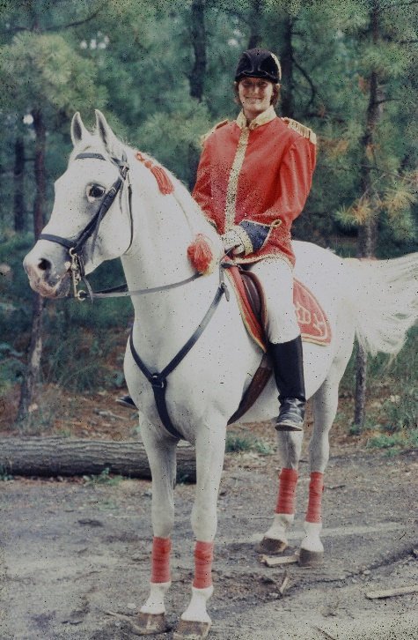 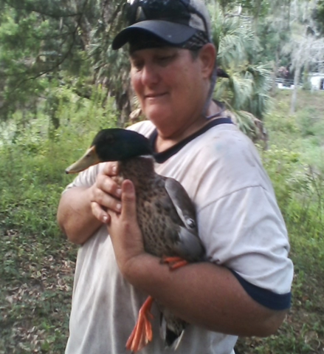 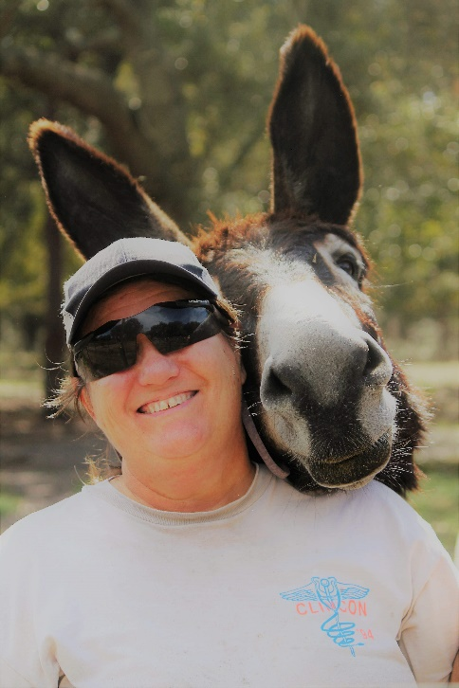

A lifetime dedicated to animals & medicine as a retired Firefighter & Paramedic, De has helped us for decades through many life challenges! *1* Tho her favorite breed has long been Lipizzaners, the horse in the photo did not belong to her. Stroger was *her* rescue who lived to be 40-years old! Considering when she purchased him, he was unrideable & barely manageable, several decades sharing their lives brought them both into a special friendship that included winning show rides, quiet/fun trails & many travels between our farms. *2* Our mallard drake, about to be set free back into our pond after susataing a wildlife injury. During recovery, his brothers (Doh, Rhe, Mhe) anxiously awaited his return after Fha had spent his convalescence in our shower! *3* Tomaluke - ultimate photo-bomb!

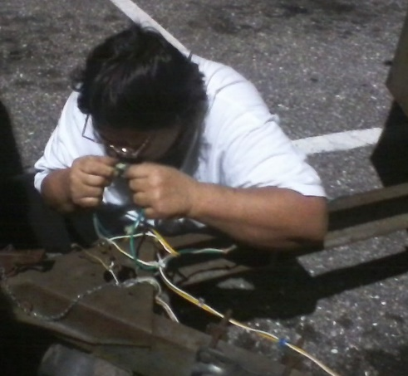 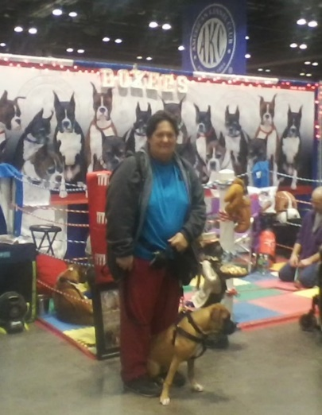  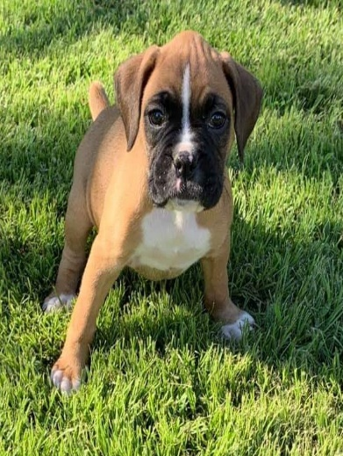

In 1987 I told a client “every barn needs a De.” True now as it ever was, Happy Birthday to our co-founder, DeLania.

*1* Legally blind, De repairs faulty wiring on her horse trailer in a parking lot after buying a set of external lights so she could safely make the remainder of a trip. It strikes me how many of us “just can’t figure out” how to help ourselves, when De simply moves forward & does *something*. BTW, I stood by & watched… & no, she did not do the driving! *2* De & Ozera on their 1st excursion. *3* I call this next picture ‘Dirty De’. A typical image after a day of fence work on our farm. I laughed so hard when she came in to announce that she had all my electric fence tops up & running, I just *had* to get a picture. Little did she know it would go public! LOL. *4* Forever grateful to Triple J Ranch for providing the most amazing Boxer pup De could have wished for! An incredibly fast learner, Ozera could not be a more perfect service dog & loving companion.

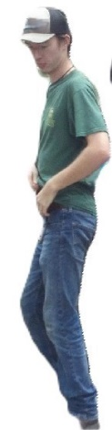 Your challenge for December… what is this man doing, why do we care; & who is Prophet’s Plea

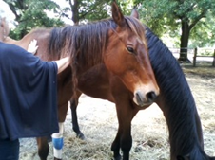 We have so many lovely photographs that I try not to use repeats, but this one makes a perfect intro to our healing topic. With gentleness literally seen in Dora’s hands & the expression on Glit-Hir’s face, even a novice can see the results.

What on earth is Reiki, one might ask? Or Bowen, Acupuncture, Herbology, IRT, AK, Homeopathy or even Massage Therapy?? For those of us quite familiar with these terms, we must pause to offer insight into the wonderful modalities that surround us daily. Whether we pay a veterinarian, professional practitioner, or just naturally rub & feed our animals properly, we can have some very positive influences on their lives!

The picture from last month is of a dear friend & Reiki Master, Dora, who volunteered her time & expertise for Glit-Hir & her friends. Techniques like Reiki have always been part of our farm, but it is also helpful to invite in outside energies, especially with one so gifted as Dora. Energy based modalities can be quiteprofound. If you are not familiar with many of these, keep an eye on our website in 2025 where we hope to list Reiki information among a variety of healing modalities & techniques.

In October I asked ‘what is Flip’. Well, their promo states: *“The best fundraising platform for small nonprofits. Customizable fundraising that brings everything you need in one place. Unlimited human support so you hit the ground running.”*

All of this is true, but an incredible understatement. Let me tell you about a company who is deeply imbedded in our dream… On November 9, 2020 I was sent an email from a fellow named Robert. Since that is the name & actual birthdate of a long-standing best friend, I decided that even though the email was ‘too good to be true’, the karma of connection with my friend was not possible to resist, so… I called. The ensuing conversation was amazing. To make a rather detailed story short (lol), Robert expalined how their company hosts small non-profit websites. One thing led to another & after hours & hours of learning on my part (laughter on theirs) the eventual launch on April 26, 2021 of a lovely new site, is as you see it now! I loved our previous website created by a talented friend, but when she moved out of the country for business, her limited availability & my total ignorance on all things technical, put a damper on my ability to make changes or additions to our site. Along came Flipcause, & my ‘web world’ reopened once more.

If you have not yet had the joy of stepping into our world, please look at the wonderful work ‘Flip’ has done for us. From *very* personal Customer Service, to pages of our life taking form, check out many beautiful pictures, read some funny stories (like the one about why we spell things the way we do…), or review heart-wrenching tales how some of our resident’s pain, brought them to our door.

In ongoing attempts to help us survive, Flipcause made a GivingTuesday link for those of you who may want to help us as we continue to ’Save the Animals’. As winter approaches, even here in Florida, things change. Our hay bill is about to double. We need new heat lamps for small animal outdoor areas. Electric bills will soar while feed & vet bills continue. Our truck needs a winter overhaul as does our feed cart.

Last year we had a donor repair our heating unit & send some really groovy/warm clothing so Moose & I would not turn to icicles while our temperatures drop (wosie as we have become, me from NY, he from NJ… who knew? – lol). Yet we need to pay electric to use the heat, order feed in advance to warm the insides of all our animal family & be ready for whatever normal everyday challenges may come our way.

**Please consider donating to Glit-Hir’s Winter Feed Fund,** click **“Save the Animals”:** [www.EquestrianSpirits.ORG](http://www.EquestrianSpirits.ORG). Help keep our critters comfortable & warm throughout the chilly months! Remember, a*ll proceeds go only to the animals* as our board is unpaid.

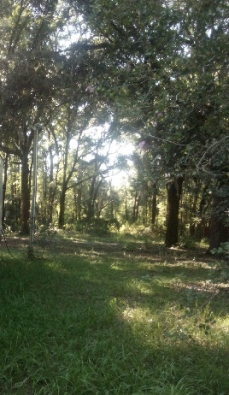 Very sincerely, and in the spirit of all who have gone on before me... 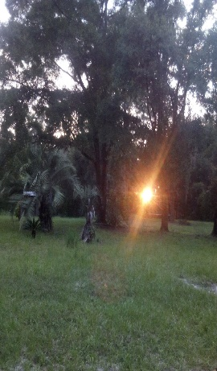

many thanks for your interest – Laurie L. Wolf each heart travels free – to Danjahl & Wade…

Newsletter for Equestrian Spirits, Inc. 501(c)(3) EIN: 35-2384797 (863) 368-0775 [www.EquestrianSpirits.ORG](http://www.EquestrianSpirits.ORG) P.O. Box 237 - Morriston, Florida 32668 copyright LLW 2024(c)