May 2024 issue 2 WELCOME TO AMIK’S LEGACY

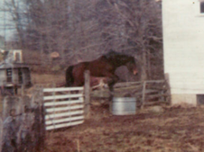 each heart travels free

**Hello to all our family & fans!!!**

Welcome to issue #2 of Amik’s Legacy, the newsletter for Equestrian Spirits Sanctuary! Follow us through Tales of Tails & keep your eyes open, you never know what might be shared! There are so many exciting things here. Please join us in a visit to our springtime Sanctuary!

This morning brought an unexpected challenge. A huge limb began to sever itself during last year’s storm season. It was almost magical how it set itself into an adjoining tree. Seeing no imminent danger, we left it to nature’s plan. Today was the day the limb decided to go. More ‘magic’ because it dropped without damaging our fence, gate, or a coop! However, it did lay across a pathway needed for feeding horses. Lo & behold, Moose & Laurie are still not too aged to move a 2-ton log (mild exaggeration – lol). I wonder what June will bring!

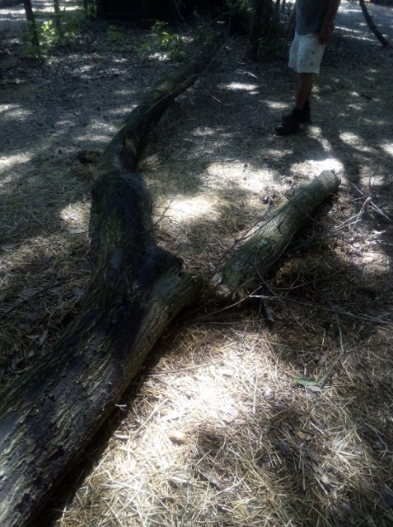 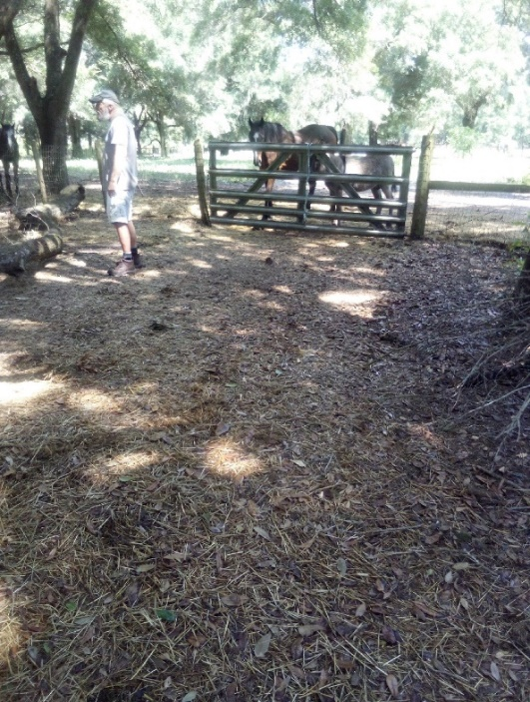 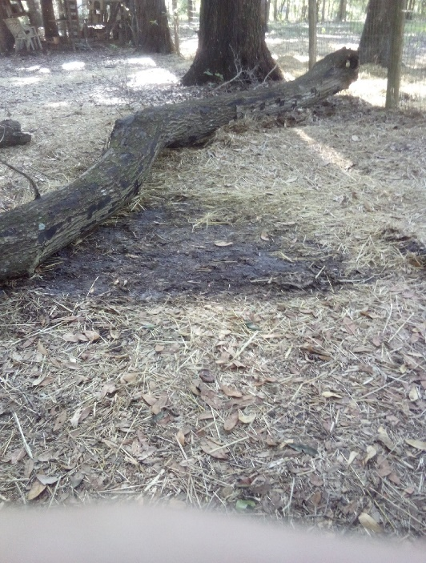

oh, what to do… what to do peanut gallery proof we dragged it!!

On a lighter note, I was informed by one of our residents, who is much smaller than a horse, that “little beings are also very important! With this in mind, here are a few ‘tiny moments’ at Amik Run, the home of Equestrian Spirits non-profit. Enjoy!

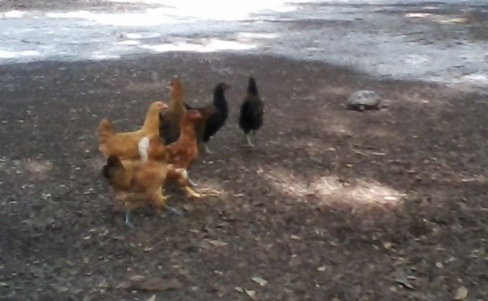 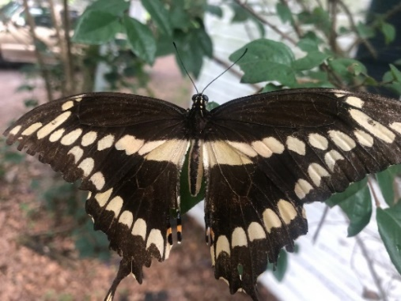 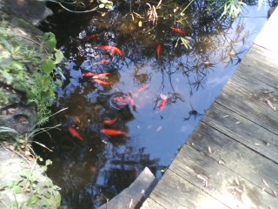

Many or our fowl are named after receptionists from companies we shop with, like Chewy or Tractor Supply. These hens are busy exploring & rounding up one of our endangered Gopher Turtles as he crosses their yard. They were discussing what they should name him! When we add more fowl to our website, you can read all the cool names they have chosen from our ‘online shopping experiences’!

My original plan is to feature at least ONE horse, current or past, as well as ONE other species but the animals their own ideas! Before I present what *THEY* want, let me explain a few things.

Equestrian Spirits, Inc. is a Non-profit Animal Rescue Holistic-Based Forever-Home Sanctuary (yes mom, a run-on-sentence). We were founded in 2010, having done the same out-of-pocket for many decades. Our farm is named Amik Run after my illustrious Show Jumper, Amik. I grew up riding at a wonderful farm called Smoke Run on Long Island, named after their dog Smokey, as a place for him to run. I have thousands of fond memories from there & always connected with the idea behind the name. So, in honor & remembrance of many riding & life lessons, I dreamed one day of having my own farm named after my horse.

Amik, as well as Amik Run, is part of my dream come true, that I now share with you…

We are located on a bit over 60 awesome acres just outside of Ocala, Florida – ‘Horse Capitol of the World’. Our animals all remain with us for life, while we help other organizations nationwide, as well as individuals, with their adoptions & behavioral issues.

Our equine features this month are who I fondly call, “The Donks” or “Ears”. Since ALL our animals stay for life, there is no need to separate families… or friends. As one can see, challenges on size are only in the eye of the beholder! Far left is a ‘hind-view’ of our illustrious farrier & ‘long-ear’ fan, JR Hall, with his pals lining up for their pedicures!

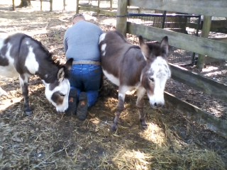 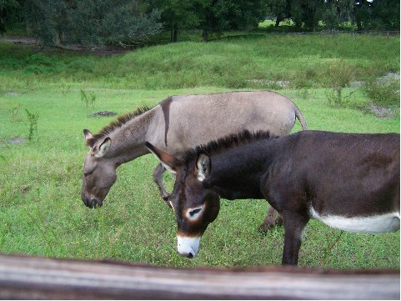

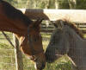 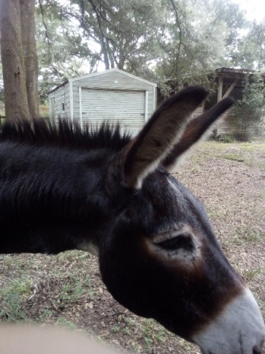 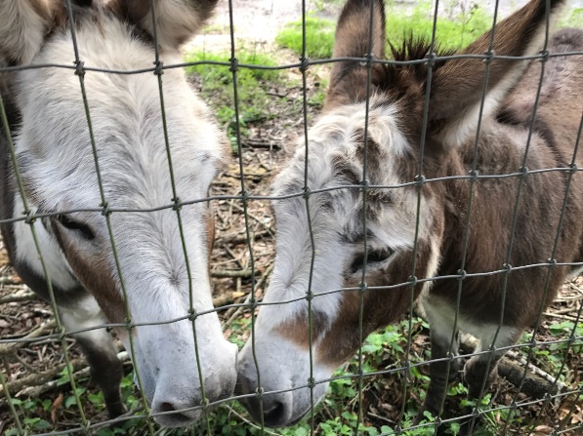

Picture #1 is Bradli explaining to an FEI level Dressage Thoroughbred that they are not scary critters, at all! These two became great friends but moments before this picture was shot, the horse was coming ‘unglued’. A patient, quiet rider subdued his mount’s reaction & the donkey did the rest. #2 is Bradli’s life-mate Brooke, together now, well over 20 years. The spotted couple (fondly called “The Spotz”) are mother & child, inherited when we initially bought the farm.

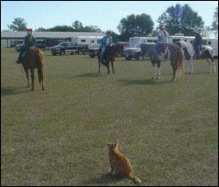 putting on a horse show in between classes teaching jumping lessons! AH-HA

There were some great guesses who the cute upside-down kitty was in our last issue. Thank you for participating! His name is Ahandhi & he was (obviously) our horse kitty. In 2003, we hosted a Bowen Clinic. In between other critters, a student asked if it would help a cat. Ahandhi was part of a feral rescue & had remained aloof with no fear, but with no use of humans… until that day. The short version is, his (& our) entire world changed that day. See for yourself, what wonders a great veterinarian, loving family & some Bowen can do. Look for Ahandhi’s story – soon to be added to our website.

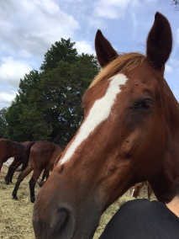 Your challenge for June … guess who? Also, who is Mhatildah & why is he special?

From time to time, we feature an animal who is not in our family. OSO is such a creature. He has the distinction of being the very 1st responder to our initial reach out about an impending newsletter.

He asked if he could make a stand to show support for the hundreds of thousands of rescued animals who are not really up to the task. Although ‘rescue’ seems like such a grand idea & in many cases, works out so beautifully, but then… there are the others…

The dream horse now able to eat & look pretty but always pins her ears when her new family comes around. The cat who refuses to live anywhere except under the bed even though the vets & shelter can find nothing wrong with him, or the dog who just cannot figure out what the rules are & how he could possibly live up to the hope of a happy home – “I, OSO, was such a dog…”

OSO says he is NOT “a rescue”, he is “a rescued”. The difference being that he is now a loving family member & is separated from the many who remain “rescues”. He also states “I have far to go to understand about family life, but deeply appreciate my chances to try. I am OSO happy now, to be alive.”

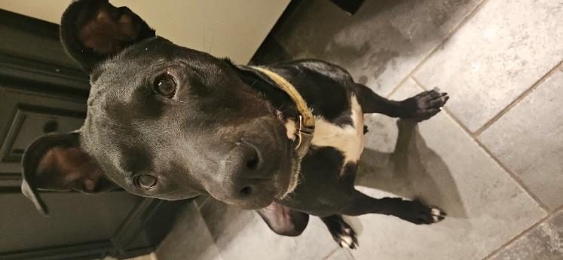 Before newsletter feature approval 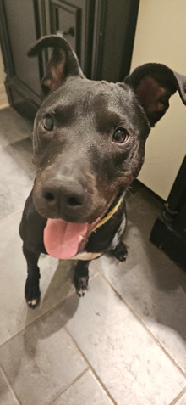 After approval!

Loving words from OSO’s mom: *“I appreciate this journey with OSO. It taught me patience, compassion, and hope. The world wanted to throw OSO away, but my gut told me he was worth saving. Always trust your gut. It is an extreme privilege when a battered, traumatized creature gives you, their trust. Thank you, Laurie, for helping us help him.”*

Again, I close on a moment of THANKS: to Mom, Moose & my loving cousin Debbye – without whom I would have definitely, lost my mind… to our friends at Bighorn Botanicals where we buy anything & everything they sell, having wonderful experiences with their great products. Check them out! <https://bighornbotanicals.com>

Alphabetically I continue to mention other, special supporters, who never gave up on us. We still have far to go, but the believers inspire the energy to carry us on. I list 1st initial only since they know who they are & many wish for anonymity: A, B, D, D, E, E, E, J, J, J, K, K, K, L, L, L, M, M, P, P, P, S, S, S, T – many thanks & much love in keeping faith, even while we were drowning…

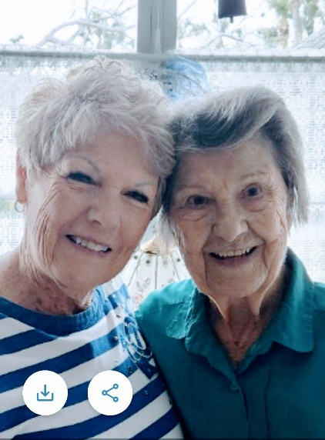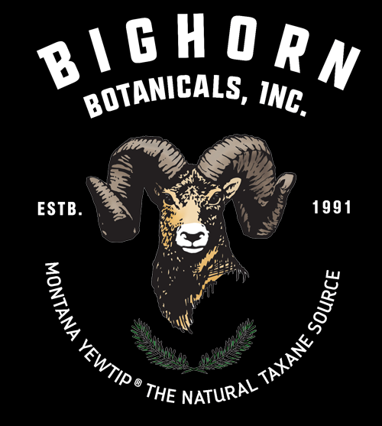

MOM & Cousin Debbye Thanks for years of great products!! Moose at his best a few years back

**Please consider donating to Wil-Hee’s Rescue Fund, click “Save the Animals”** on our website: [www.EquestrianSpirits.ORG](http://www.EquestrianSpirits.ORG). *All proceeds go only to the animals*, as our board is unpaid.

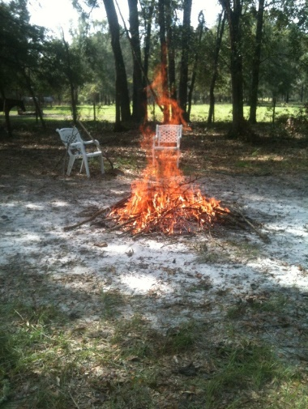 We love you, Fire Horse. May the Heavens be set ablaze by your Playful Spirit…..

Nicknamed ‘Fire Horse’ by Moose in 2017, he & Wil-Hee became the best of pals. Moose would constantly collect fallen branches & make beautiful bonfires. Wil-Hee’s pasture is in the background. He came running any time he saw the flames getting set & would stand for hours watching Moose work at lessening the wooden debris. We miss you, beautiful Wil-Hee man… the Fire Horse.

Very sincerely, and in the spirit of all who have gone on before me...

many thanks for your interest – Laurie L. Wolf

Newsletter for Equestrian Spirits, Inc. 501(c)(3) EIN: 35-2384797 (863) 368-0775 [www.EquestrianSpirits.ORG](http://www.EquestrianSpirits.ORG) P.O. Box 237 - Morriston, Florida 32668 copyright LLW 2024(c)