June 2024 issue 3 WELCOME TO AMIK’S LEGACY

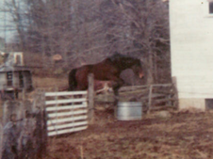 each heart travels free

**Hello to all our family & fans!!!**

Welcome to issue #3 of Amik’s Legacy, the newsletter for Equestrian Spirits Sanctuary! Follow on through Tales of Tails. Better keep eyes open, who knows who you might recognize! There are so many friends here who plan to share their stories. So, join us in a visit to our springtime Haven!

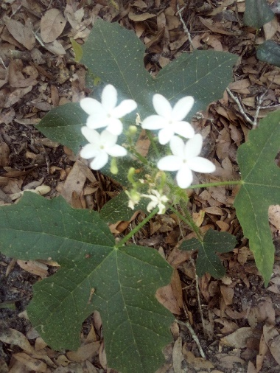 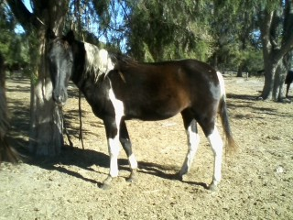 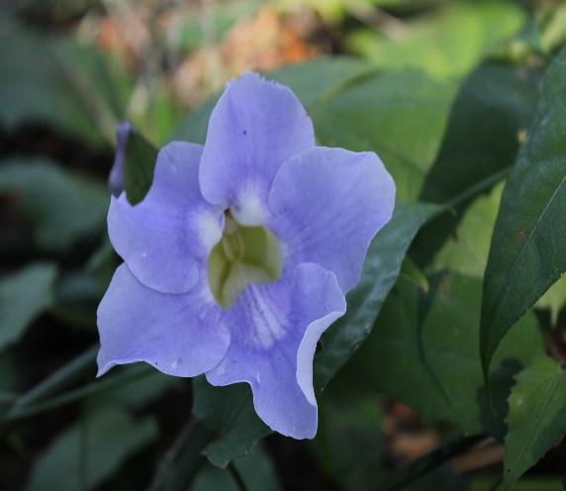

daily, tiny joys our biggest photo bomb resident colors for healing hearts

Horses love to eat! Florida has been a wonderful place to have a sanctuary, especially for so many who have come our way with empty bellies & damaged hearts. As grand as the grasses are for most of the year, we have always supplemented hay for free-choice feeding. All our equines eat whenever they want, partially in hopes from us that they push the memories of starvation far, far away…

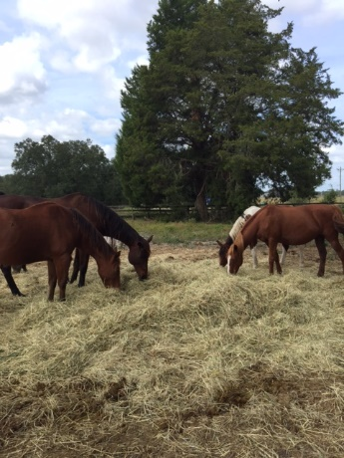 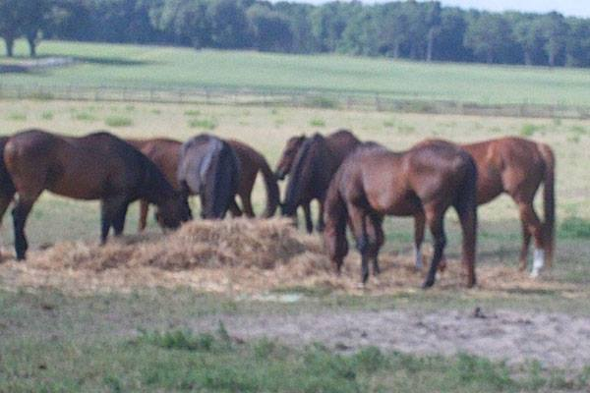 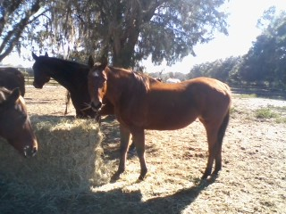

2023 2014 2017

Let me introduce us. Equestrian Spirits, Inc. is an Animal Rescue Holistic-Based Forever-Home Sanctuary (yes mom, a run-on-sentence). Though our non-profit was founded in 2010, we had been doing the same since 1970, out-of-pocket. Our farm is Amik Run, named after my illustrious Show Jumper, Amik. In my teens, I rode at Smoke Run, on Long Island, which was named after their dog Smokey, as a place for him to run. Within my thousands of fond memories, I always connected with the idea behind their name. So, in honor & remembrance of many riding & life lessons, I dreamed one day of having my own farm named after my horse.

Amik, as well as Amik Run, is part of my dream come true, that I now share with you…

Located on over 60 beautiful acres just outside of Ocala, Florida – ‘Horse Capitol of the World’, our animals remain with us for life. We help individuals & organizations nationwide with their adoptions & behavioral issues.

Our June equine feature is a stately, yet silly ‘man horse’ known as Whintir. Our second tallest equine resident came to us after a checkered past, having a conflicted future. Difficult to manage his whole life, his disruptive behavior found him without options. Unlike many of our residents, Whintir was not starved, or abused. He was simply misunderstood. However, that misunderstanding left his breeders with limited options: either keep the costly, unruly troublemaker, get rid of him (somehow), or euthanize him. Needless to say, here he is. Meet Whintir aka, ‘Fast Horse’.

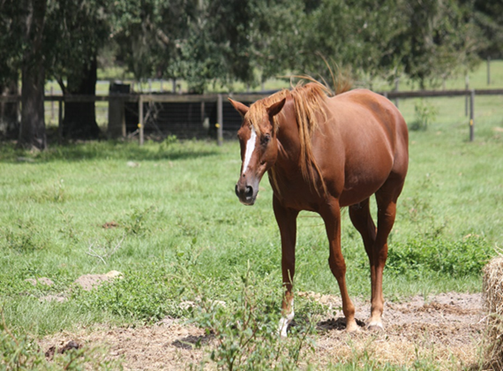 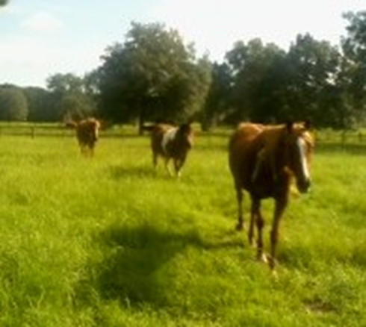

As a failed racehorse, failed show horse, kamikaze pasture-mate, who was gelded due to erratic behavior & injuries, Whintir’s humans were relieved to find us. As time went on, this big boy became more tractable & finally, friendly. Having found a best friend, collected two ‘wives’, earned his nickname of Fast Horse while running alongside of Moose during rounds, Whintir now has his very own herd!

What a lovely story of recovery, if not for the eye cancer that began its assault in early 2023. We started a treatment fund for this illustrious fellow, within our fundraiser ‘Save the Animals’ on our website. Thanks to some awe-inspiring veterinary care, Whintir remains happy & ever playful. However, his now lifelong remedies are costly & very explicit. Any & all support towards the continuation of his comfort & well-being is deeply appreciated! Help to keep Whintir & his girls, happy & safe. The joy in him when he frolics in his field, belies the illness trying to take him over. So far, so good….

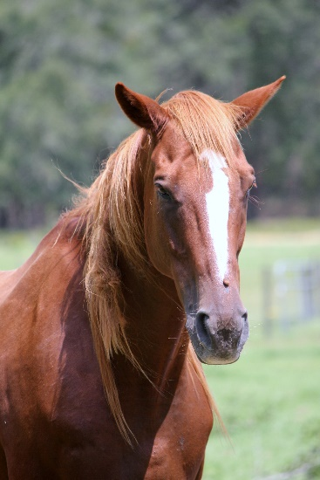 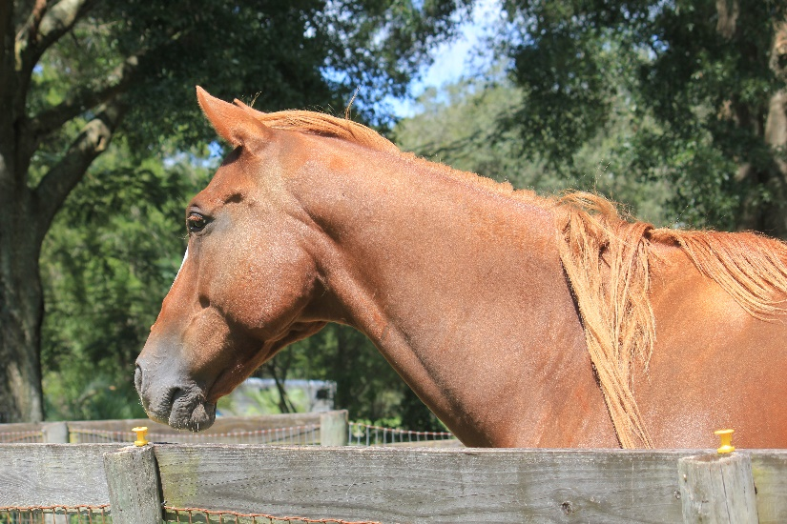 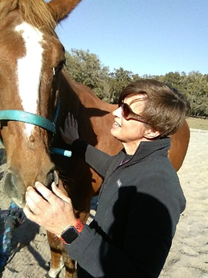

Whintir began his eye treatments with acupuncturist Dr. Kristi Fox of Blue Run Veterinary Practice in Dunnellon, Florida. Immediately receptive, he thoroughly enjoyed his new friend, while the eye improved!

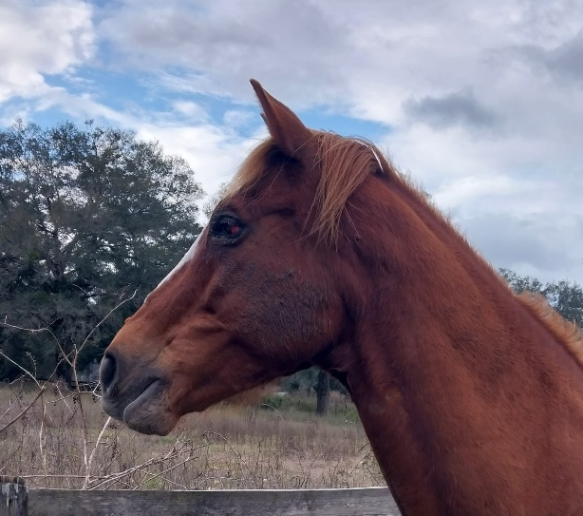 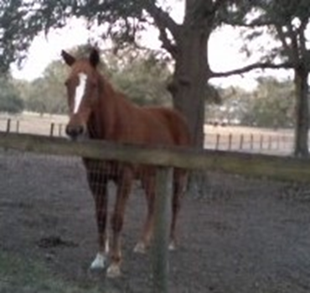 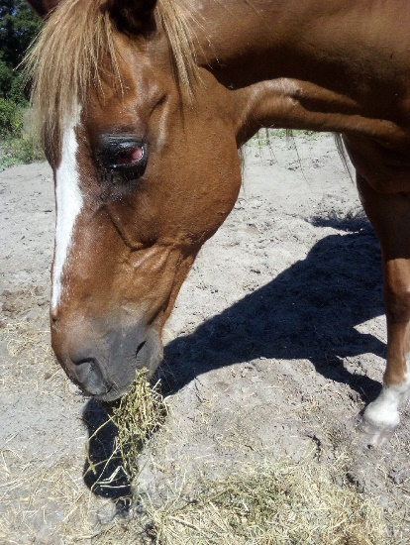

As time would have it, equine ocular squamous cell carcinoma does not give in easily. Since 2023, Whintir has also been being treated by Dr. Sue Howell with herbs, supplements & various remedies that she tests for. Although this form of physical challenge is progressive, Whintir remains comfortable, plays with his family, willingly ingests every morsal of foods & remedies. He is a proud fellow, with an eagerness that has been in him since birth. Now that those energies have been channeled to more positive terms, he is a vibrant, often silly, joy to be around.

One of our sanctuary’s specialties is guiding animals to “redefine their lives”. Whintir’s people did not cause his entire situation. He just did not ‘fit the criteria’ for their form of life. Rather than hurt him or take his life & future from him… he was allowed to join our family, which he fits into quite nicely!

Please consider making a donation on Whintir’s behalf so he can continue his medical treatments… & his life [https://www.equestrianspirits.org](https://www.equestrianspirits.org/)

Whintir would like you to meet Sue Howell, DVM, CVFT, CVA of Thrive Holistic Veterinary Care!!

This gigantic Thoroughbred takes friendship *very* seriously. From the first, he consideres her a *best* friend.

<https://thrivepetvet.com>, [drsue@thrivepetvet.com](mailto:drsue@thrivepetvet.com) He feels her smiles in his heart even from miles away. Message from the once wayward racehorse: “Thanks, Doc!”

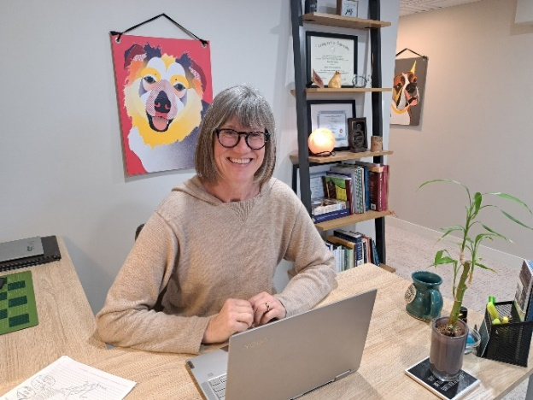 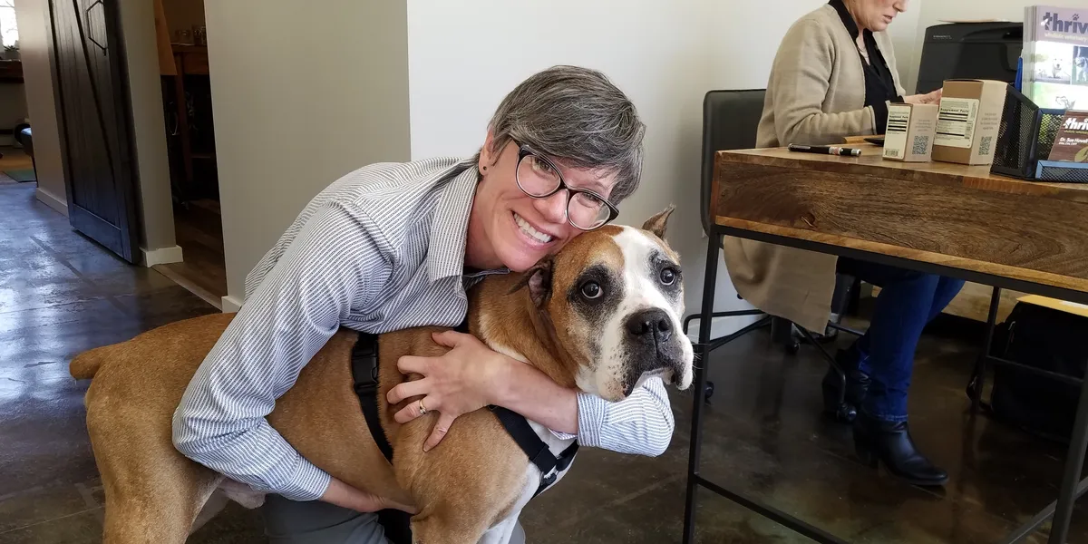

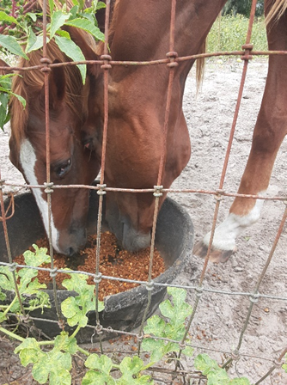 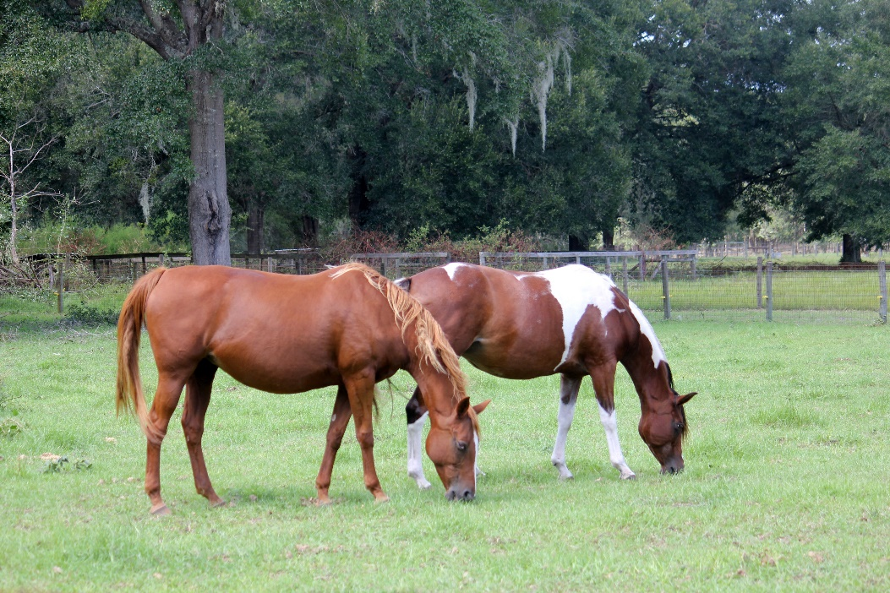

Whintir, munching with wife Rhinny Rhinny with best friend, Whintir’s other wife, Khaya

Whintir’s girls were horribly neglected before joining Equestrian Spirits. They now thrive in their haven.

The question from last month was “Who is Mhatildah & why is he special?” Well, this is Mhatildah:

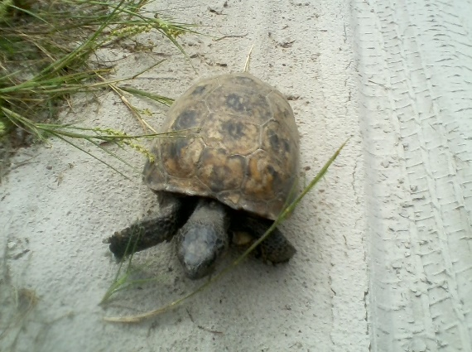 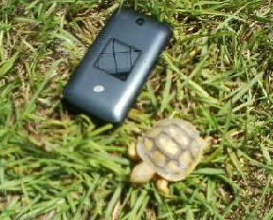 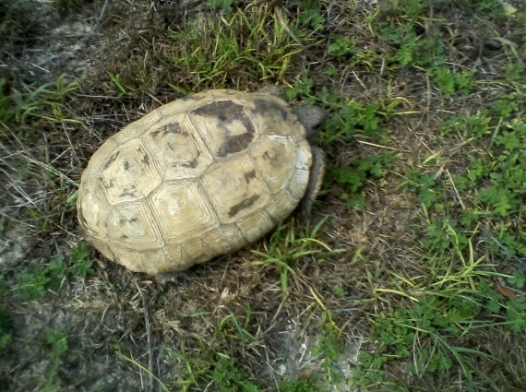

Mhatildah (L) is a Florida Gopher Tortoise, as is his wife Shel-Hee (R).

When I met our driveway tortoise in 2017, I was thrilled to be greeted openly. Our new family member clearly stated to be referred to as ‘Mhatildah’. What a great name for a turtle! Several weeks later, we returned from errands & saw another turtle on the opposite side of our driveway. Moose called her Shel-Hee right away (how creative!). When we had a specialist come to the farm to identify our ‘slow crawlers’ further, we were informed Mhatildah was a ‘man turtle’ & Shel-Hee is his mate! Our ‘man’ wanted NO change in his moniker & has been called by his chosen name ever since.

Our Florida State Turtle is the Gopher Tortoise. They are considered ‘Threatened’ by U.S. Fish & Wildlife. We did not name our tiny baby, nor attempt to touch. We have a rather safe environment even for our turtles so one day, we may see Mhatildah or Shel-Hee junior, strolling along our pastures…

Mhatildah makes a regular trek to visit his wife at her own house. Recently he had to rebuild his entire kingdom. He was fastidious & thorough & is now far safer than living only partially on our farm.

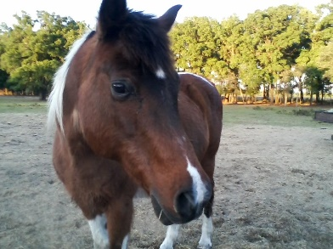 Your challenge for July … guess who? Also, who is our advertising executive??

Once again, I must thank all our wonderful friends & supporters for sticking by us through thick & thin. For those who wish to remain anonymous, we could not have survived without you.

For those we will *not* let remain anonymous… we must thank some *very* special friends. Perry Clark has kept our carts in working order since 2012. For Bill Bullock & his son Lidden, no job has been impossible. Sam at Air Ducks (great name, eh?) has kept us hot & cold (only at the right times) while SECO power company has not let us down through any storm & Williston Tractor Supply is there for us at every turn!

Through it all, Moose’s smile as he became transformed from a mortgage banker, musician, football champ, into a simple rural farmer, has been amazing (& often humorous - lol).

Hard working, knowledgeable, local companies impede my fear when a waterpipe explodes, our work-carts threaten to leave us on foot, our power company saves the day, our heat & air grind to a halt, or our feed becomes too heavy to tote ourselves... all are here with sunny smiles & perfect repair!! Thanks, y’all!!

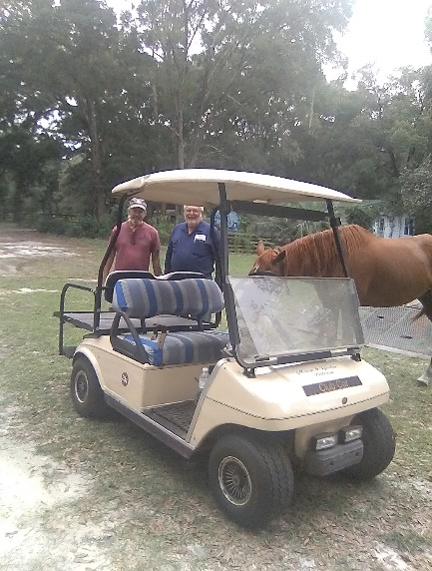 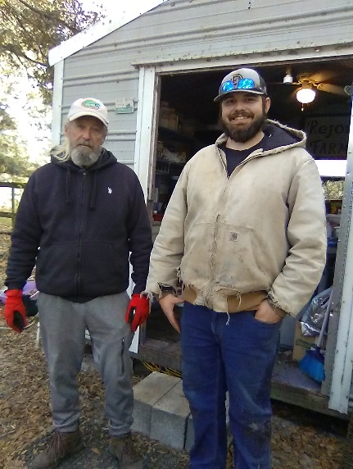 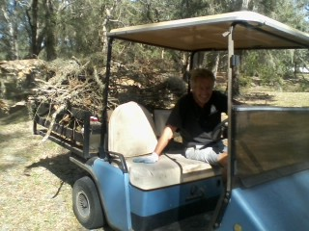

Perry’s Carts & Cars Bullock Pump & Well Bonfire Moose

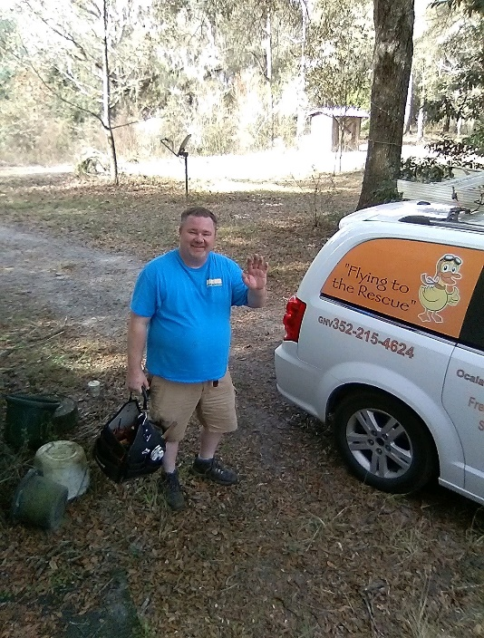 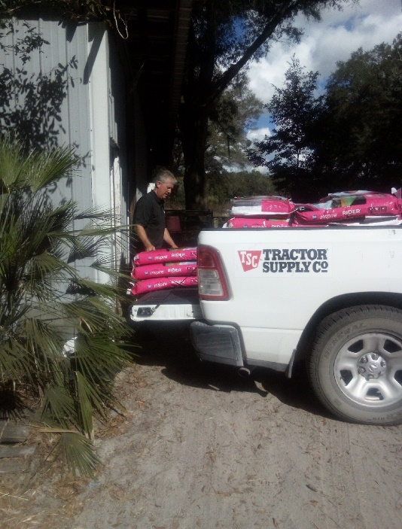

Air Ducks Heat & Air Sumpter Electric (SECO) Williston Tractor Supply

**Please consider donating to Whintir’s Rescue Fund, click “Save the Animals”** on our website: [www.EquestrianSpirits.ORG](http://www.EquestrianSpirits.ORG). *All proceeds go only to the animals*, as our board is unpaid.

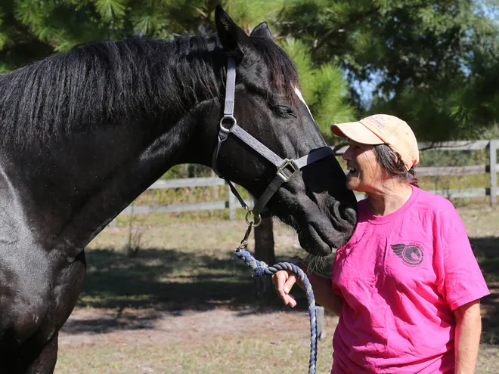 We love you all, as you love us. Invictus ……..

Very sincerely, and in the spirit of all who have gone on before me...

many thanks for your interest – Laurie L. Wolf

Newsletter for Equestrian Spirits, Inc. 501(c)(3) EIN: 35-2384797 (863) 368-0775 [www.EquestrianSpirits.ORG](http://www.EquestrianSpirits.ORG) P.O. Box 237 - Morriston, Florida 32668 copyright LLW 2024(c)