December 2024 issue 9 AMIK’S LEGACY
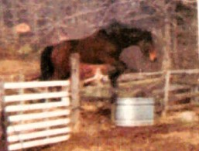 Happy Holidays to All!!! 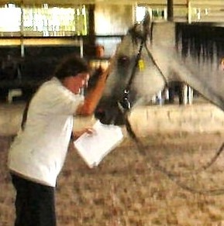
My beloved soulmate continues to lend his honor, memory & name to our final newsletter of 2024!!! We hope you enjoy this one as much as the others & are looking forward to even more fun from Tales of Tails. Amik means Bever in Chippawa Indian. He had the biggest, heaviest, tail I have ever seen on any horse, anywhere; symbolic of never letting the weight in our lives… get us down.
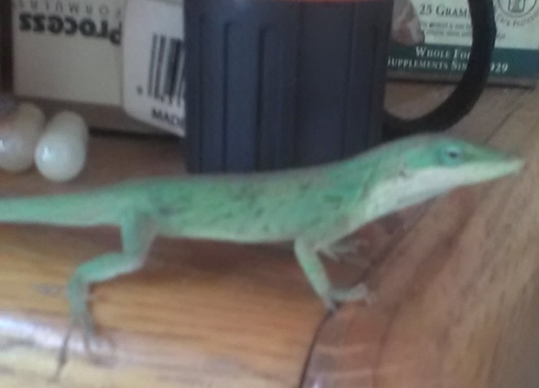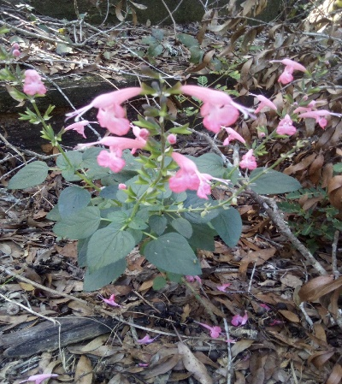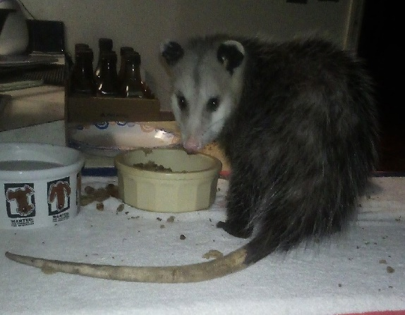
I just had to close out our year sharing wildlife. Our doors are open to many in need, but some find us in quite unusual fashion: an anole lizard who found his way into our Apothecary supply of Standard Process supplements, or our new friend who has decided the cat food in our house is far better than any outdoor hunting! Over the years birds have nested & raised young in our living room, while various armadillo or opossum have meandered indoors to indulge in natural ingredient cat foods!
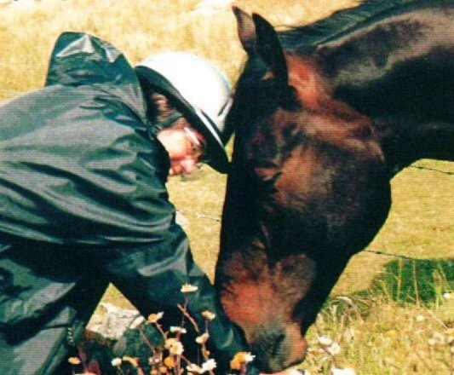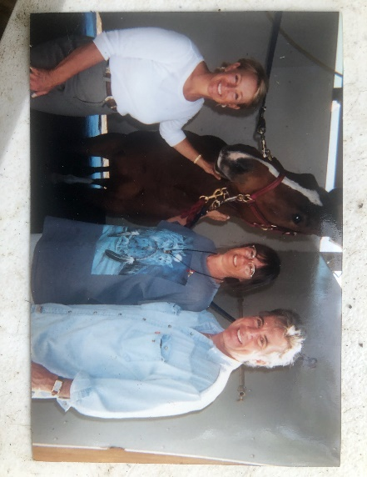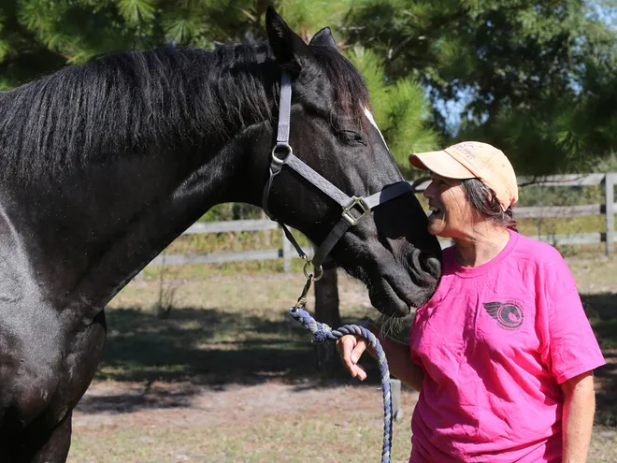
When I was 12, I fell in love with an ad in Horse Lover’s Magazine about riding tours In Ireland. Forty years later that dream became reality! There I met Wille Leahy, not so ironically, he was the one who ran that ad I saw as a child. There I was, riding the Connemara Trail with him for 17 wet & gorgeous days through the Irish mist… Left - sharing a break with my Anglo-Connemara mare, reveling in the magical countryside, feeling like I was inside of my own dream. Center - though never selling any of my own, or horses of ES, for decades I have matched many gifted animals to overjoyed buyers as a rep for private sellers. The smiles on all our faces, including the lovely, kind mare who was the 1st of 4 mounts who I found for John & Reve in 2000, reflect a very special union. Right – kissing any safely kissable animal daily, keeps my heart beating. Nyte makes a point of always kissing back.
For all my years in rescue, I have been asked why we do not feature more information about the people behind the scenes. Well, maybe it’s time! The true answer is that we are truly ALL about animals. I fully believe results speak for themselves, but I must say, it has been fun over these initial months of Amik’s Legacy finding photos of family, friends, visitors or co-founders. Hello to all!
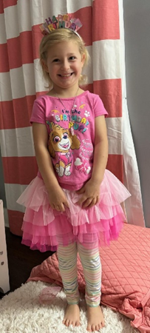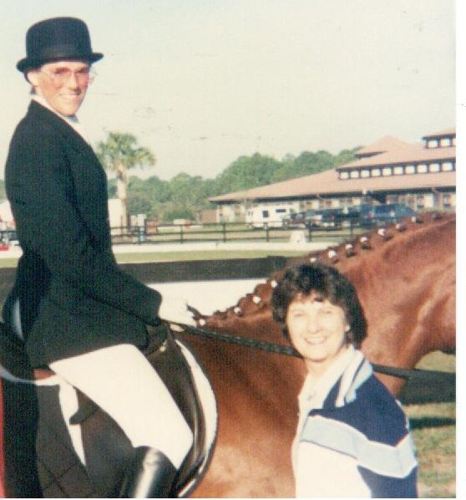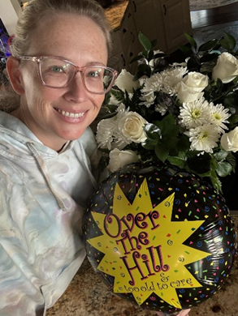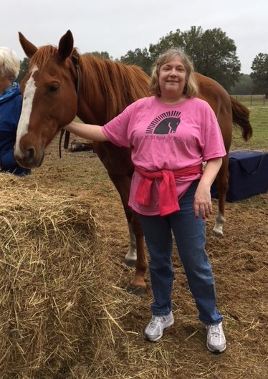
December birthdays are just as special as any other time of year except that it is MY month! From a princess, one who is certainly not ‘over the hill’, a pal from way back & other December babies, may this month be grand! New friend, ‘old’ friend, hopefully as time travels on we can expand our albums.
In November I honored my father for part of my existence, my extraordinary mother is my other half. I am mounted on one of the most versatile horses who ever shared her life with me; she was also the sweetest who ever came through our doors. This was taken at the 1989 Dressage World Cup Qualifying Horse Show with my mother– a staunch supporter of all my equestrian endeavors.
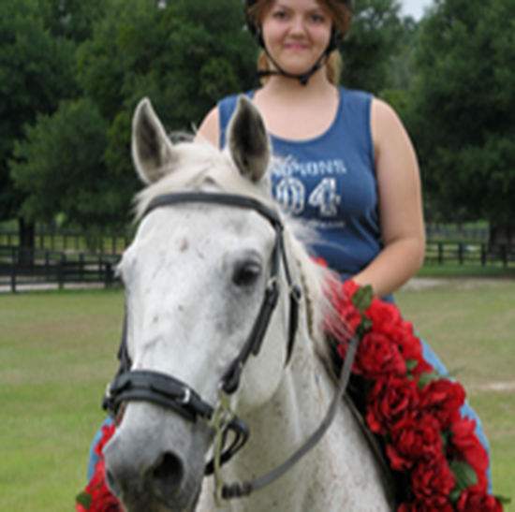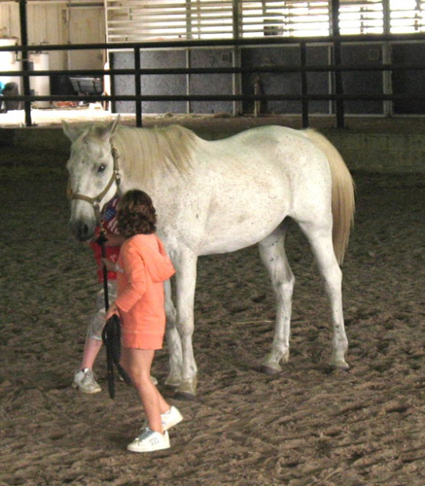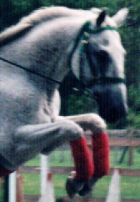
Last month I asked: who is Prophet’s Plea. Only one of the many who knew this marvelous fellow responded, & she was right: Ezekiel, fondly Zeik, alias Prophet’s Plea. Part of his story is already on our website & he was recently featured in the 2024 November issue of Feather Sound News.
Gold Medalist in our Junior Olympic Invitational 1998, this tenacious gelding went from riches to rags… & back again. It took him 10 tormented years to return to kind & knowledgeable hands when his downhill path met with ours. Gentle to beginners, silly in parade or party costumes, exciting to gallop or jump, Zeik worked his way deep into the hearts of many over the 17 years he spent with us.

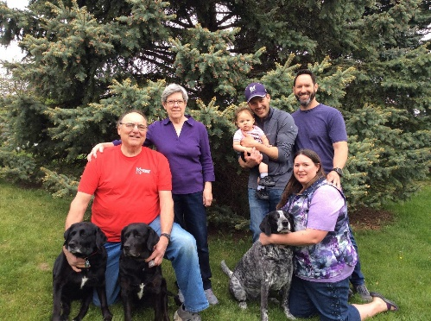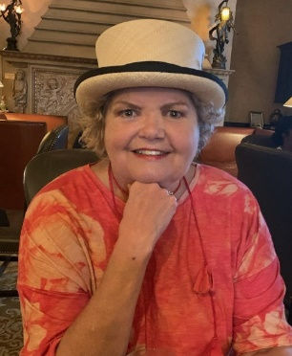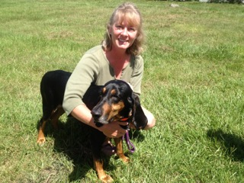
Families, friends, ponies, puppies, kitties or kids - so many extrordinary guests through our doors! May the coming year bring more visits & many more smiles – our best to all in 2025!
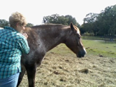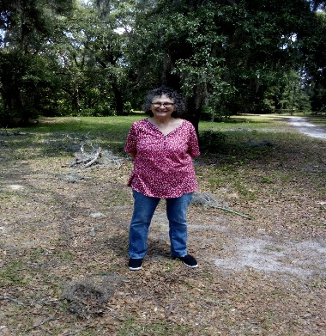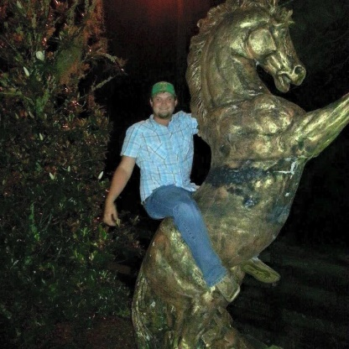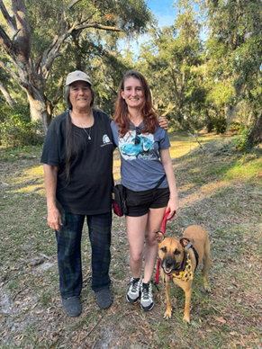
They say “a picture is worth 1000 words…” so I will let parts of this collection speak for themselves. A single glance easily shows how many wonderful animals, human & otherwise, grace our would.
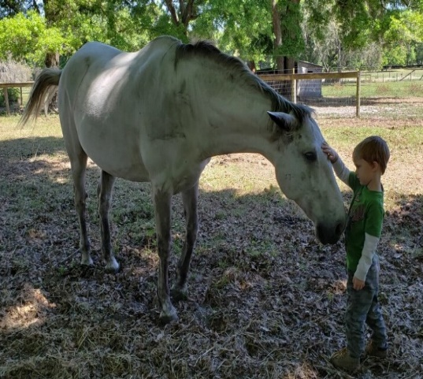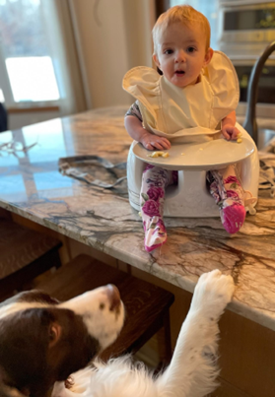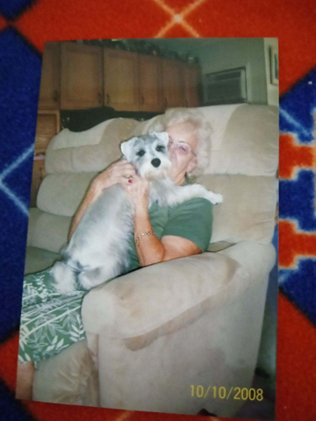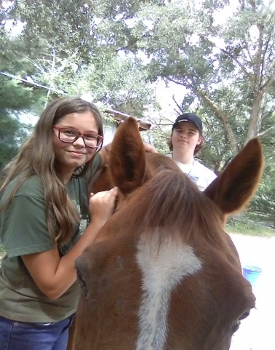
Smiles are so easy when we are loved! Service Dog, Agility Champion, beloved pet or damaged horses learning to find peace again, they make our lives much richer as we enrich theirs. So many griining faces & sparkling eyes reflect what we get back for all that good food & kindness! Maybe next year many guests will return as new ones arrive. From Minnesota, Wisconsin, New York, Utah, Texas, Pennsylvania, Gainesville & more! We welcome all who are kindred spirits within the world of critters!
 In November I asked what this man was doing: well, it sure looks to me like he is dancing! In my promise to try to include silly things I just could not resist this for a giggle but also praise. This gentleman is a special fellow who is part of a larger picture: that of lifting & toting heavy feed bags & dealing with a wide array of clientele – not always the easiest way to make a living!
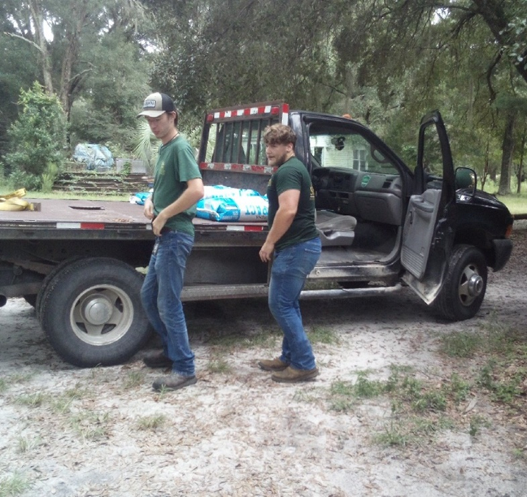 I call this “Dancing with the Sparrs”. 
Meet Eric & Matt, 2 hard-working employees at our local feed dealer. Not only does Sparr provide great food, fun & reliable service but when I tried to take a picture of these young men off-loading one ton of horse feed, impressed with their work ethics & attitudes, my first intent was to show their employers a picture of them hard at work & to extend our gratitude for such lovely people. Instead, when I looked at my picture, all I did was laugh!!! I showed the men their man-power, forever captured in a photo, but it looks more like they are dancing rather than lifting 40, 50-pound bags of feed! 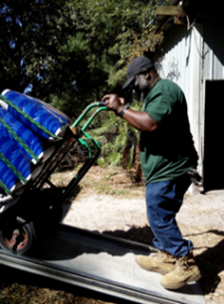 next delivery I managed to catch Anthony rolling an impressive load of grain. Now I can show employers how their drivers, loaders & friendly check-out help really earn their keep! Thanks to Jaz, Layla, Tim, Dennis, Nikki & all who bring such great workers & great fare to our ‘table’!
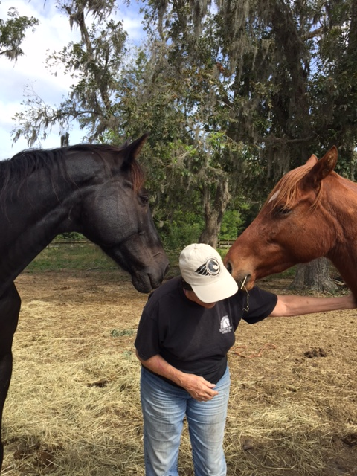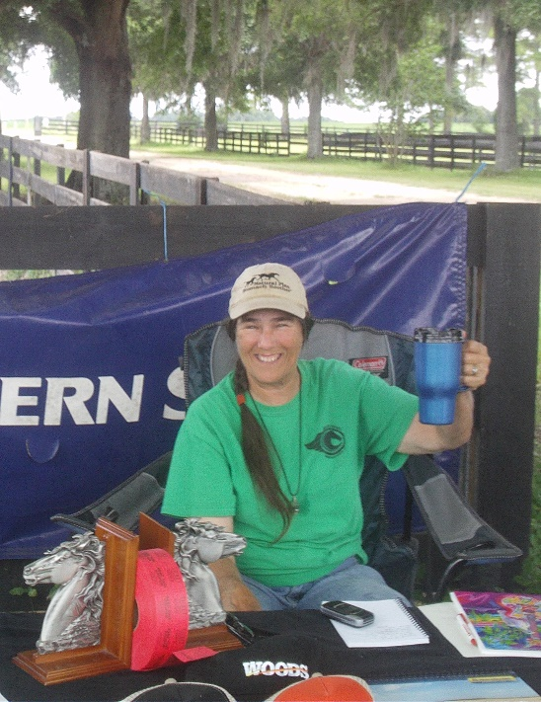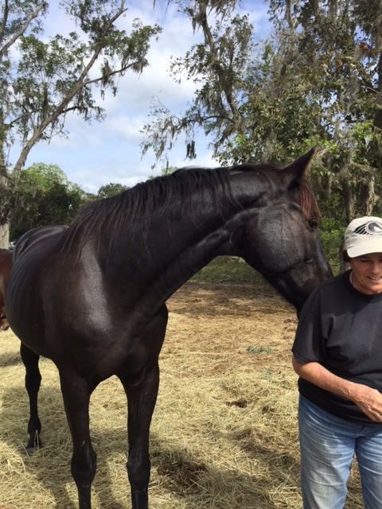
In between all the snuggles & love comes the raising of awareness & of funds. Yardsales, raffles for Bitless Bridles, t-shirt sales or simply a dollar in the pot, every penny makes such a difference!
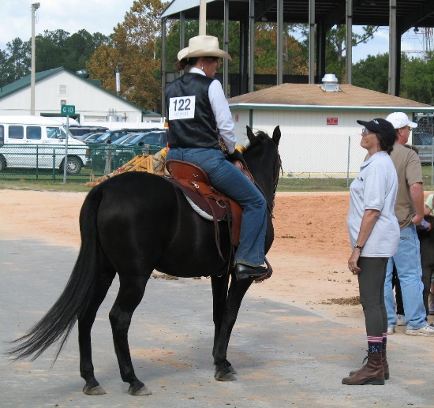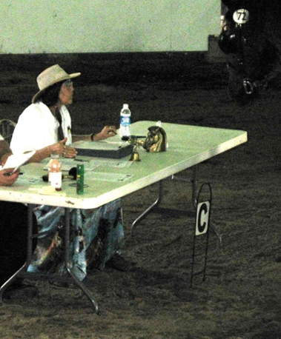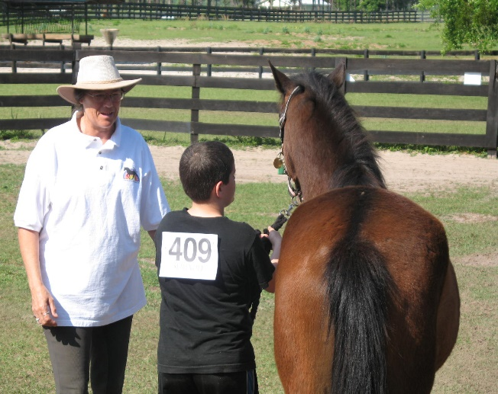
From my 1st judging job for a friend at age 15, with plastic trophies and her homemade ribbons, I fell in love with judging. Whether a schooling show, 4-H, Pony Club, Dressage, Driving, FOSH or Jumping, fun costume, breed specific or a clinic on ‘How the Judge Sees It’, the chance to aid novices, reward or critique the more experienced, has been a highlight of my equestrian career.
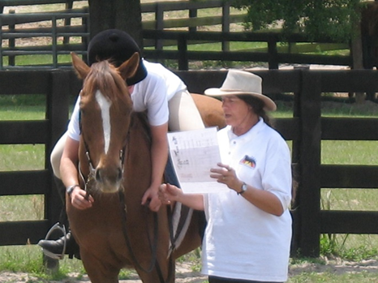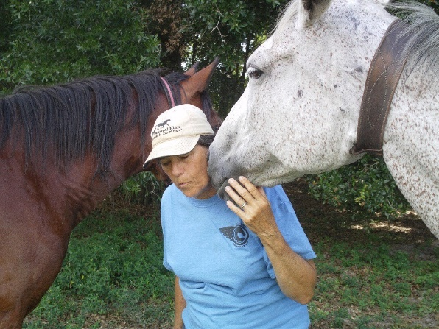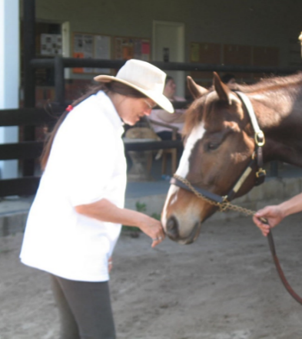
Personal attention from my equine companions makes all the trauma & toil so very worthwhile.
As a Non-profit Animal Forever-Home, we specialize in dangerous behaviors, hopeless attitudes, soundness & starvation issues. I always dreamed of having my own farm & for many years ran competitive show, breeding & training facilities but as time moved along, the levels of negligence & abuse became too much to help in a small way, hence founding Equestrian Spirits in 2010. I have dedicated my life to animals, but my involvement with organizations like Friends of Sound Horses (FOSH), founding our own Sunshine Advocates for Sound Horsemanship (SASH), writing Centaur Farm CFA Dressage Tests, one of which was used as USDF’s initial Intro Test, or being one of only 4 women to write the first ever Gaited Dressage Rule Book in the world, just didn’t seem like enough. Then along came a barrage of abandoned, tortured & starving animals. I had been rescuing them a handful at a time for decades, but life called me to take on more of the painful side of ‘pet-parenting’.
I must pause to thank some ‘behind the scenes’ businesses we could not do without. By becoming friends, they helped carry another year full circle. What all have in common is outstanding customer service! To have smiles & dependability every day should be a given, but to have people actually care for our well-being is as rewarding as it is refreshing. May we all prosper in the coming year!
 A-C Print began a relationship with us in 2003 when they printed our newsletters, brochures, a variety of horse show forms & promotions. In 2008, we moved from the area & in 2014 we were thrilled to find them as good as ever upon our return. Reliable, inventive & friendly (sometimes even silly), they are back to printing all our brochures & hard copies of Amik’s Legacy. Thank you, Sandi & Bob, for years of well done, dependable work & happy faces!
In the spirit of offering our horses the very best, we have been using Finish Line for decades! There always seems to be something for everyone! From our mare Whilo, breathing well thanks to Air Power, or Sky who loves Performance Builder …, Saint & his Iron Power & so many others, we thank Finish Line for helping us keep our herd well & looking good!
 Kind, helpful, fun reps seem to make giving them money an easy task! Their prompt service & huge inventory make shopping time smooth! Please consider donating a Chewy Gift Card so our critters can choose their very own Holiday Fare!
 One might think you only buy &/or sell, but when a realtor becomes a friend, you know life has made a good turn! Words of thanks to Marc Pompeo will never be enough for his faith & compassion towards our endeavor. Marc, we would never have gotten his far without you…
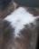Next month’s challenge … what is the difference between Ziggi & Zhighi & why do we chose Pepsi?
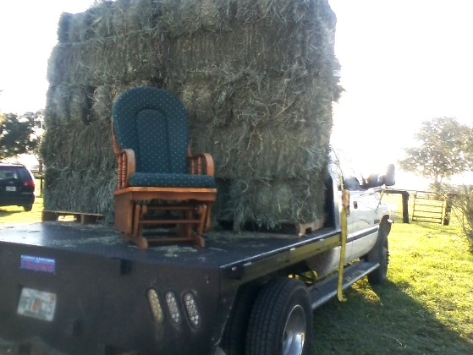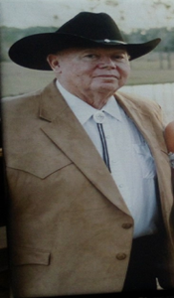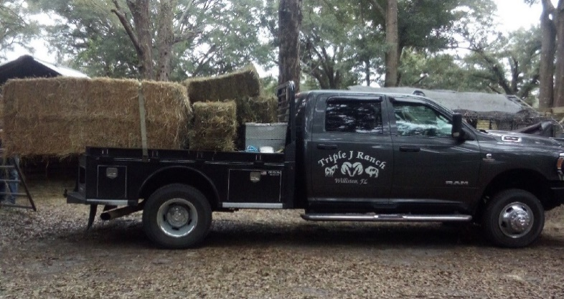
A new meaning to ‘hayride’! Thank you for your Darling friendship & the very best hay in town!
I will close out the year with a moment of thanks: to Moose – without whom I would have long-ago lost my mind… to our ever-reliable friends at Triple J Ranch, amazing suppliers as Bighorn Botanicals, Finish Line, Real Mushrooms, Chewy, & of course Sparr. To our vets at Chi University, Peterson & Smith, Dr. Sue Howell of Thrive, Dr Charles Loops, Dr. Ashley Paper & Dr. Kristi at Blue Run there are not enough words of gratitude for all the care & guidance these gifted practitioners have offered all these years… Thanks to our ever dependable repair artists: Perry’s Carts & Cars, Bullock Pump & Well, Air Ducks, Amy’s Mobile Dog Grooming ‘Love to Groom’, Colina Auto Repair, A-C Print, Harriett Downs Realty, Justin & Tracy IT gurus, Post Office pals, Dollar General, Darwin’s, & so many more!
Among all the thanks & praise – to my board of directors, volunteers & steadfast friends who have stood strong beside me while our world tried to collapse. We are here today, still standing in part because of each of you. JM, KU, PZ, PS, my sister, cousins D-D & D, our patient accountant & the lawyers who channeled us through the mire, I thank you all from so deep within. For those too numerous to list – you know who you are – many thanks & much love in keeping faith in us, even while we were drowning…
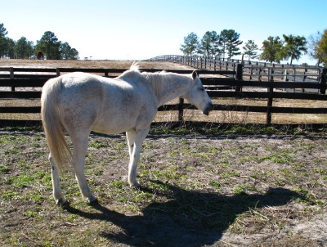 scars only show where we have been; they do not dictate where we are going… we all live in the shadow of our loved ones - Hoz, Budd, all the magic sisters; fin, fur or feather; 2 or 4 legs
Anyone wishing to donate to Zeik’s Winter Feed Fund, please click “Save the Animals”: www.EquestrianSpirits.ORG. All proceeds go only to the animals, as our board is unpaid.

Newsletter for Equestrian Spirits, Inc. 501(c)(3) EIN: 35-2384797 (863) 368-0775 www.EquestrianSpirits.ORG P.O. Box 237 - Morriston, Florida 32668 copyright LLW 2024(c)

