AUGUST 2024 issue 5 AMIK’S LEGACY

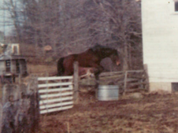 each heart travels free 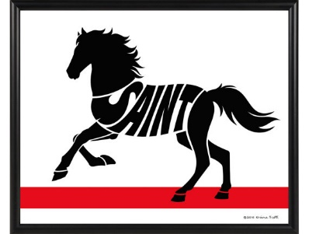

**Happy Summer to friends & family & fans!!!**

August is a different kind of month for me. My heart-horse, Amik, was born on August 13th 1967 & miraculously entered my then, rapidly fading life… in 1970.

From there, things changed. A lot of things changed…. As life would have it, a renewed purpose surfaced. As my vet informed me that my new-found love would be unlikely to survive (full-blown double pneumonia, among other problems), I deepened my quest to help any & all living beings – as ever I could. Well, the horse lived.

Welcome to our newsletter bearing the name of my beloved soulmate. We’ve had quite an interesting journey together. His tenacity, exuberance for life & unequalled endurance, is in everything I do…

Follow me through Tales of Tails to vicariously experience the love held within each day. Keep your eyes open, you never know what you might learn or who you might find! There is so much of our wonderful world to share… please “read on!”.

A slightly unusual set of pictures begin this issue. One more lovely flower gracing us with its life is Campsis radicans aka the Trumpet Vine. We are hoping the hummingbirds will find it! Our natural spring-fed pond alternates between clear duck water or a carpet of heathy, edible algae. I could not resist the grapes. No, we did not grow them, but we do have many friends who donate various produce for our menagerie. Shortly after I captured this photo, the horses devoured the fruit & the chickens noshed on the stems. I was intrigued by the perfection of the ‘bunch’.

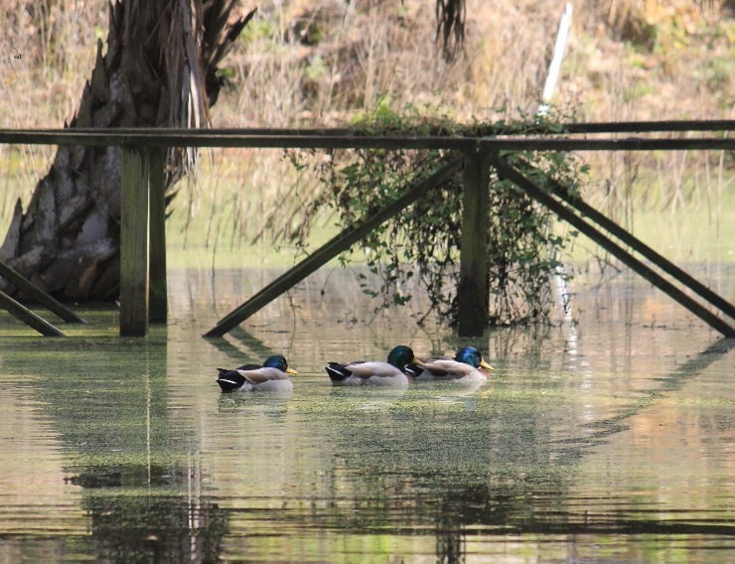 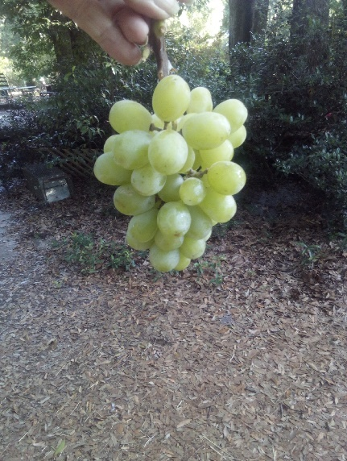

My original plan to feature at least one horse, current or past, as well as one other species has led me to share another of our kind residents. Last month you were asked if anyone remembered the running horse. Well, in 2000 we were donated an injured yearling Thoroughbred who was consigned in one of Racing’s Select Sales - that injury ended that opportunity, & his racing career. However, with Kentucky Derby ‘black type’ bloodlines, Never Saintless still lived up to his name.

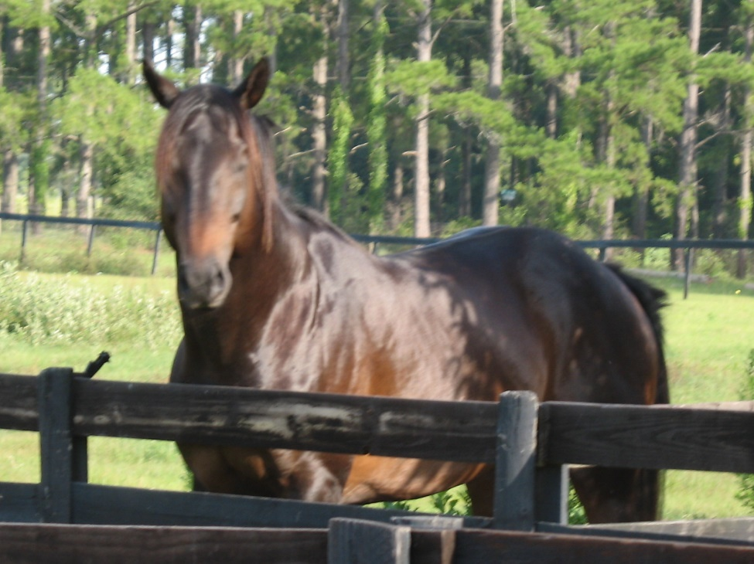 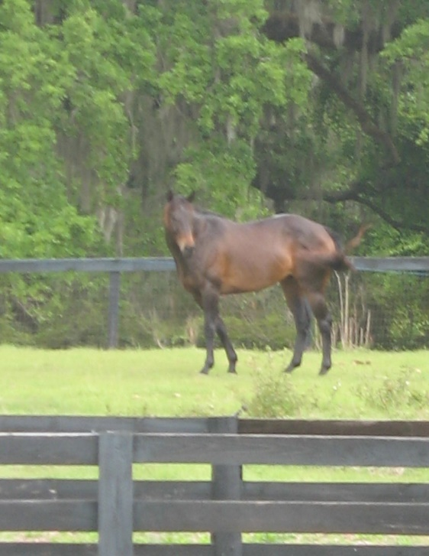

Later in his initial year with us, Saint regained 100% soundness & has remained sound throughout his 24 years with us. The illustrious Holistic Veterinarian, Dr. Gerald Wessner, was responsible for the blessing of full health for this handsome fellow. The injury that his x-rays showed, is still visible to the trained eye, but he has never taken a bad step since it healed. His prognosis was “fair” by conventional medicine criteria, but this was one of those times an alternative would prove the right choice. #1 Protecting, as he does best #2 Guarding the mare, whose life he saved. #3 In his late 20s, quietly grazing as he watches over his herd.

1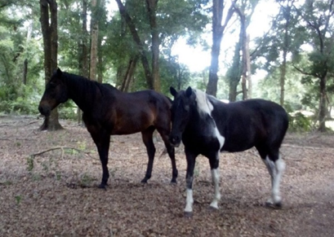 2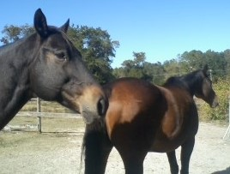 3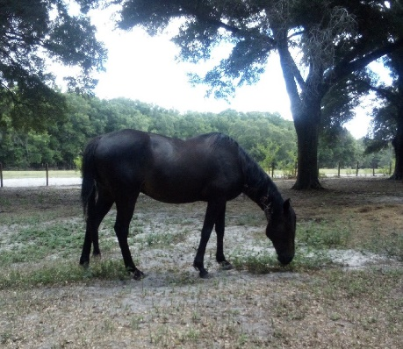

Saint is part of Equestrian Spirits, Inc., a Not-for-profit Rescue Sanctuary. We are Holistically-Based, founded in 2010 by Lynn S. Peck, DVM, MS, clCAK, Laurie L. Wolf & 2 other animal lovers. Named Amik Run after my gifted Show Jumper, our farm has over 60 perfect acres, providing the space & freedom many residents hadn’t dared to dreamed of, & the privacy so many craved to find peace for their tortured spirits. Being close to Ocala, Florida, we have access to some of the best animal medical care in the country. Although Equestrian Spirits does not rehome, we do help individuals & other organizations place rescued or displaced animals into loving situations.

For any wishing to visit peaceful & lovely Levy County, you will find along our roadway, a local farmer who grows melons, hay, cows & cotton! But little known in our area, there is a secret crop – Marshmallows!

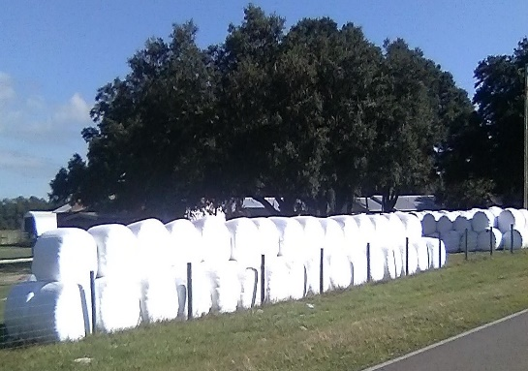 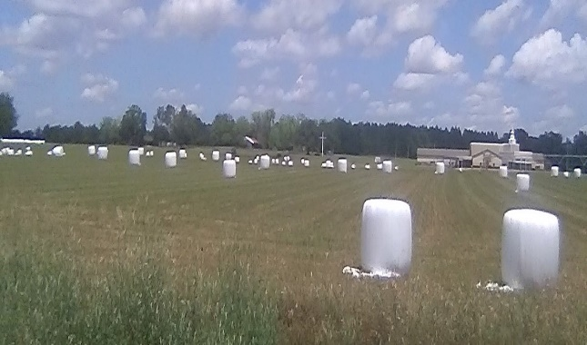 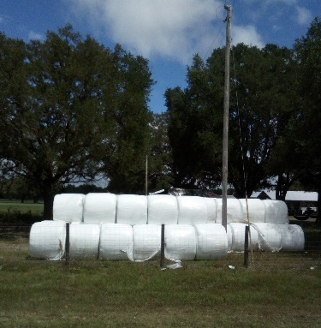

*When my dear friend & excellent volunteer, Marla, first exclaimed “Oh, look! Marshmallow Farming!” I nearly crashed my truck from laughter! I had seen silage bales for years & years. I also have a rather quirky mind, but never had I seen the huge, plastic wrapped bales - as gigantic marshmallows!!*

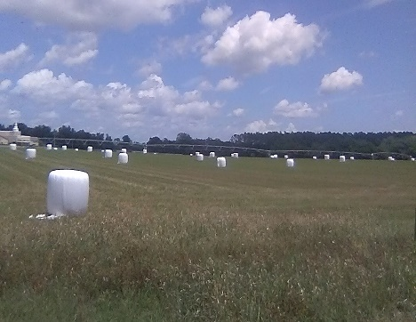 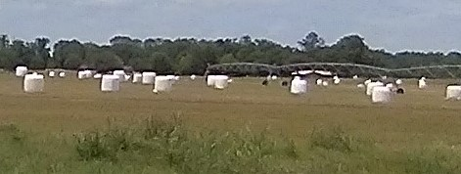

After our laughter subsided, we went on to speculate that the huge mallows would be sent to Jacksonville (since everything seems to need to go to Jacksonville…) where they would be chopped into reasonable sizes, packaged & sold to the world as the sweet, puffy morsels we have come to call ‘marshmallows’.

Kidding aside, these wrapped bales, as well as the common, large block & round field bales & smaller square bales (which are actually rectangular…go figure) feed tens of thousands of grazers throughout our county & beyond. Present a farmer with a delemma & watch what they can do!

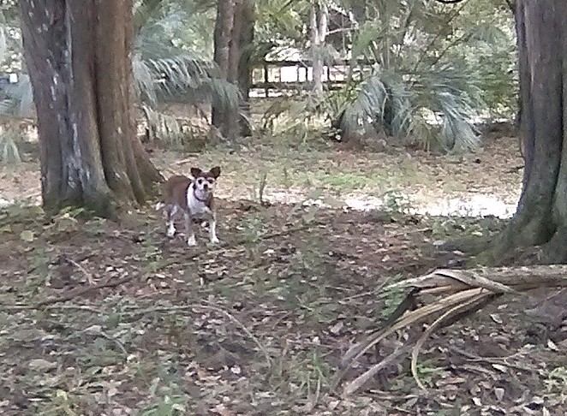 tiny Tikkho 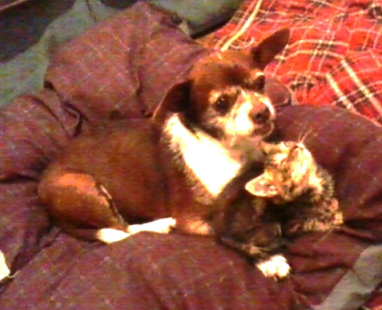

Speaking of farmers… upon arrival to our current location in 2017, the previous property owner had a few family members he believed would not be comfortable moving to the city with him. He then entrusted us with a few of his beloved critters, one of whom asked to be called, Tikkho!

The smallest canine resident we have ever had, our little man ran this farm from day one! He made sure we fed HIS way, drove our work carts HIS way, even threatened a 100+ pound dog who came into our lives. As he aged, Tikkho rode in the feed cart with me at the helm, while he rested his head on my arm, still making sure I did not falter in my duties to him & his now enlarged family. Although never fully accepting collars, harness or any restraint, he came to love his purple jacket when the coolest days settled between the balmy Florida weather. Besides, he could be carried anywhere!

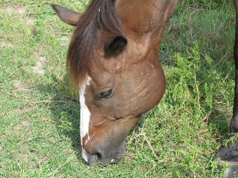 Your challenges for September … who is this & what makes Alice special?

Gratitude is about remembering to say thank you, but it is also what remains in our heart, no matter what the years… Here is a moment of memory lane. Nostalgia & a glimpse of some corners of my mind. Photos or not, I strive to never forget… from 1952 - until tomorrow.

1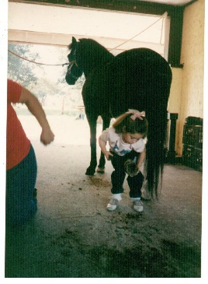2 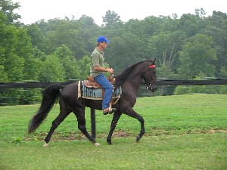3 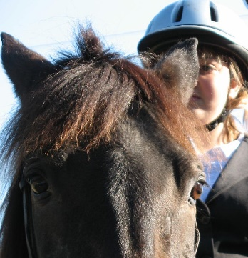4 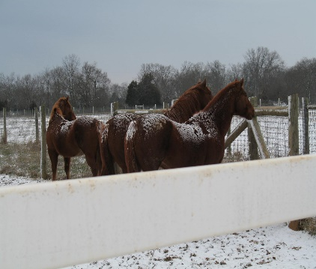

Top: #1 1986 CF Working Student Program #2 2003 Morgan Rhoads FOSH/SASH Clinic #3 2006 special friends #4 2005 IJA/FOSH Mountain Horse Judges Clinic, in the Tennessee snow.

1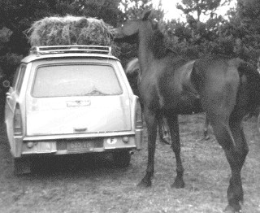2 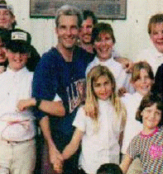 3 1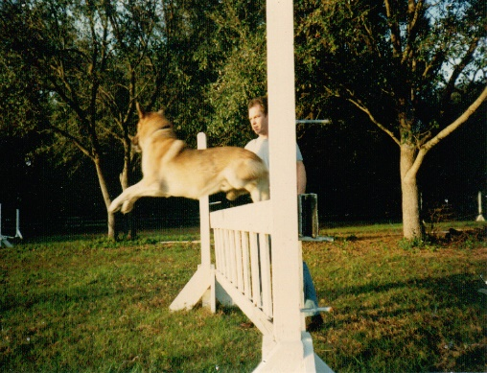2 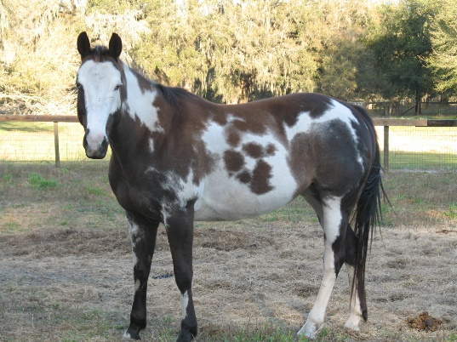 3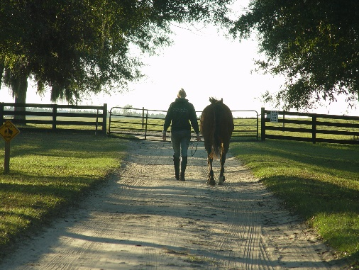

Center: #1 1970 Canada #2 1991 Bradenton, Fl #3 2006 IJA/FOSH Clinic & show, Morriston, Fl.

Lower: #1 1987 Centaur Farm #2 2003 Patchiz, Amik Run #3 2004 the close of many perfect days…

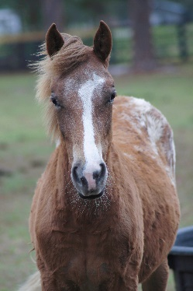**Anyone wishing to help Saint & his family with their medical needs, please consider a donation to our Medical Rescue Fund; click “Save the Animals”** [www.EquestrianSpirits.ORG](http://www.EquestrianSpirits.ORG) *All proceeds go only to the animals, as our board is unpaid.*

Very sincerely, and in the spirit of all who have gone on before me...

many thanks for your interest – Laurie L. Wolf - and to Amik, who keeps my heart beating, even today…

Newsletter for Equestrian Spirits, Inc. 501(c)(3) EIN: 35-2384797 (863) 368-0775 [www.EquestrianSpirits.ORG](http://www.EquestrianSpirits.ORG) P.O. Box 237 - Morriston, Florida 32668 copyright LLW 2024(c)