July 2024 issue 4 WELCOME TO AMIK’S LEGACY

 each heart travels free 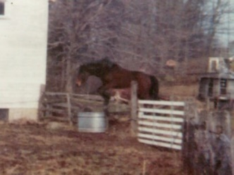

**Greetings to all our family & fans!!!**

Welcome to issue #4 of Amik’s Legacy, the newsletter for Equestrian Spirits Sanctuary! Follow on through Tales of Tails. Better keep eyes open; have you recognized anyone yet?? There are so many friends here who are sharing their stories, please join us in a visit as spring turns into summer!

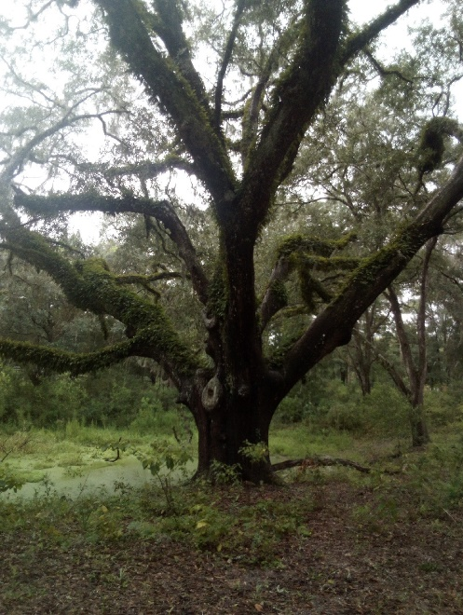 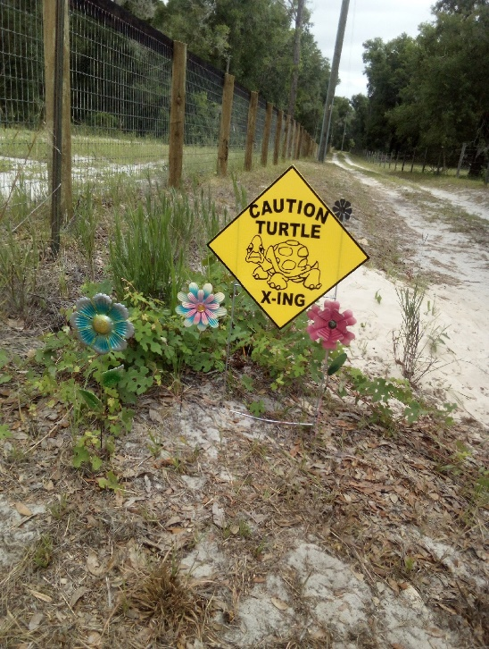 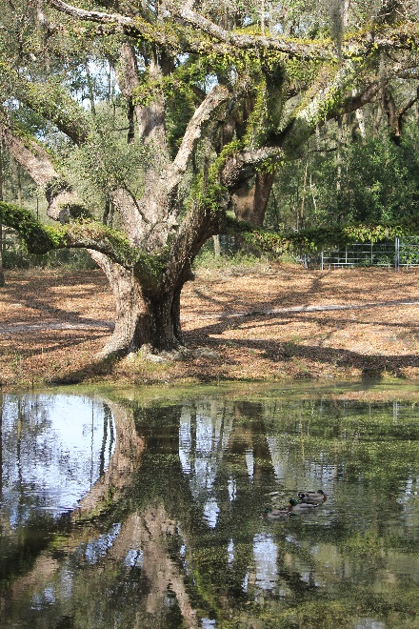

our magical tree, Avatar we protect wildlife too Avatar in the fall

Any form of life is precious, it is when a new life allows us in, that the miracle becomes… reality…

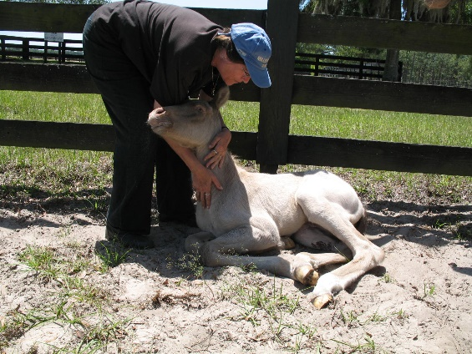 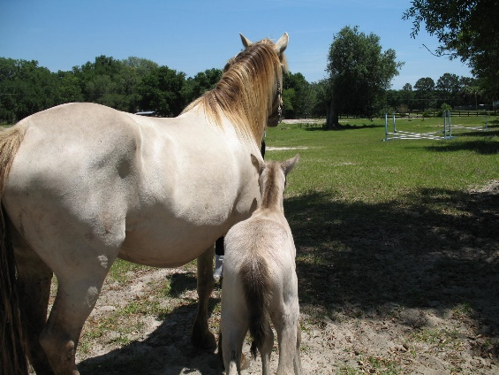 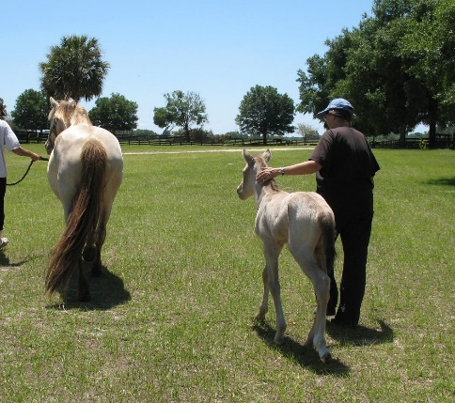

“*I am so happy to have 2 moms*!” “*Mom, do I get to jump soon?*” “*Where he leads, I will follow.*”

Meet Kefi & his perfect mother, Sage. Born in 2006, this colt has seen many sides of life’s journey.

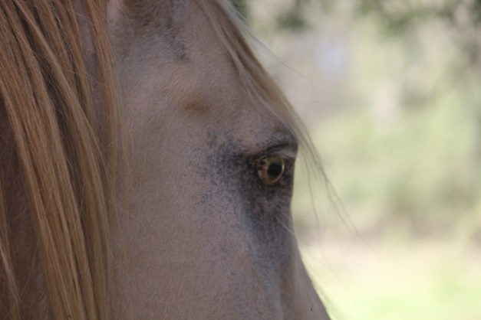 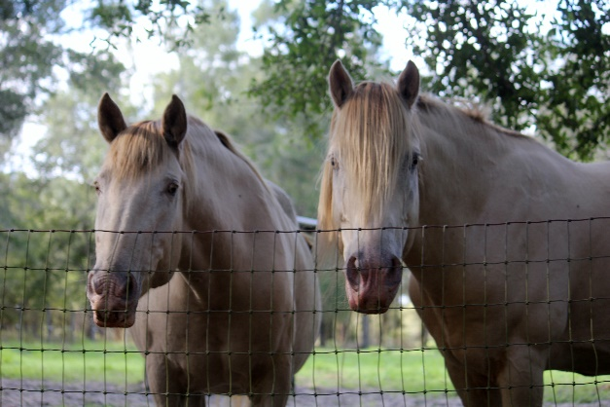 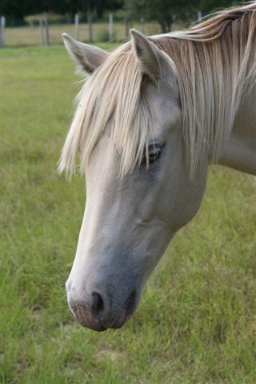

Considered one of the most difficult words to translate from original Greek: ***Kefi*** – the spirit of joy, passion, euphoria, enthusiasm, exuberance, frenzy. Overpowering emotion when one completely let’s go in the moment, release inhibitions, allow to joyfully feel life pulsing thru body & soul; reminded of beauty; feeling alive. Tap into spirit, an appetite for life, create bliss/excitement in everything we do.

Or from the Hebrew – ‘all the joys of the world’. Golden, light, sun, vibrancy… what a joy it is to feel.

A joy that is infectious. Dance in the rain, when no one is watching.

Kefi & his dam have seen both sides. In nearly two decades together, they have been stolen, starved, taunted & whipped. To look into their eyes today, all that can be seen is the love they have for each other, & the faith they have in us – the ones who intervened at every turn, at every struggle, at every moment of darkness. Nobody can make certain that every day will go well, but resolve is about never stepping away.

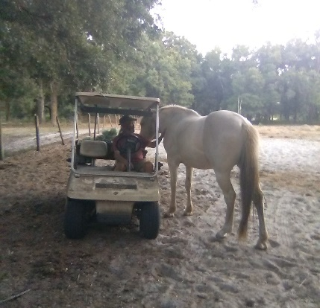 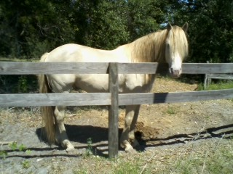 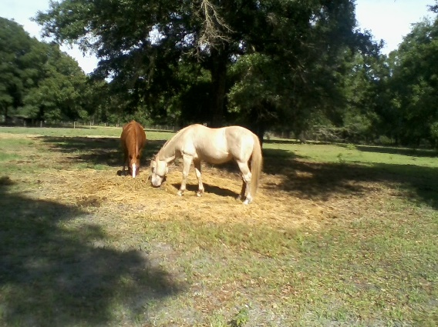

Kefi loves Moose all growed up Kefi & best friend for life, Wil-Hee

Kefi & Sage live at Equestrian Spirits, Inc., an Animal Rescue Holistic-Based Forever-Home Sanctuary (yes mom, a run-on-sentence). Though beginning in 2010, our founder has been doing the same since 1970, out-of-pocket. Our farm is Amik Run, named after the miraculous Show Jumper, Amik. Nestled on over 60 secluded acres just outside of Ocala, Florida, our animals remain with us for life. We help individuals & organizations nationwide with adoptions & behavioral issues as our residents find the confidence & freedom, to redefine their lives. Kefi is always hoping for donations to care for & protect him & all his friends, maybe you will be his next new ‘pal’. He is hoping you will check out the ‘before’ & ‘after’ pictures on our closing page, that he has chosen to share.

Our May issue asked if anyone knew the pinto horse. Well at least ONE should have recognized the sweet mare in the picture, as she is part of an unusual group in our family, who have ‘co-owners’. Bhaya was ‘gifted’ by Equestrian Spirits to a very special young lady, who is quite dear to us.

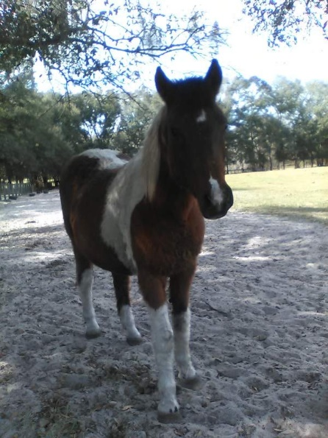 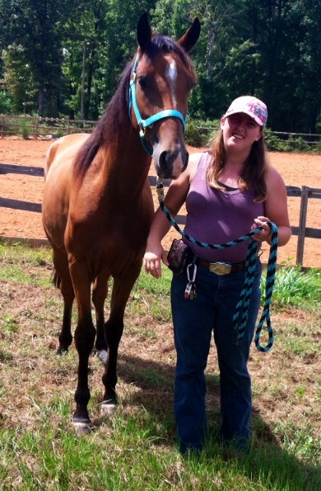 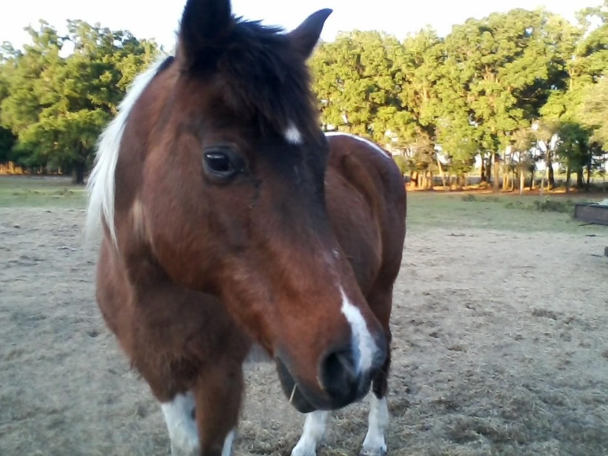

woolly winter Bhaya Athena in N. Carolina sleek summer Bhaya

One of the very most gentle, calmly intelligent, patient, uncomplicated mares we have ever known. Starved with her herd, who we saved in 2014, this horse never lost her quietude. In our care she gained her weight & eventually revived in spirit. We have always had a special place in our life for a ‘horse-kid’ who we met in her early teens. Athena had had her own life challenges when we met, but she always smiled, kept her kindness & immersed herself in her love of horses. Her dad & mom worked off the sale price of a horse who stole her heart, but due to personal & health challenges Athena found herself needing to sell her beloved sport-horse pinto gelding. Our co-founder Polly, purchased Pepsi, with the promise to keep him for life. Although Athena moved out of state, she has come back & been able to visit Pepsi & us. In 2018, on a trip to Florida, Athena spent several excellent days with us & was surprised to happy tears - when we gifted Bhaya to her.

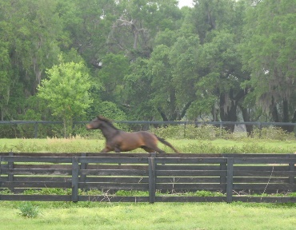 Your challenge for August … guess who & what is Florida’s most unique crop?

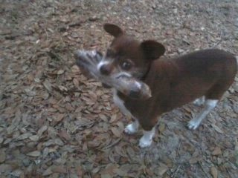

When asked if we only care for horses… our response is we do not really care for anyone, they care for us.

Normally I would be thanking a volunteer, or a business we rely on, but this month we *must* honor our Advertising Executive. Here is a brief look into the busy, thorough & decisive day in the life of, CarlBob.

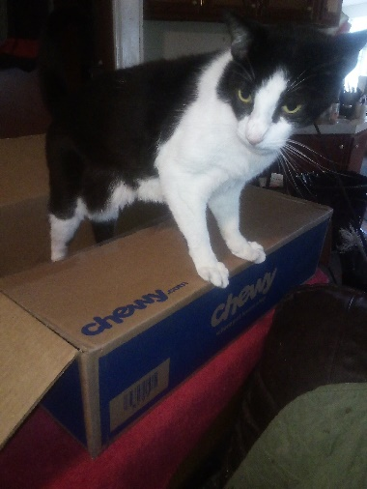 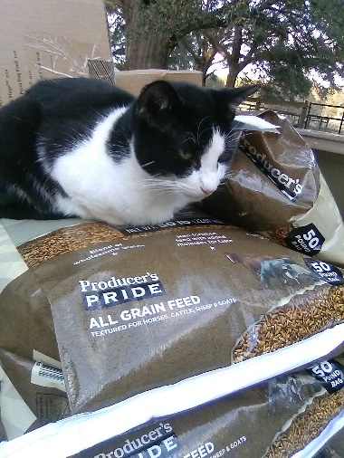 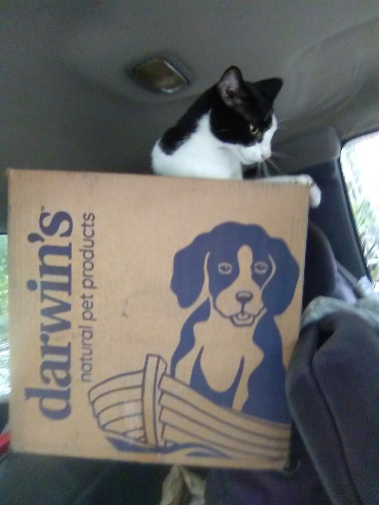 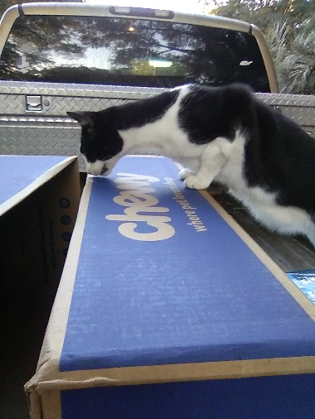

BoB (to his friends) acquired his name from a rather successful Race Car Driver, Road America official & our friend, Carl Jensen. Long story, which you will have to learn from our website – lol. BoB is our self-appointed advertising agent & quality control ‘freak’. BoB demands packages arrive *on time* & with proper contents. He test-tastes everything from cat, dog, equine, poultry food & treats to salads being prepared for our family of fowl or human meals of many kinds. Although forbidden to taste the ice cream he is determined to try, he does receive a special treat from our Chewy wish list, that only *he* likes.

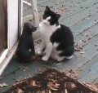 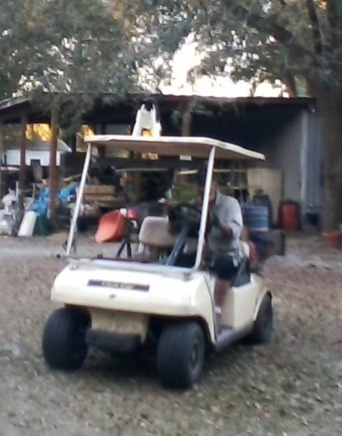 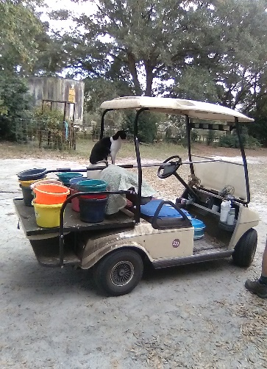 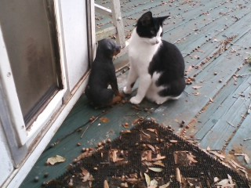 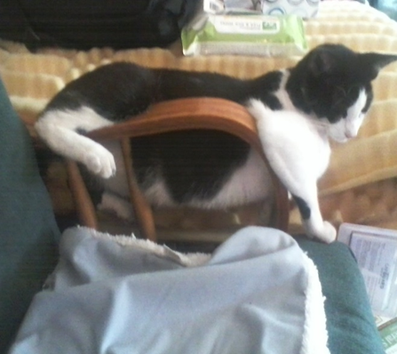 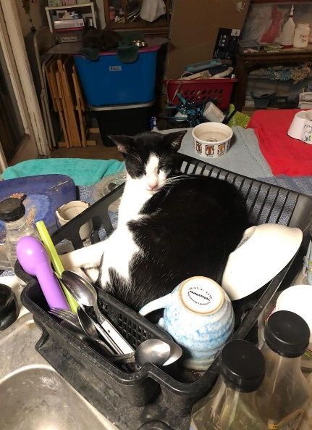 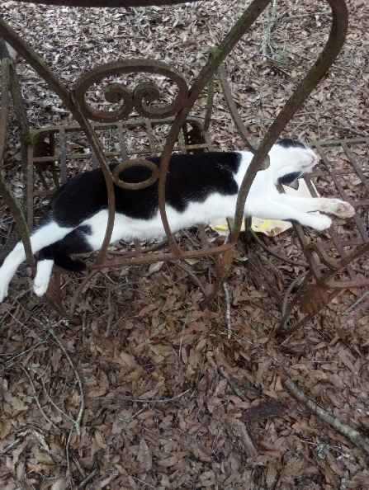

From dog trainer to co-pilot, furniture tester to taste tester, BoB does it all. In his overtime, he loves us.

1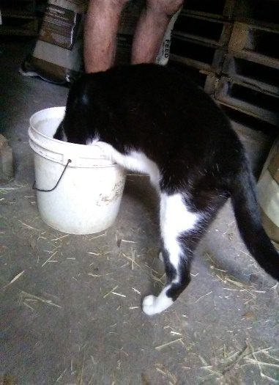2 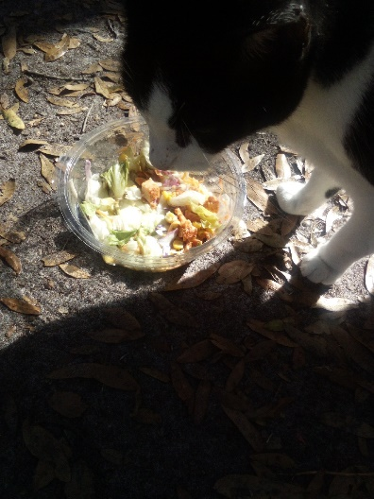3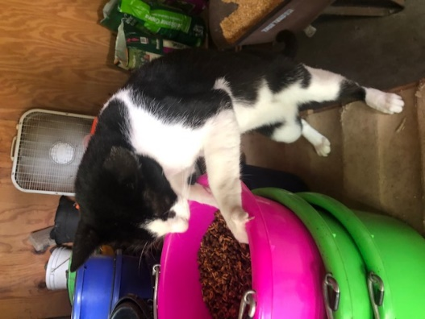4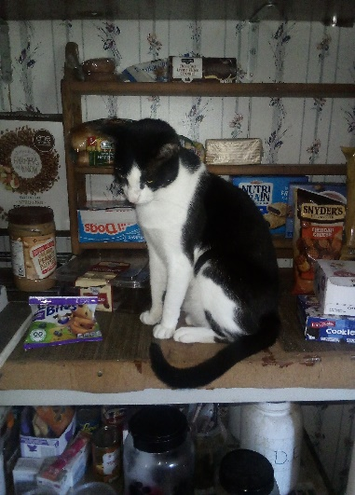

*BoB’s written evaluations*: #1 “This mash is too soupy! Fix it Moose, or else you will get a low score…” (notice Moose’s legs in the background while he anxiously awaits BoB’s final decision. In the end, Moose added more feed to improve the mash & BoB was pleased. The end score that day, was another perfect ‘10’ for Moose, whew!) #2 “I really enjoyed the Chicken’s Salad; I will give it a good score.” #3 “This looks like just the right amount of food. Great score for Moose’s mixing techniques.” #4 “I must say, I am disappointed in the home pantry. With all the amazingly wonderful meals & supplies for us all, Moose & Laurie have weird things in their pantry… they get an overall 3 out of 10. I did have this marked as a ‘Pantry Fail’ until my humans sheepishly said they keep that stuff around for a volunteer! That is different. I give my humans a perfect 10 because they eat mostly organic (except for that ice cream they refuse to let me test – something about chocolate or coffee being a problem…). Anyway, although they got a ‘10’, I had a talk with our main volunteer about her tastes in healthy snacks. She giggled but refused my Blue Buffalo treats as a substitute. She needs to get with the program!”

“Hi, my name is Bhenn. I am a horse. I am not featured this month BUT, I must defend my great friend, Beckie. She is the volunteer BoB was picking on about organics & cat treats. You see, Beckie is a good worker & has many special talents. Here are a few pictures I submitted to BoB for his review.”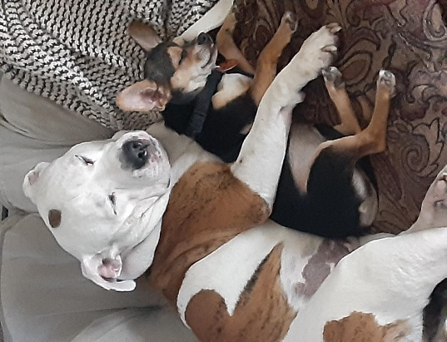 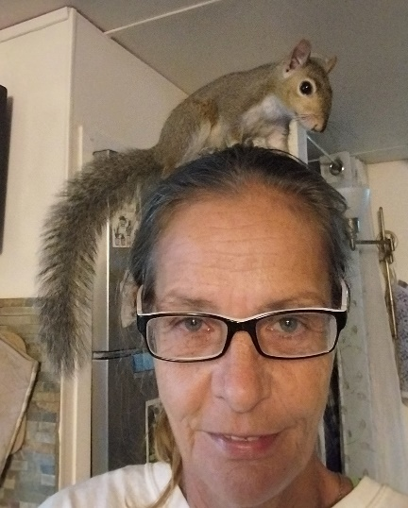 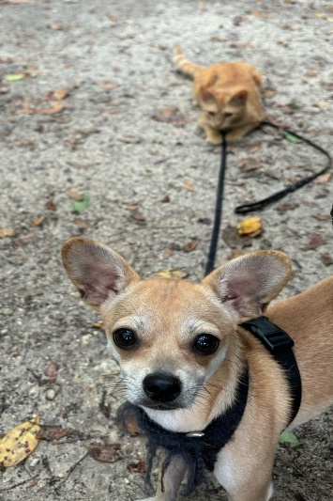 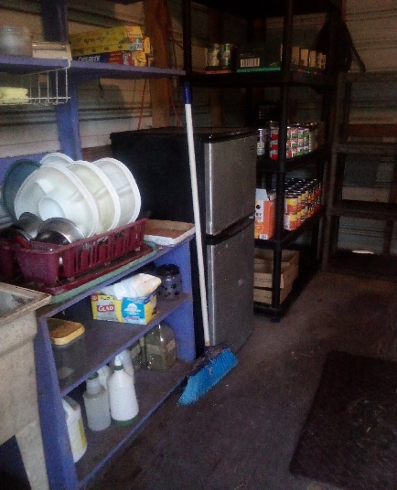

BoB – “I do admit Beckie is a nice lady & she is quite kind to Bhenn, BUT apparently, she does NOT realize dogs come in varying sizes! I do see she accepts that cats are far better trainers than humans, (& no, I do *not* think we should tell her she has a squirrel on her head!), BUT the job she did revamping Keila’s Kitchin (where all my cat foods are stashed…) is staggering. So, I guess she can eat whatever she wants… Beckie is officially, ‘Approved By BoB’. Thanks Bhenn, often an outside opinion is worthy.”

As a child, my father taught me a poem that has identified my life ever since. In 1981 when we founded Centaur Farm, I adopted Henley’s ‘Invictus’ as our Creed of the Centaurs. So many who suffer at the hands of man, become miracles with some good meals, a vet… & a whole lot of love. The strength & tenacity to overcome their torments sets an example for us all. Taking liberty with format, I share the creed of all who have stepped through our doors….

*“Out of the night that covers me, Black as the Pit from pole to pole, I thank whatever gods may be, for my unconquerable soul. In the fell clutch of circumstance I have not winced nor cried aloud. Under the bludgeoning of chance my head is bloody, but unbowed. Beyond this place of wrath and tears looms but the Horror of the shade, and yet the menace of the years finds, and shall find, me unafraid. It matters not how strait the gate, how charged with punishment the scroll.*

I am the master of my fate: I am the captain of my soul.”

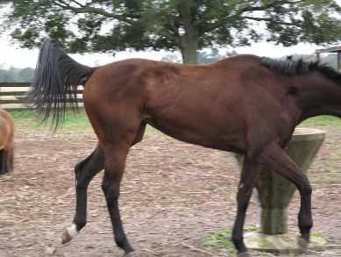 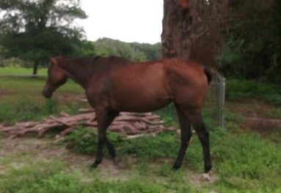 or 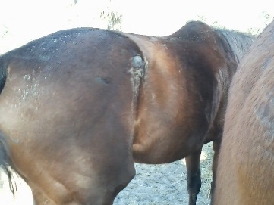 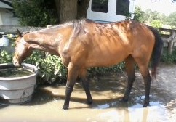

From this…. To this This …. To this

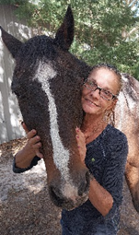 **Bhenn ‘n Beckie hope you will consider Kefi’s request of donating to our ongoing support fund, click “Save the Animals”** on our website: [www.EquestrianSpirits.ORG](http://www.EquestrianSpirits.ORG). *All proceeds go only to the animals*, as our board is unpaid. Help us keep helping them…

Very sincerely, and in the spirit of all who have gone on before me...

many thanks for your interest – Laurie L. Wolf

Newsletter for Equestrian Spirits, Inc. 501(c)(3) EIN: 35-2384797 (863) 368-0775 [www.EquestrianSpirits.ORG](http://www.EquestrianSpirits.ORG) P.O. Box 237 - Morriston, Florida 32668 copyright LLW 2024(c)