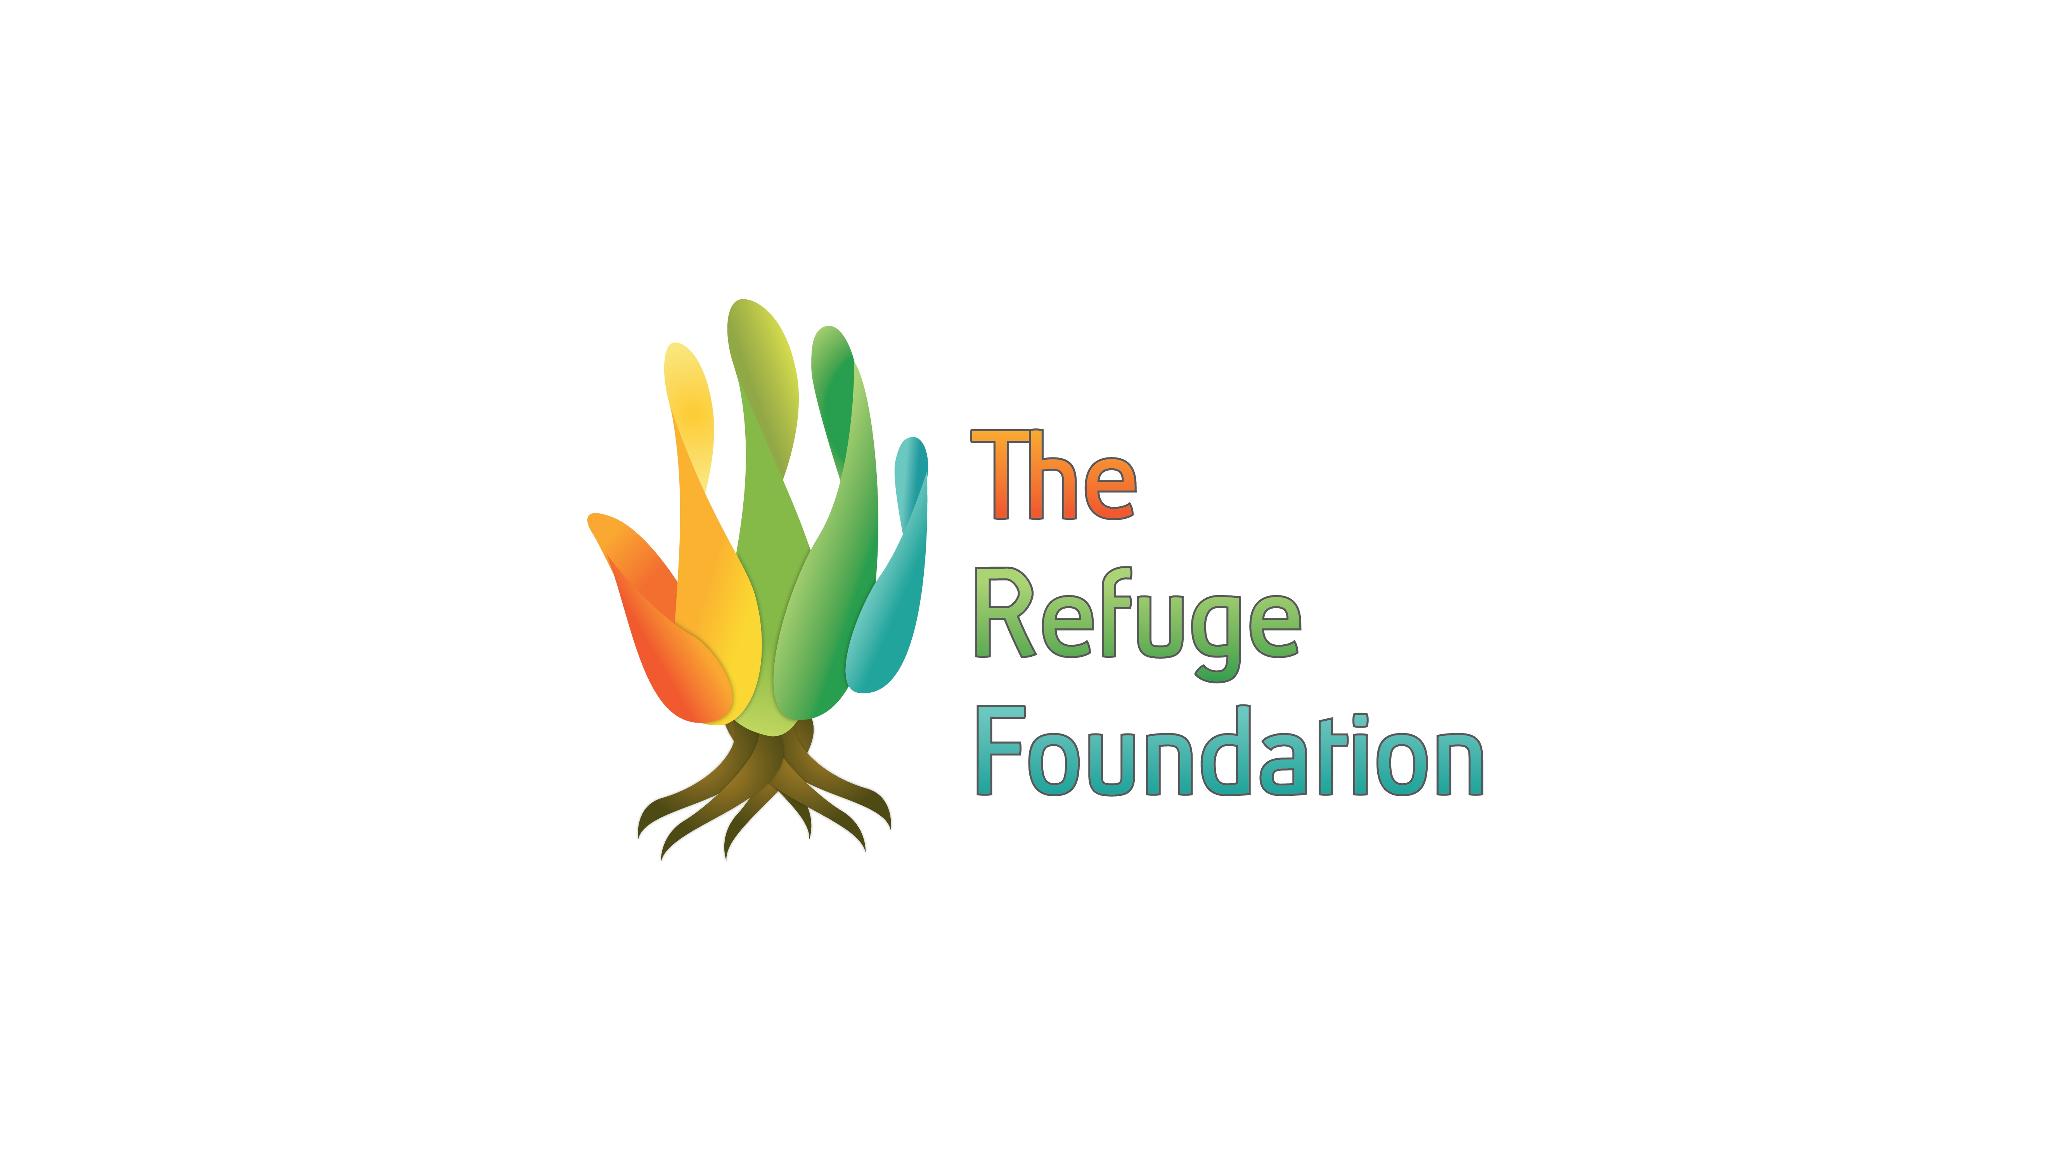

Application Completion Information

Please Send the following items electronically combined in one email to refugefoundation2012@gmail.com, subject line: TRF International of TRF Arizona Application (whichever applies).

Application Completion List:

- Cover Letter
- Completed Application Form
- Resume
- Statement of Faith
- Background Check Release Form
- Please include a two page double spaced writing sample with your application.

Additionally, send the following items together in one package to:
The Refuge Foundation:
PO Box 31807
Phoenix, AZ 85046

- Three completed letters of recommendation. Pertaining to the specific
fellowship/internship you are applying for.
- Official transcripts from all secondary education.

Statement of Faith:
Please provide a description of your faith and include your current spiritual
disciplines (not more than two pages).

Application Deadlines

- March 15th for August deployment.
- September 13th for January deployment.
- All completed applications, forms and references must be postmarked by the application deadlines.
- We will send an email confirmation within 5 business days of receiving your application.

Please email additional inquiries to refugefoundation2012@gmail.com.

